**DEWATERING OF AL A PROJECT**

**DESIGN REPORT**

**28 March 2024**

Contents

[1. PREFACE 6](#_Toc162645753)

[2. DESIGN 6](#_Toc162645754)

[2.1. Scope of design 6](#_Toc162645755)

[2.2. Dewatering system 6](#_Toc162645756)

[2.3. Dewatering calculations 8](#_Toc162645757)

[2.3.1. Design methodology 8](#_Toc162645758)

[2.3.2. Permeability coefficient 8](#_Toc162645759)

[2.3.3. Discharge Quantities & Pumping 8](#_Toc162645760)

[2.3.4. Water drawdown inside the project area 9](#_Toc162645761)

[2.3.5. Water drawdown on adjacent structures 10](#_Toc162645762)

[2.3.6. Discharge and Pumping lines sizing 14](#_Toc162645763)

[2.3.7. Pumps 15](#_Toc162645764)

[2.3.8. Filter pack 15](#_Toc162645765)

[2.3.9. Well screen 15](#_Toc162645766)

[2.3.10. Main Discharge Lines 17](#_Toc162645767)

[**2.4.** **Analytical calculation of stresses and settlements** 17](#_Toc162645768)

[**2.5.** **Settlements using cohesionless soil conditions:** 17](#_Toc162645769)

[2.5.1. General 17](#_Toc162645770)

[2.5.2. Input Data 17](#_Toc162645771)

[2.5.3. Bearing pressure of footing at foundation level 18](#_Toc162645772)

[2.5.4. Settlements at each building point 20](#_Toc162645773)

[**2.6.** **Stresses and Settlements using cohesive soil material.** 24](#_Toc162645774)

[2.7. Displacement at two Nodes areas, using analytical cohesion soil model calculations and numerical model. 33](#_Toc162645775)

[2.7.1. Excavation and dewatering numerical modeling 33](#_Toc162645776)

[2.8. Summary of analytical maximum settlements and differential settlements at buildings’ nodes 43](#_Toc162645777)

[2.9. Summary of analytical and numerical maximum settlements at points F and B 46](#_Toc162645778)

[2.9.1. Comparison of results to the standards 47](#_Toc162645779)

[2.10. Recommendation 48](#_Toc162645780)

[2.10.1. Supporting system 48](#_Toc162645781)

[2.10.2. Contractor’s precautious measures During Excavations 49](#_Toc162645782)

[3. WORKS EXECUTION 50](#_Toc162645783)

[3.1. Execution steps 50](#_Toc162645784)

[3.2. Sequence of work 50](#_Toc162645785)

[3.3. Control Panels 50](#_Toc162645786)

[3.4. Connection from pumps to discharge Lines 50](#_Toc162645787)

[4. COMMISSIONING 50](#_Toc162645788)

[5. HEALTH AND SAFETY 51](#_Toc162645789)

[**ANNEXES** 51](#_Toc162645790)

[ANNEX A1 51](#_Toc162645791)

[Pumps 51](#_Toc162645792)

[ANNEX A2 51](#_Toc162645793)

[Method1-Big Well Equivalent 51](#_Toc162645794)

[ANNEX A3 52](#_Toc162645795)

[Superposition Method Wells-InsideProject 52](#_Toc162645796)

[ANNEX A4A 52](#_Toc162645797)

[Superposition Method Wells-Building A, Points A1,A2,A3,A4,A5 52](#_Toc162645798)

[Cohesion soil material 52](#_Toc162645799)

[ANNEX A4B 52](#_Toc162645800)

[Building A, Summary of initial and final water levels 52](#_Toc162645801)

[ANNEX A4C 52](#_Toc162645802)

[Building A, Point A, Schemertmann method, Cohesionless soil material 52](#_Toc162645803)

[ANNEX A4D 52](#_Toc162645804)

[Building A, Point A1, Schemertmann method, Cohesionless soil material 52](#_Toc162645805)

[ANNEX A4E 52](#_Toc162645806)

[Building A, Point A1, Schemertmann method, Cohesionless soil material 52](#_Toc162645807)

[ANNEX A4F 52](#_Toc162645808)

[Building A, Point A1, Schemertmann method, Cohesionless soil material 52](#_Toc162645809)

[ANNEX A4G 52](#_Toc162645810)

[Building A, Point A1, Schemertmann method,Cohesionless soil material 52](#_Toc162645811)

[ANNEX A4G 52](#_Toc162645812)

[Building A, Summary of settlements and differential settlements 52](#_Toc162645813)

[ANNEX A5A 52](#_Toc162645814)

[Superposition Method 52](#_Toc162645815)

[Wells- Building C, Points C1,C2,C3,C4,C5 Cohesion soil material 52](#_Toc162645816)

[ANNEX A5B 53](#_Toc162645817)

[Building C 53](#_Toc162645818)

[Summary of initial and final water levels 53](#_Toc162645819)

[ANNEX A5C 53](#_Toc162645820)

[Building C, Point C1, Schemertmann method, Cohesionless soil material 53](#_Toc162645821)

[ANNEX A5D 53](#_Toc162645822)

[Building C, Point C2, Schemertmann method, Cohesionless soil material 53](#_Toc162645823)

[ANNEX A5E 53](#_Toc162645824)

[Building C, Point C3, Schemertmann method, Cohesionless soil material 53](#_Toc162645825)

[ANNEX A5F 53](#_Toc162645826)

[Building C, Point C4, Schemertmann method, Cohesionless soil material 53](#_Toc162645827)

[ANNEX A5G 53](#_Toc162645828)

[Building C, Summary of settlements and differential settlements 53](#_Toc162645829)

[ANNEX A6A 53](#_Toc162645830)

[Superposition Method 53](#_Toc162645831)

[Wells- Building C, Points B1,B2,B3,B4 Cohesion soil material 53](#_Toc162645832)

[ANNEX A6B 53](#_Toc162645833)

[Building B 53](#_Toc162645834)

[Summary of initial and final water levels 53](#_Toc162645835)

[ANNEX A6C 53](#_Toc162645836)

[Building B, Point B, Schemertmann method, Cohesionless soil material 53](#_Toc162645837)

[ANNEX A6D 53](#_Toc162645838)

[Building B, Point B1, Schemertmann method, Cohesionless soil material 53](#_Toc162645839)

[ANNEX A6E 53](#_Toc162645840)

[Building B, Point B2, Schemertmann method, Cohesionless soil material 53](#_Toc162645841)

[ANNEX A6F 53](#_Toc162645842)

[Building B, Point B3, Schemertmann method, Cohesionless soil material 53](#_Toc162645843)

[ANNEX A6G 53](#_Toc162645844)

[Building B, Point B4, Schemertmann method, Cohesionless soil material 53](#_Toc162645845)

[ANNEX A6H 54](#_Toc162645846)

[Building B, Summary of settlements and differential settlements 54](#_Toc162645847)

[ANNEX A7A 54](#_Toc162645848)

[Superposition Method 54](#_Toc162645849)

[Wells- Building D, Points D1,D2,D3 Cohesion soil material 54](#_Toc162645850)

[ANNEX A7B 54](#_Toc162645851)

[Building D, Summary of initial and final water levels 54](#_Toc162645852)

[ANNEX A7C 54](#_Toc162645853)

[Building D, Point D1, Schemertmann method, Cohesionless soil material 54](#_Toc162645854)

[ANNEX A7D 54](#_Toc162645855)

[Building D, Point D2, Schemertmann method, Cohesionless soil material 54](#_Toc162645856)

[ANNEX A7E 54](#_Toc162645857)

[Building D, Point D3, Schemertmann method, Cohesionless soil material 54](#_Toc162645858)

[ANNEX A7F 54](#_Toc162645859)

[Building D, Summary of settlements and differential settlements 54](#_Toc162645860)

[ANNEX A8A 54](#_Toc162645861)

[Superposition Method 54](#_Toc162645862)

[Wells-Points B, foundation depth 5.0m, Cohesion soil material 54](#_Toc162645863)

[ANNEX A8B 54](#_Toc162645864)

[Superposition Method 54](#_Toc162645865)

[Wells-Point F, foundation depth 2.5m, Cohesion soil material 54](#_Toc162645866)

[ANNEX A8C 54](#_Toc162645867)

[Superposition Method 54](#_Toc162645868)

[Wells-Points F, foundation depth 5.0m, Cohesion soil material 54](#_Toc162645869)

[ANNEX A9 55](#_Toc162645870)

[Dewater Lines Sizing 55](#_Toc162645871)

[ANNEX A10 55](#_Toc162645872)

[FilterPack calculations 55](#_Toc162645873)

[ANNEX A11 55](#_Toc162645874)

[WellScreen calculations 55](#_Toc162645875)

[ANNEX A12 55](#_Toc162645876)

[Permeability index 55](#_Toc162645877)

[ANNEX A13 55](#_Toc162645878)

[PLAXIS NUMERICAL ANALYSIS 55](#_Toc162645879)

# PREFACE

This design refers to the dewatering system for a Project.

The location of the project site is shown below and in the attached drawings

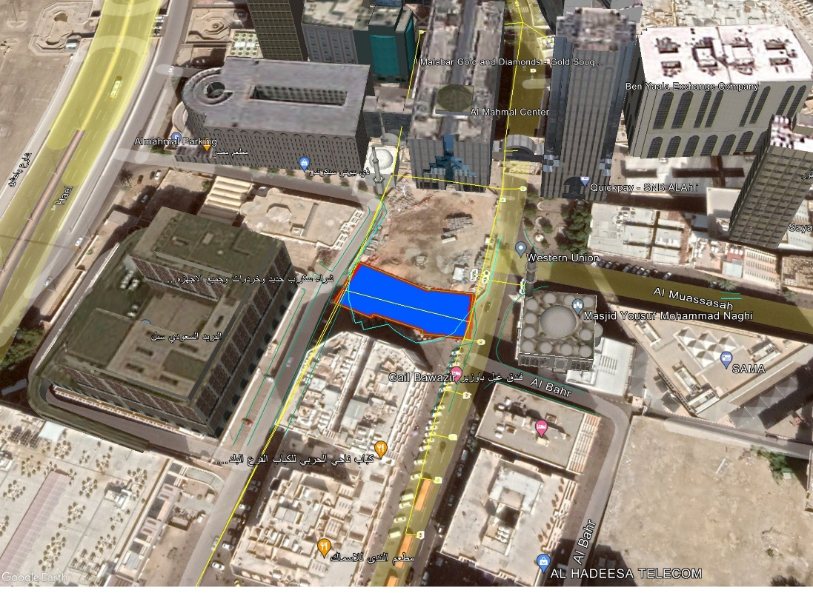

# DESIGN

## Scope of design

The scope of this design is the dewatering system applied during construction of the project, to allow excavation to reach and maintain final dry level.

It is mentioned that shoring system design is not in CONSULTANT’s scope. The dewatering system is only in the scope and within this, CONSULTANT is proposing also relevant shoring system to diminish the settlements and protect the heritage buildings in the vicinity of the project.

Detail design of the shoring system must be implemented by others.

The dewatering Contractor has to verify the present design, based on the actual site conditions, the tested pumping rates, the final shoring methodology and the used materials characteristics and adjust the sequence of the operation of the pumps, their depth, etc.

Moreover, and based on the geotechnical report, there are not compressible alluvial clay or peat soils in the project area.

## Dewatering system

As per para. 10.1 of the Geotechnical report, soil improvement is required at the building location, consisting of 7.0m excavation and replacement of the ground material.

The Dewatering system as designed by CONSULTANT is composed of 6 duty (and 3 standby) submersible pumps of 4”, placed in sump pits with filter pack at 8.6m depth, as shown in the attached design drawings and calculations.

The pumps will be placed in the pits and will be lowered gradually, following the excavation rate.

A slotted casing shall be installed and surrounded with filter aggregate, as shown in the attached updated drawing S.2.

The basic setout of the wells is shown below (*Construction dewatering and groundwater control, New Methods and Applications, J. PATRICK POWERS, P.E., ARTHUR B. CORWIN, et al, 2007*)

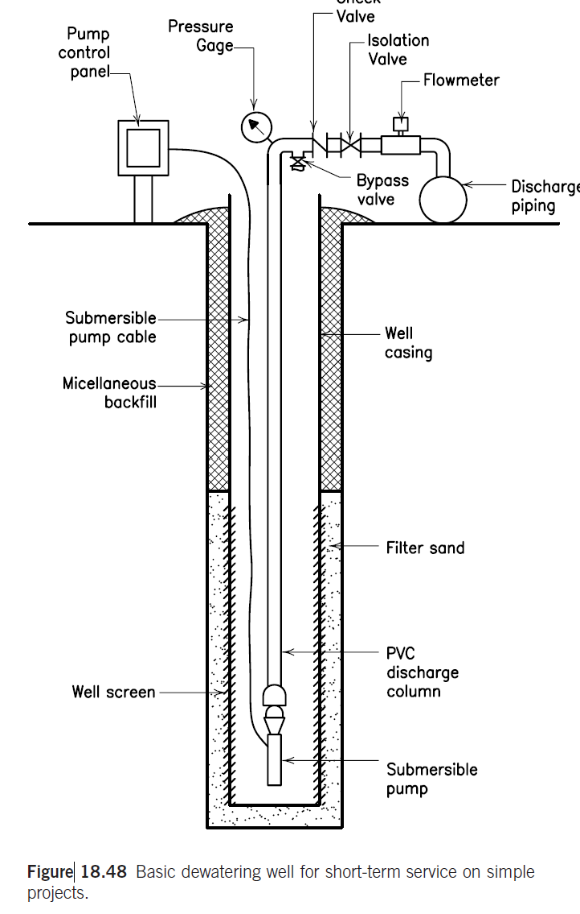

A riser pipe HDPE 110mm external diameter will be installed on the pump to direct the water to the ground floor and with horizontal pipes HDPE 200mm external diameter to the sedimentation tank and then, to the discharging lines of 500mm.

The pipes material of the riser and horizontal pipes will be HDPE or equivalent approved.

Temporary trenches 50x50cm filled with aggregates will be constructed, to facilitate the direction of the water flow to the pump pits. The trenches will be constructed at various levels during the excavation.

The pumping will continue until the uplift force due to floating will be balanced from the building weight and any foundation tension piles, with a safety factor of 50%.

The main Contractor and his specialized sub-contractor have to submit detail proposal of the various stages, trenches, filters, permeability index based on pumping test and dewatering flow, pumps, etc. and the uplift balance calculations for approval from the supervision Consultant. Also has to prepare detail shop drawings of the external discharge lines, taking into account of all existing in the area networks, in coordination with the supervision consultant and the authorities.

## Dewatering calculations

### Design methodology

#### General

In CONSULTANT’s scope the dewatering system is included. The supporting system is out of scope.

Calculations of the pumping rate, the drawdown and pumps are provided with the attached Excel workbook (240313-AlBunt\_calcs.xlsm), based on

1. *A Practical Guide to Dewatering, 2nd Edition, Pat M. Cashman and Martin Preene*
2. *Construction dewatering and groundwater control, New Methods and Applications, J. PATRICK POWERS, P.E., ARTHUR B. CORWIN, et al,*
3. *As per standard practice with other Municipality’s similar projects*.

Excel calculation provided in the sheet (Annex A10 FilterPack), considering the available data from the three boreholes and available depths of the Geotechnical investigation that received from the Client (Ref S22000091 Rev.5/11-3-2023).

In addition to these, settlement numerical analysis also conducted using the Plaxis software, to estimate the settlements under the adjacent buildings. For this, the shoring system deformations disregarded by implementing movement restrictions of the supporting wall panels, anchors de-activated, in line with the reviewer’s directions.

### Permeability coefficient

The permeability coefficient K as is proposed by the geotechnical report falling head test, of the geotechnical report (Ref S22000091 Rev.5/11-3-2023 para.7.3), is:

|  |  |  |
| --- | --- | --- |
| PERMEABILITY INDEX as per para. 7.3 of the Geotechnical report | | |
| Test Depth (m) | Permeability (m/sec) | Drainage characteristics |
| 3 | 1.70E-06 | Low Permeability |
| 5 | 2.00E-06 | Low Permeability |
| 7 | 1.90E-06 | Low Permeability |
| TAKEN | 1.90E-06 | At 7.0m depth (excavation) |

### Discharge Quantities & Pumping

The discharge pumping quantity is calculated with the attached Excel sheet Annex (sheet “A2 Meth1-BigWellEquival”), based on a big equivalent well, bibliography:

1. *A Practical Guide to Dewatering, 2nd Edition, Pat M. Cashman and Martin Preene*
2. *Construction dewatering and groundwater control, New Methods and Applications, J. PATRICK POWERS et al*
3. *Deep excavation Theory and Practice Chang-Yu Ou*

The required pumping discharge quantities are calculated based on the big equivalent model (Construction dewatering and groundwater control, New Methods and Applications, J. PATRICK POWERS, P.E., ARTHUR B. CORWIN, et al).

The following formulas are applied:

$$Q=\frac{πk(H^{2}-h^{2})}{ln\frac{R_{0}}{r_{w}}}$$

$$R_{0}= r_{1}+ r_{w}$$

$$r_{w}= \sqrt{\frac{ab}{π}}$$

$$r_{1}= 3000(H-h_{w})/\sqrt{K}$$

The required water pumping discharge quantity is calculated to 30 m3/h

Six (6) duty pumps of 4” diameter are selected. Their working rate of each pump is selected to be **14m3/h**, to keep the drawdown inside the project within the required depth from surface of 7.6m (required flow drawdown 6.70m), see Excel sheet and Annex 3 (sheet “A3 SuperWells-InsideProject”).

During the dewatering phase and the long term pumping, the total flow Qtot of all pumps will be stabilized to the theoretically required discharge flow and the pumps have to be adjusted to the actual working capacity as per the dewatering site conditions.

### Water drawdown inside the project area

The drawdown is calculated in the attached Excel sheet, based on the Wells superposition model, Annex 3 (sheet “A3 SuperWells-InsideProject”).

#### Wells superposition model

The superposition model of all wells is applied at the center C and the points D and E inside the project, as shown in the below sketch (dwg S13)

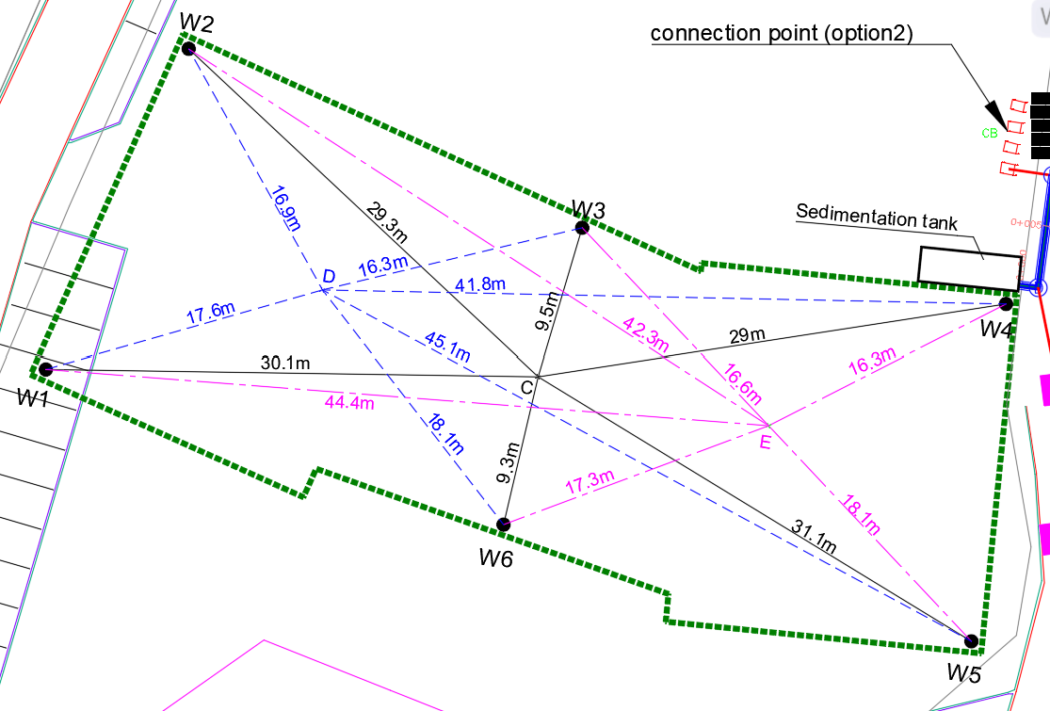

(Deep excavation Theory and Practice Chang-Yu Ou, para 9.4.2.1, Eq. 9.18):

$$h_{i}=\sqrt{H^{2}- \frac{Q_{i}}{πk}ln\left(\frac{R}{r_{i}}\right){}}$$

Where

hi = hydraulic head at distance ri from well #i

H= Hydraulic head of the original water table

Qi = Pumping water quantity at well #i

k = permeability index (m/sec)

R = Total Radius of influence of Well = R1+rw

Where

rw = well #i radius, and



Applying this formula, the drawdowns inside the project area are as follows (Excel sheet and Annex 3):

* Point C: 8.09m
* Point D: 7.12m
* Point E: 7.25m

These are more than the required drawdown of 6.70m

### Water drawdown on adjacent structures

#### The water drawdown at the heritage buildings is calculated applying two different models, the Big equivalent model, Annex 2, (sheet “A2 Meth1-BigWellEquival”) and the Wells superposition model Annex 3, (“A3 SuperWells-InsideProject”) as well.

The distance of the wells from the nearest heritage and other buildings is shown in the drawings:

* For Building A and points A1,A2,A3,A4,A5 in dwngs S12a,b,c,d,e
* For Building C and points C1,C2,C3,C4 in dwngs S13a,b,c,d
* For Building B and points B,B1,B2,B3,B4 in dwngs S14a,b,c,d,e
* For Building D and points D1,D2,D3 in dwngs S15a,b,c

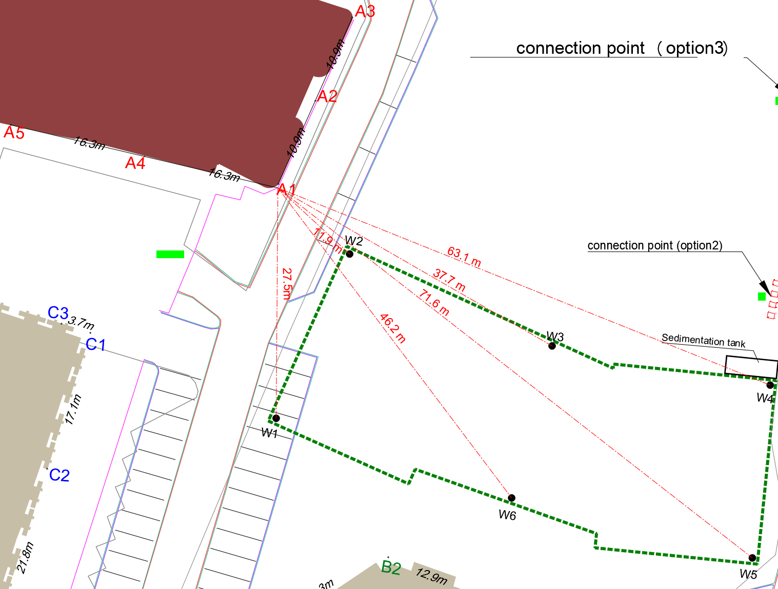

#### Big well equivalent model

The big well model could be considered as a very rough estimate, however more accurate estimate is provided using the wells superposition model, as per below item.(2.3.5.2)

Depuit-Thiem's equation: (Free aquifer - Drawdown is far smaller than aquifer thickness)

From this, the drawdown at distance r from the center is given as:

$$h=\sqrt{H^{2}- \frac{Q}{πk}\ln{(\frac{r}{r_{w}})}}$$

From the attached spreadsheet and Annex 2, the drawdown is 0.76m

Alternatively, is calculated from the formula.

$$H_{x}= \frac{R_{x1}}{3000\sqrt{K}}+h_{w}$$

This gives a drawdown beneath the nearest heritage building (45m from the project center) of 0.76m (Annex 2). This is just an indication concerning the drawdown and more accurate calculation will follow using the wells superposition model, as per below item.(2.3.5.2)

#### Wells superposition model

The wells superposition method is applied to find the cumulative drawdown at a point

##### Wells radius of influence

The radius of influence of each separate well, is calculated from the equation of above para. 2.3.4.1 and is

$$R=R_{1}+r_{w}$$

Where

R = Total Radius of influence of Well

rw = well #i radius, and



As per the calculations in the attached Excel sheet “A3 SuperWells-InsideProject” is:

$R=R_{1}+r_{w}$ = 27.71 + 0.31 = 28.01 m

The influence radius of the wells and their surrounding curve is shown in below figure and the attached dwg S12a.

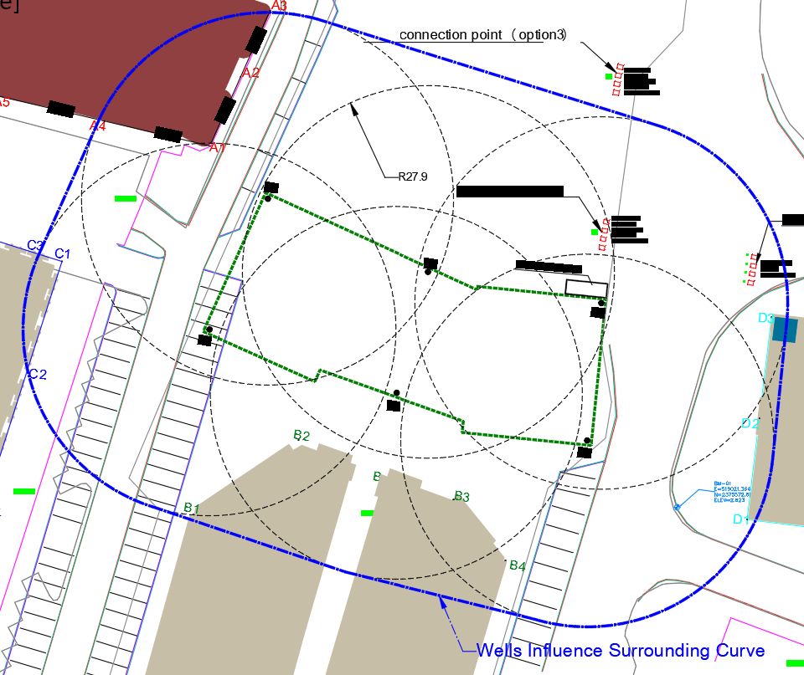

Points outside the wells influence surrounding curve, will not be affected from the dewatering, since the drawdown will be 0.

So, drawdown and settlements of points inside the surrounding curve are examined.

#### Wells superposition drawdown

The superposition model of all wells is applied based on the below references:

1. NAFAC P-418, page 4-19:



1. Deep excavation Theory and Practice Chang-Yu Ou, para 9.4.2.1, Eq. 9.18):

$$h_{i}=\sqrt{H^{2}- \frac{Q_{i}}{πk}ln\left(\frac{R}{r_{i}}\right){}}$$

Where

hi = hydraulic head at distance ri from well #i

H= Hydraulic head of the original water table

Qi = Pumping water quantity at well #i

k = permeability index (m/sec)

R = Total Radius of influence of Well = r1+rw

Where

rw = well #i radius, and



The water drawdown due to pumping is calculated with the separate wells’ superposition methodology in the attached spreadsheets, as follows:

1. For building A, Annex A-4A, Excel sheet “*A4a SuperWells-A1,A2,A3,A4,A5*”
2. For building C, Annex A-5A, Excel sheet “*A5a SuperWells-C1,C2,C3,C4,C5*”
3. For building B, Annex A-6A, Excel sheet “*A6a\_SuperWell-B,B1,B2,B3,B4m*”
4. For building D, Annex A-7A, Excel sheet “*A7a SuperWells-D1,D2,D3*”

The calculations are conducted for each point of every Building, as for example shown in the below figure:

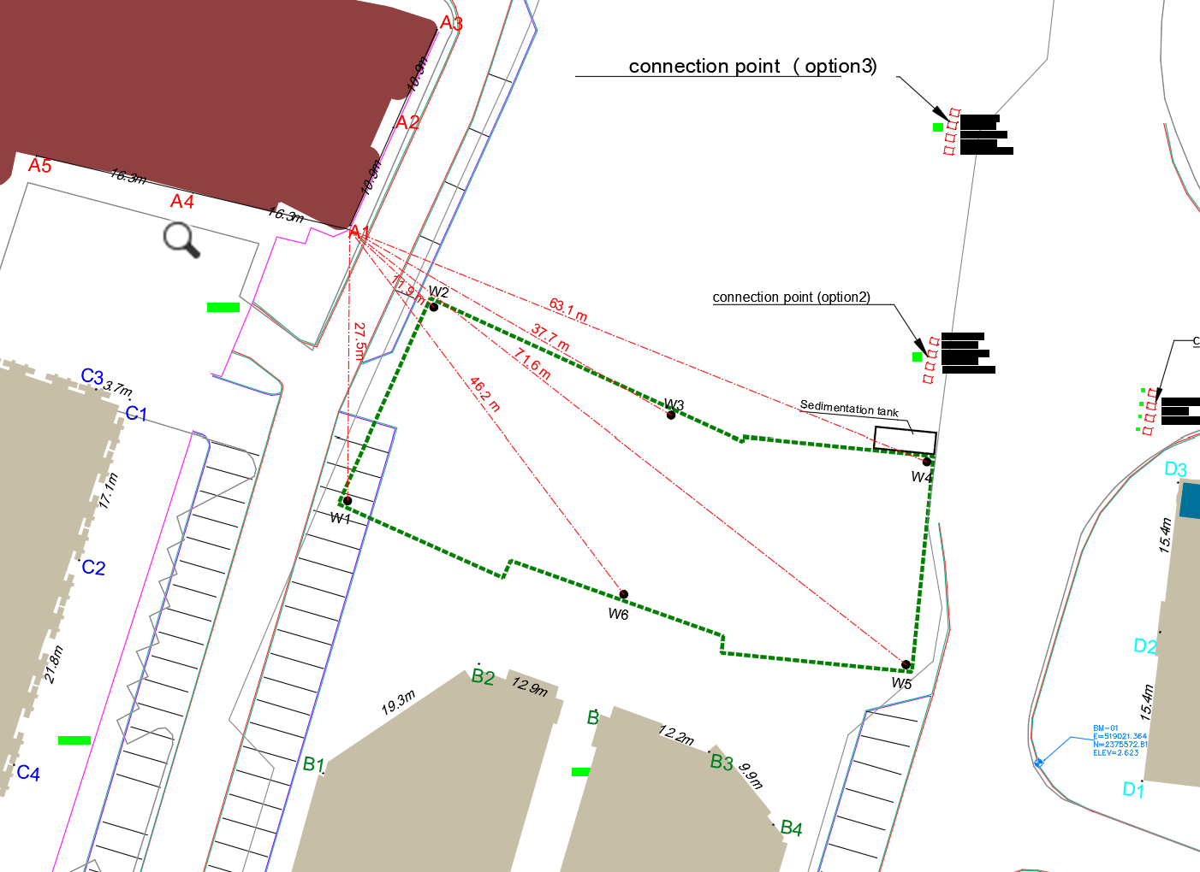

The results of the drawdowns at each point of Building A(A1,A2,A3), B(B,B1,B2,B3,B4), C(C1,C2,C3,C4) and D(D1,2,D3) with the relevant differential settlements are shown in below paragraph 2.8.

### Discharge and Pumping lines sizing

In Annex A-9 (sheet “*A9 DewaterLinesSizing*”), the calculations are shown of the vertical riser pumping lines from the pumps, the horizontal up to the sedimentation tank and from there to the discharge external lines up to the Amana’s external outfall.

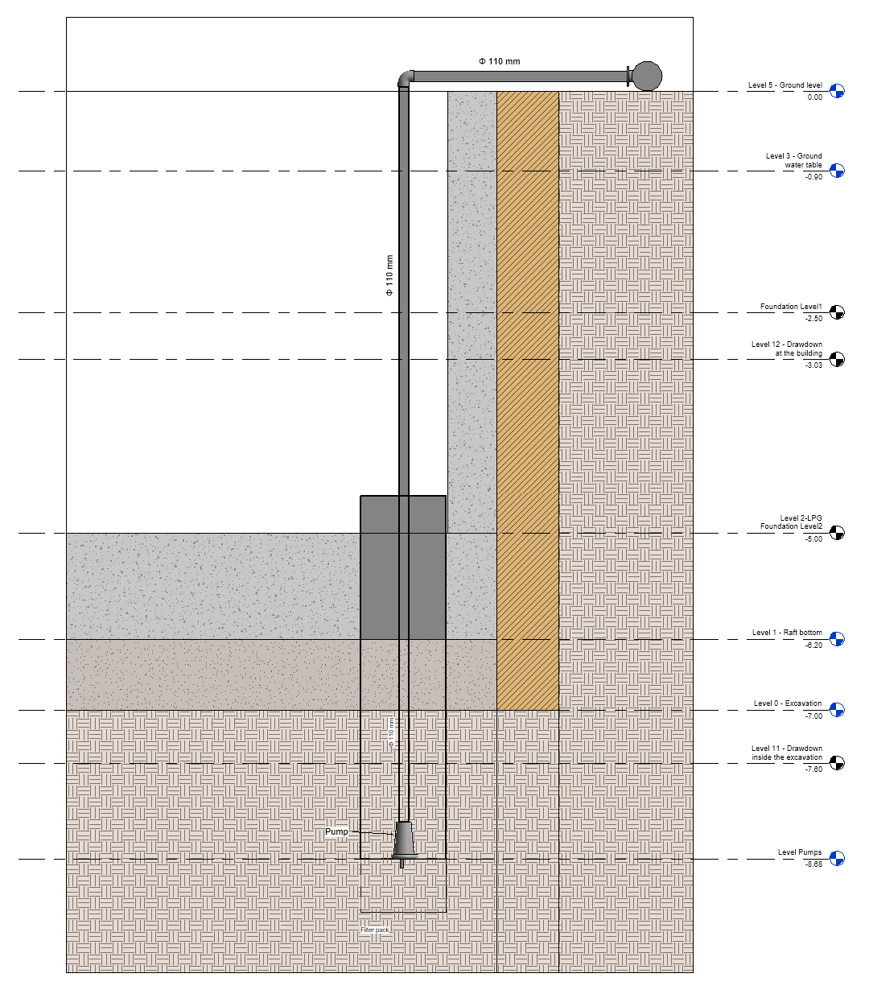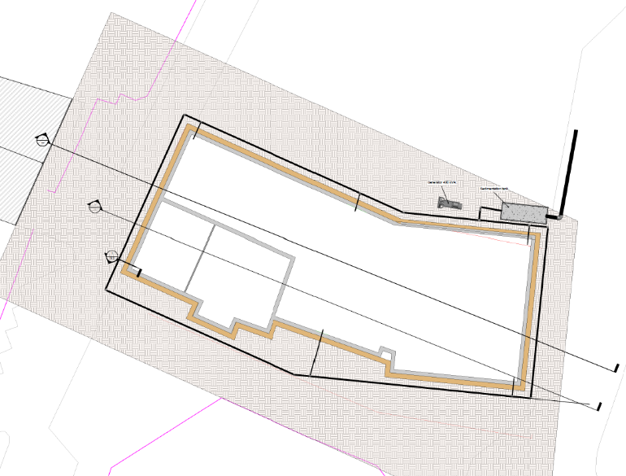

### Pumps

In Annex 1, the pumps selection is indicated. The proposed brand is for indication and any similar dewatering pump can be used.

### Filter pack

The filter pack is selected, as per the calculation of Annex 10 (sheet “*A10 FilterPack*”:

|  |  |  |  |  |  |
| --- | --- | --- | --- | --- | --- |
|  | Percentage passing |  | size |  |  |
|  | 100% |  | 9.500 | mm |  |
|  | 85% |  | 6.162 | mm |  |
|  | 50% | > | 1.390 | mm |  |
|  | 10% | > | 0.199 | mm |  |
|  | 5% | > | 0.063 | mm |  |
|  | Filter pack thickness, is taken: | | | **150** | mm |

### Well screen

*Well screen slot size*

The screen opening size is selected, as per the calculation of Annex 11 (sheet “*A11 WellScreen*”):

The Well screen slot size is taken 2 mm, which is satisfactory. It will pass the 10% of the filter at the finer limit of tolerance.

*Well wetted area screen length*

The minimum wetted area screen length is selected, as per Annex 11 sheet “*A11 WellScreen*”) calculations:

hmin=0.83m

This is the required depth of the well screen that will be beneath the final drawdown level.

it is taken 1.0m the screened part and another 0.50m the casing beneath, as is shown below and the dwg S8

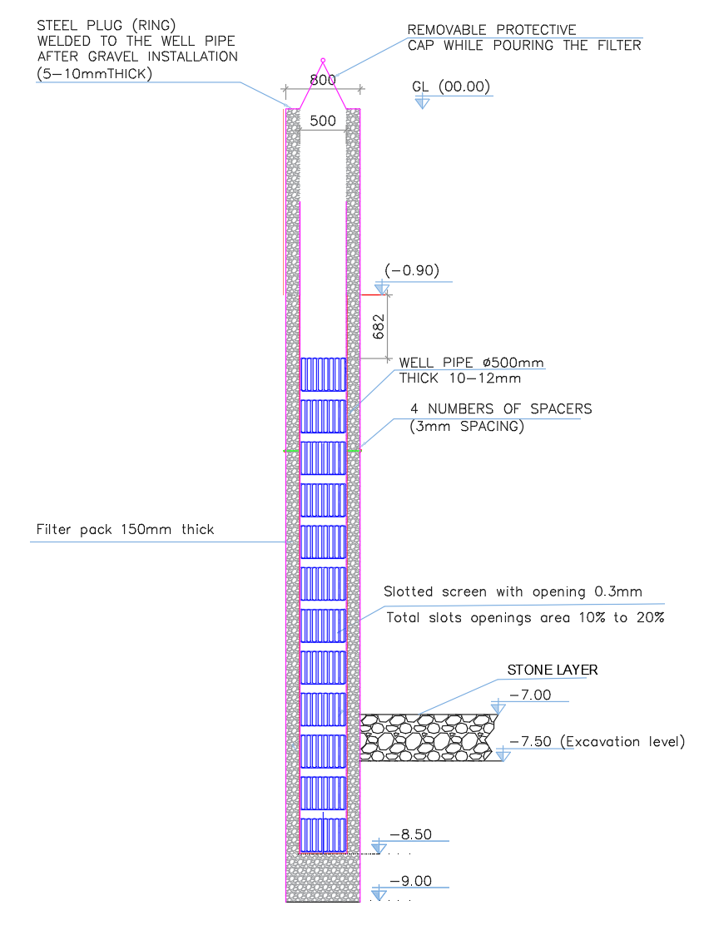;’

The well horizontal cross-section is shown in dwg S2

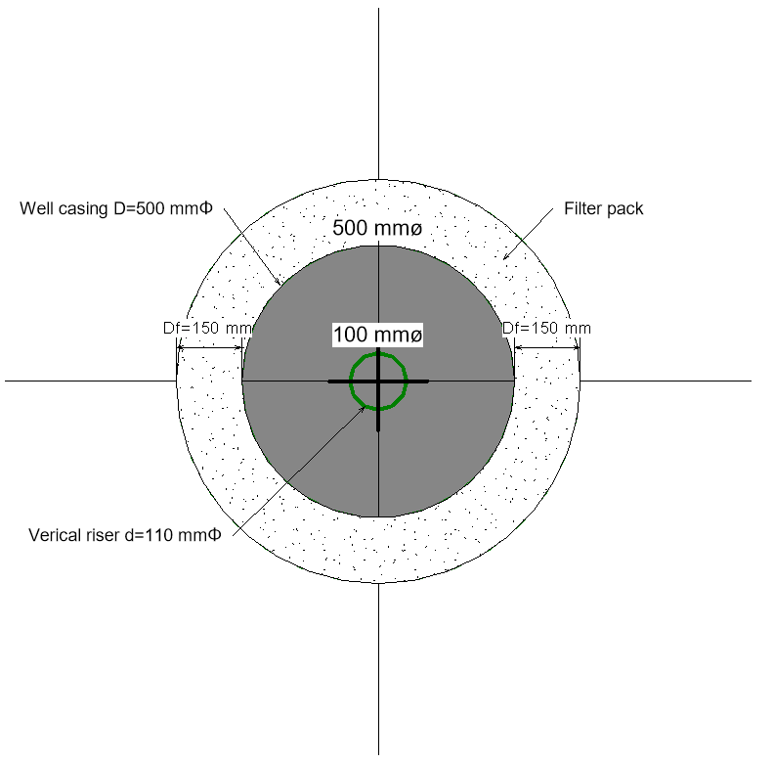

### Main Discharge Lines

The main discharge line from the sedimentation tank to the existing storm line, will be from GRP pipes of 500mm diameter, with hardness 5,000N/m2, pressure 6 bar. The minimum diameter for external lines is taken 500mm Annex 9, (Sheet “*A9 DewaterLinesSizing*”), as per Amana’s standards.

Manholes will be installed and gullies to collect the rainwater from the roads, as per the drawings, in line with Municipality’s specifications and standards, as per dwg No S07.

## **Analytical calculation of stresses and settlements**

Analytical calculations can be applied to calculate the stresses and settlements. The aim is to calculate the settlements and from these the differential settlements at the surrounding buildings points, due to dewatering effect.

The main soil material, as per the geotechnical report, is silty sand.

Two different methods are applied, based on:

1. Cohesionless soil material
2. Cohesive soil material

The elastic settlement for cohesionless soil method is more appropriate (para. 2.5).

Since the main soil material is silty sand, the cohesive soil method is also used for completeness and comparison (para. 2.6).

## **Settlements using cohesionless soil conditions:**

### General

This method requires the bearing pressure on the footing foundation level. This also involves the loading from the existing building, for which there is not clear information, only estimates can be done (see Annex 13, sheet “A13 LoadsNeighborBuildings”). But since the buildings have existed for a long time, any consolidation settlements have already been imposed. Moreover, in this study we are interested only in the effects of dewatering on the existing buildings.

For this, we consider the bearing pressure resulting from the footing weight and the water pore pressure, ignoring the loads from above buildings.

The Schmertmann’s method is used, to compute the settlement of the neighboring foundation footings, soon after dewatering, as per reference: *Foundation Design Principles and Practices, 3nd Ed, Donald Coduto et al.*

### Input Data

The required input data in the Excel sheet to implement Schmertmann’s method are (e.g. for building A, ANNEX A-4C “A4c Build A1-Schem” Excel sheet):

|  |  |  |  |  |  |
| --- | --- | --- | --- | --- | --- |
|  |  | **Input** |  |  |  |
|  |  | Units | SI | E or SI |  |
|  |  | Shape | RE | SQ, CI, CO, or RE |  |
| Foundation Width | | B = | 5 | m |  |
| Foundation Length | | L = | 8 | m |  |
| Foundation depth | | D = | 2.5 | m |  |
| Bearing pressure | | q = | **74.68** | kPa |  |
| Ground water table | | Dw = | **4.12** | m |  |
| Dry unit weight | | gamma dry= | 16.8 | kN/m^3 |  |
| Saturated unit weight | | gamma sat= | 19 | kN/m^3 |  |
|  |  | t = | 1 | yr |  |

The above data are common for all buildings, except the bearing pressure on the foundation level and the ground water table.

The duration of the effect is considered 1 year.

### Bearing pressure of footing at foundation level

The Schmertmann’s method requires to provide the loading of the whole building on the footing foundation level.

Bearing pressure at foundation level, as per *Foundation Design Principles and Practices, 3nd Ed, Donald Coduto et al.,* Para. 6.3:

$$q=\frac{P+W_{f}}{A}- u_{D}$$

where

q = bearing pressure

P = vertical. column load

Wf = weight of foundation, including the weight of soil above the foundation, if any

A = base area of foundation B2 for square foundations or BxL for rectangular foundations

uD = pore water pressure at bottom of foundation (i.e., at the foundation depth D=2.50m below the ground surface).

Since we are interested in the settlements due to dewatering only, then the bearing pressure resulting from the footing weight and the water pore pressure is calculated, ignoring the loads from the above buildings.

Since P=0, the bearing pressure becomes

$$q=\frac{W_{f}}{A}- u_{D}$$

The pore water pressure will be the difference between values after and before the dewatering:

uD = uD1-uD0

And thus

$$q=\frac{W_{f}}{A}- {(u}_{D1}-u_{D0})= \frac{W_{f}}{A}+ {(u}_{D0}-u_{D1})$$

And

$$q=\frac{W_{f}+P_{w} }{A}$$

Where

${P_{w}=(u}_{D0}-u_{D1})$ x A

For the Schmertmann analysis, a footing is required with dimensions, so a standard footing of 5.0x8.0x2.50m for all points is selected.

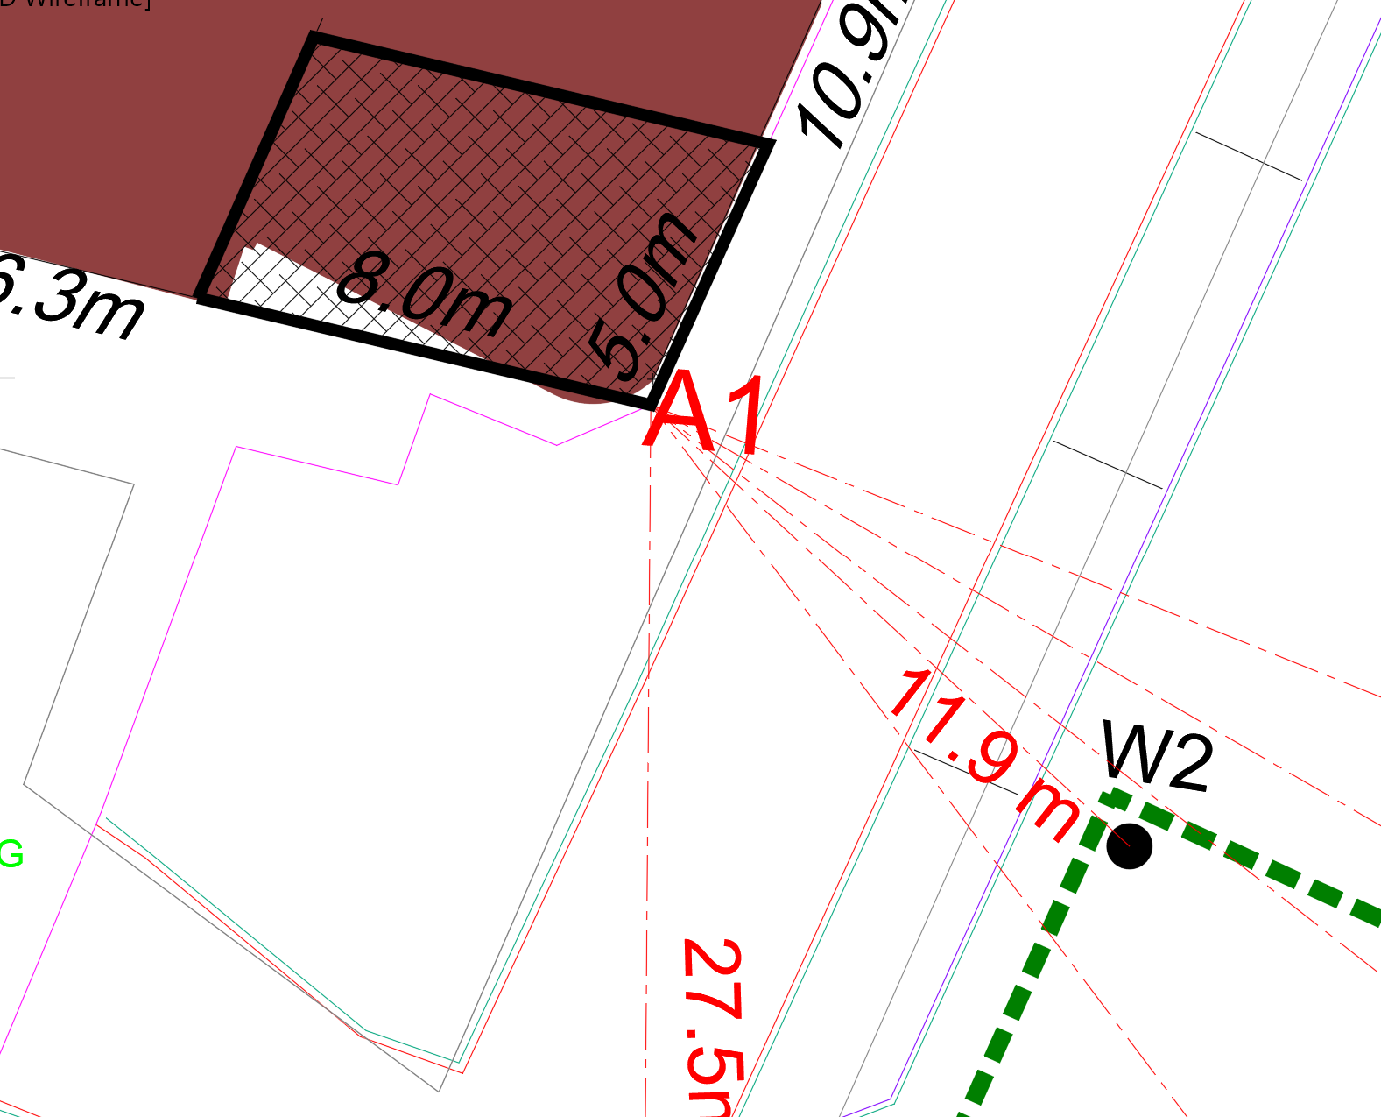

Virtually all shallow foundations are made of reinforced concrete, so Wf is computed using a unit weight for concrete, gc, of 23.6 kN/m3 (150 lb/ft3).

Based on the dimensions of the footing, its weight is calculated and its pressure is added to the pore water pressure.

#### For the water pore pressure, the final water levels at each building point are taken as calculated with the Wells superposition drawdown (see above para. 2.3.5.3).

For example, at the bottom of the point A1 footing of building A:

Footing weight:

Wf = B x L x D x γc = 5.0x8.0x2.5x23.6 = 2,360 kN

Pore water pressure:

Before dewatering:

Ground water table: Hw0 = 0.90m

Pore water pressure: uD0 = (2.50-0.90) x γw = 1.60m x 9.80 kN/m3 = 15.68 kN/m2

After dewatering and final ground water table of -4.12m, the whole foundation (-2.50m) will be out of the water:

Hw1 = 2.50m

uD1 = (2.50-2.50) x γw = 0m x 9.80kN/m3 = 0

Thus, after the dewatering will be an additional bearing load of:

qadd = uD0-uD1=15.68-0= 15.68 kN/m2

Pw = qadd x A = 15.68 x 5.0 x 8.0 = 627 kN

And finally, the total bearing pressure on footing at foundation level will be:

$$q=\frac{W_{f}+P_{w} }{A}= \frac{2360+627 }{5.0x8.0}= \frac{2987 }{40}=74.68 kN/m2$$

For this bearing pressure 74.68 kN/m2 and the final ground water table of 4.12m at Point A1 of Building A, the settlements will be calculated.

These values for all points of Building A can be found at Annex A-4B (Excel sheet “A4b Build A-FWL&p”):

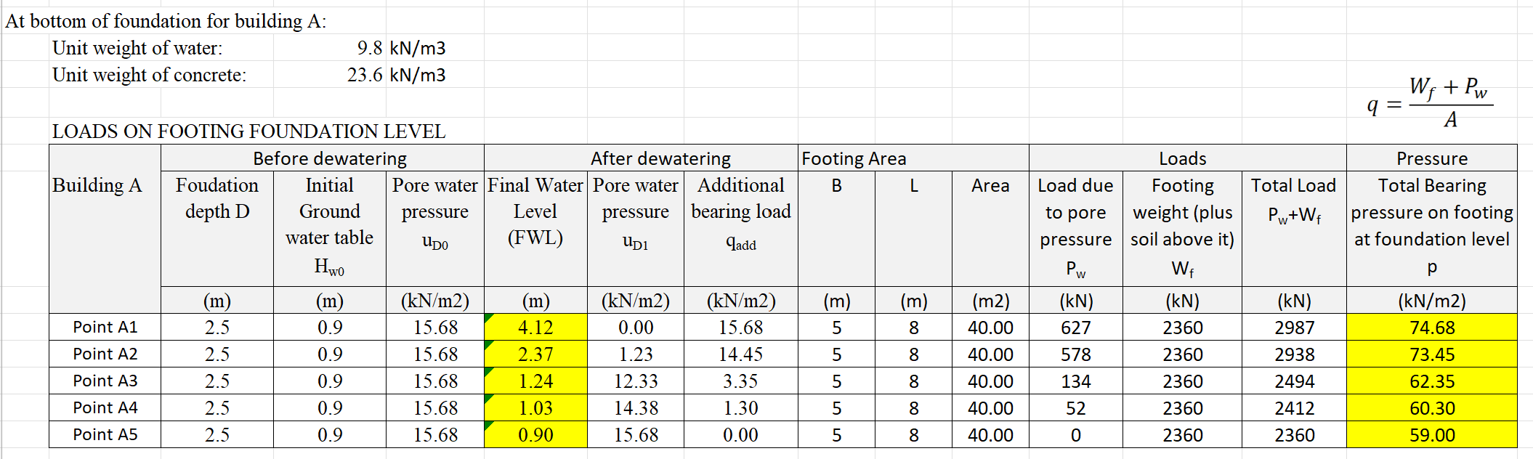

The foundation level (lower part of the footing) of the neighboring buildings is taken -2.5m from ground level (no basement).

### Settlements at each building point

The settlements of each building point is calculated and for Point A1 of Building A can be found in the attached Excel, ANNEX A-4C, sheet “A4c Build A1-Schem”

Below, the methodology for building A-West/North (Port Museum) is presented, and specifically for Point A1. For the rest of the points and buildings, similar approach is followed.

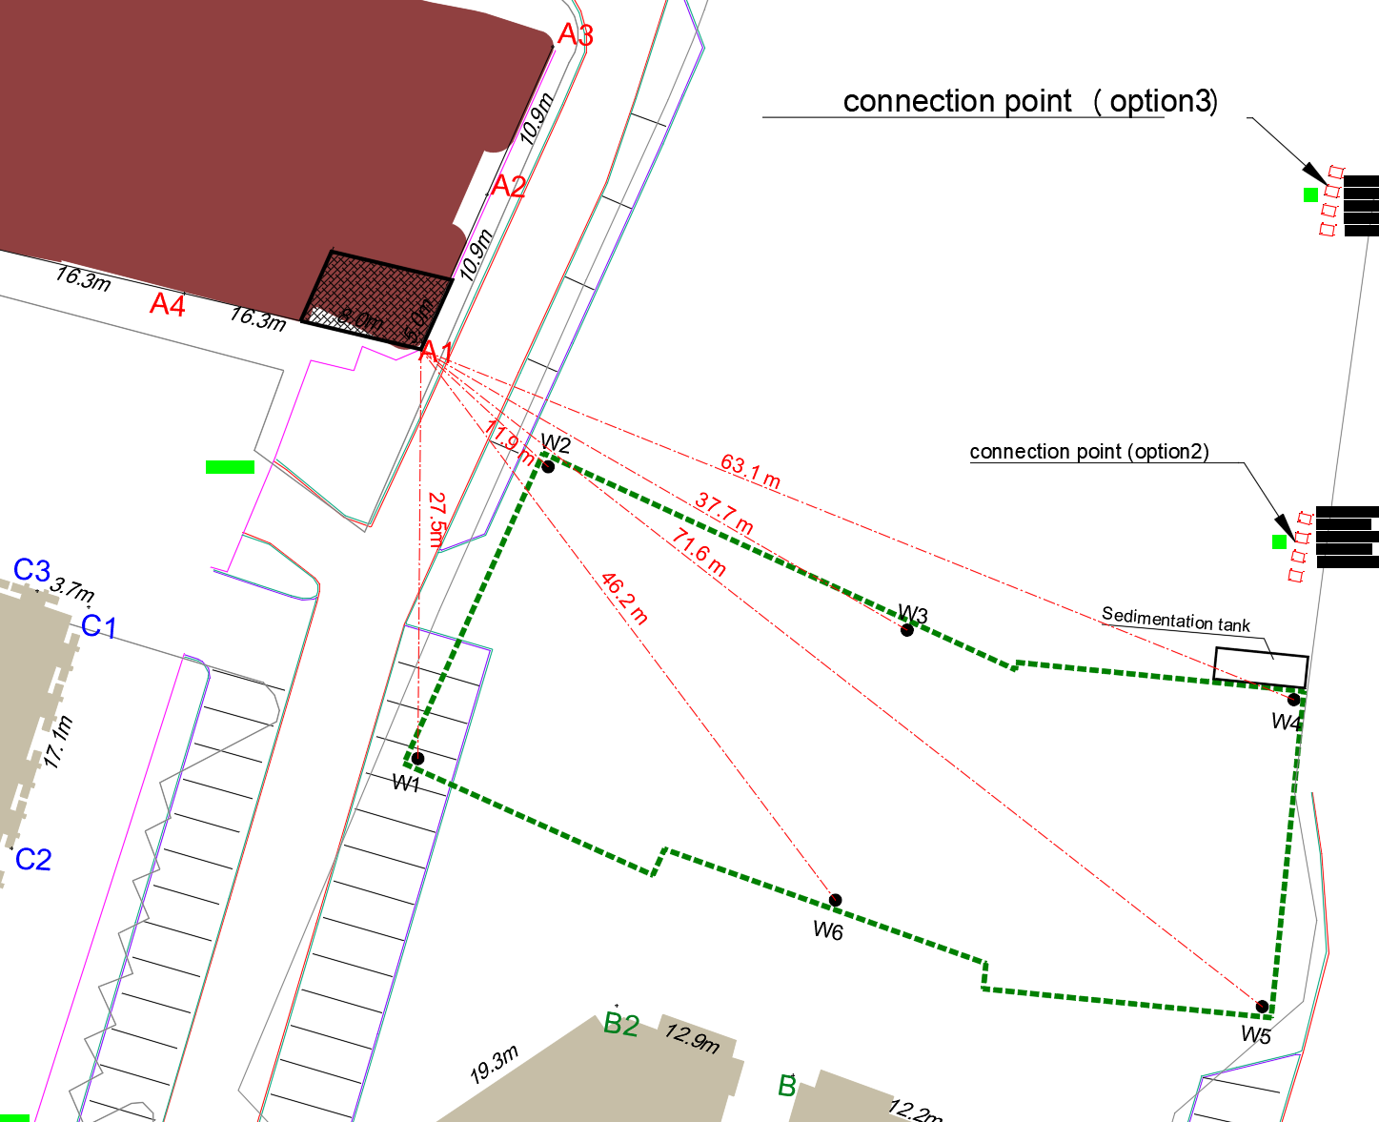

#### Depth of influence

The depth of influence (para. 8.2, Example 8.5, of *Donald Coduto et al)* is:

For Square (SQ) and Circular Footings (CIR), L/B=1, depth of influence 2B

L/B >= 10, Continuous Footing, depth of influence 4B

1 < L/B <10, Rectangular Footing, depth of influence 2B

For footing 5x8m and depth 2.50m:

Di = D + 2B = 2.5 + 2x5 = 12.5 m

As per the Geotechnical report the available information of the boreholes is up to 25m, which covers the 12.5m depth.

#### Correlation between CPT and SPT

As per (*O. Kara & Z. Gündüz, 2nd International Symposium on Cone Penetration Testing, Huntington Beach, CA, USA, May 2010*)

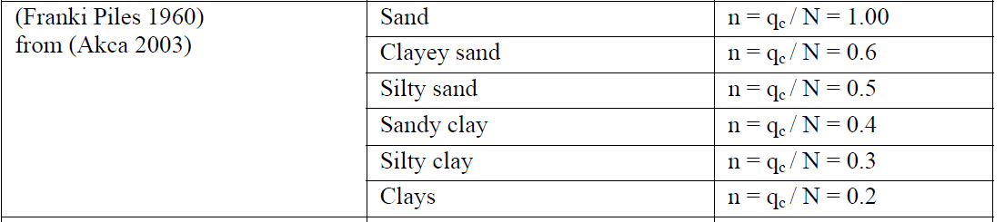

Also, relevant correlation is included in *Foundation Engineering Handbook, Braja M. Das, 2011, para. 1.8.2, Table 1.10*

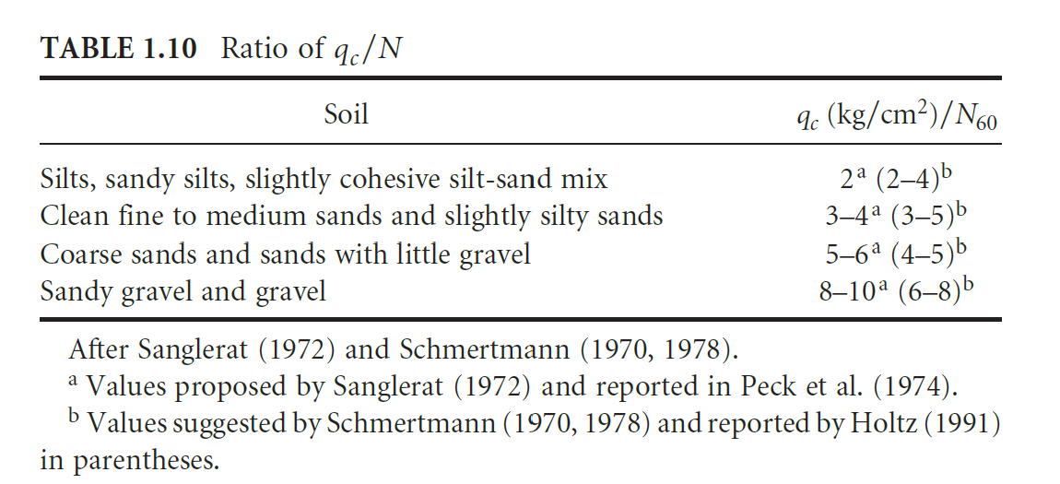

From the above tables and for Silty Sand, it is taken:

n=qc/N=0.5 (MPa)

#### Average Young’s Elastic Modulus Es

The average Es can be calculated as follows:

Form the Geotechnical report, para 7.1, ACES 11/3/2023, the

SPT= 30 (average at 7.5m depth)

N60 = 32

Silty Sand is the main soil layer.

From the n value and the SPT the qc (CPT cone resistance) ca be found:

n=qc/N=0.5 (MPa) -> qc = Nx0.5 = 30x0.5=15 MPa = 15,000 kPa

From *Foundation Design Principles and Practices, 3nd Ed, Donald Coduto et al., Table 4.8*:

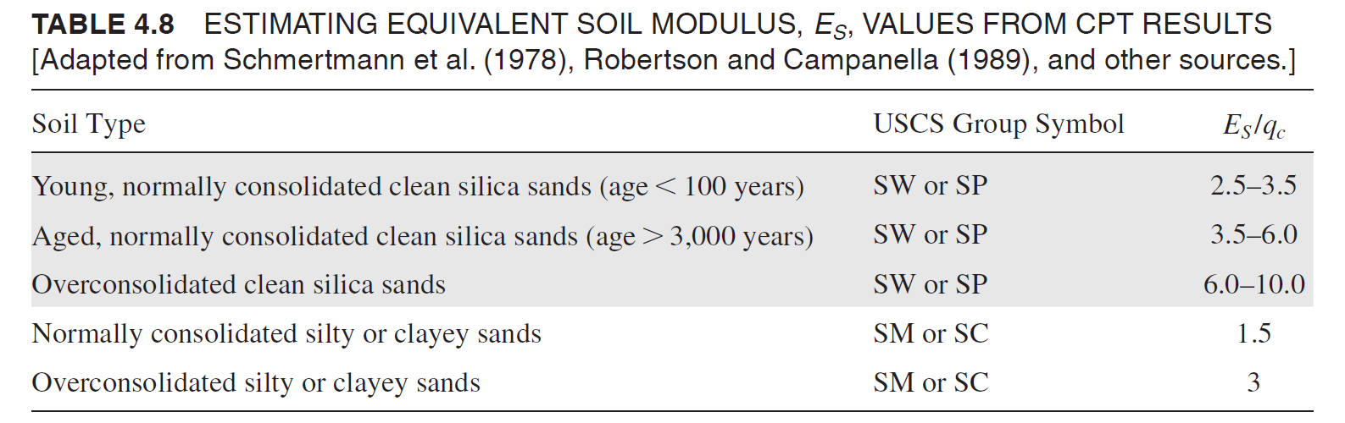

Es/qc = 1.5 -> Es = 1.5x15,000 kPa = 22,500 kPa

#### Soil separation into layers and Es calculations

The soil beneath the footing up to the depth of influence of 12.5m (above para 2.5.4.1), is separated into layers. The thickness of each layers is taken 1.50m thick, same as the layers’ of Geotechnical report results.

For each layer the soil modulus is calculated, as per above, based on the information provided from the Geotechnical report (para 7.1, ACES 11/3/2023). The calculations for Building A and point A1 are included in Annex A4C, Excel sheet “A4c Build A1-Schem”)

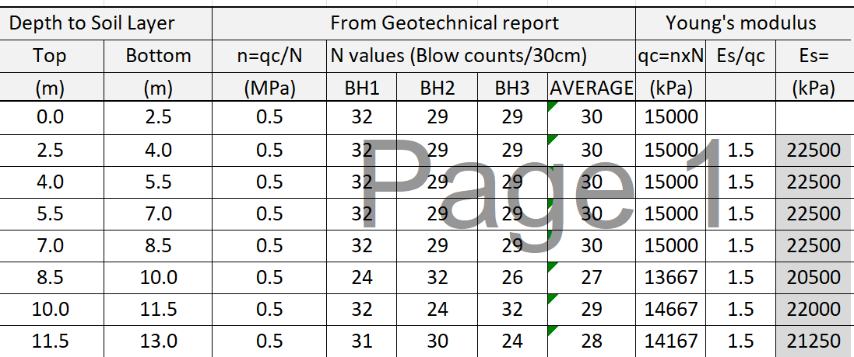

Optionally, the formulas provided with the Geotechnical report, ACES 11/3/2023, Appendix G, can be used:

*From SPT*

Normal sand:

Es = 1000 x N60 (kPa)

Silts, sandy silts or Clay silts

Es = 330 x N60 +1800

Gravelly Sand

Es = 1300 x N60 +7200

*From CPT*

Square footing

Es = 2.5 x qc (kPa)

Strip footing

Es = 3.5 x qc (kPa)

#### Buildings A Settlements

Vertical effective stress at depth *D* below the ground surface

*σ’zd* = γ*D* – *u*

As per and *Donald Coduto et al,* Para. 8.2, Example 8.5, Eq (8.11), (8.16), (8.12) and (8.13)

$$I_{εp}=0.5+0.1\sqrt{\frac{q-{σ'}_{zD}}{{σ'}_{zp}}}$$

For rectangular footing:

$$I_{ε}=I_{εs}+0.111\left(I_{εc}-I_{εs}\right) \left(\frac{L}{B}-1\right)$$

Where $I_{εs}$ for square footing:

$I_{εs}=0.1+\left(\frac{z_{f}}{B}\right)\left(2I_{εp}-0.2\right), for \frac{z_{f}}{B}<0.5$

and

$I_{εs}=0.667I_{εp}\left(2-\frac{z_{f}}{B}\right), for 0.5 ≤\frac{z_{f}}{B}<2$

And $I_{εc}$ for continuous footing:

$I_{εc}=0.2+\left(\frac{z_{f}}{B}\right)\left(I_{εp}-0.2\right), for \frac{z_{f}}{B}<1$

and

$I_{εc}=0.333I_{εp}\left(4-\frac{z_{f}}{B}\right), for 1 ≤\frac{z_{f}}{B}<4$

Settlements:

$$δ={C1C2C3\left(q-σ_{zD}^{'}\right)\sum{\frac{I_{ε}H}{E_{s}}} }_{}$$

$$δ=\sum{S_{t}H}$$

Where strain St

and H is the thickness of each layer.

Shape factors:

$$C_{1}=1-0.5\left(\frac{{σ'}_{zD}}{q-{σ'}_{zD}}\right)$$

$C_{2}=1+0.2 \log\left(\frac{t}{0.1}\right)$ for $t≥0.1$ year

$$C_{3}=\max\left\lfloor 1.03-0.03\left(\frac{L}{B}\right), 0.73\right\rfloor$$

where

*C*1 = depth factor

*C*2 = secondary creep factor

*C*3 = shape factor

The settlements of each building point is calculated and for Point A1 of Building A can be found in the attached Excel, ANNEX A-4C, sheet “A4c Build A1-Schem

## **Stresses and Settlements using cohesive soil material.**

Since the main soil material is silty sand, the cohesive soil method is also presented here, for completeness and comparison.

The formulas for calculating analytically the stresses at an adjacent building are presented here.

In the below figure the excavation and the initial and final (after dewatering) water levels are shown.

The final water level from the ground surface (after dewatering) at the building location is hd meters, as calculated, see above para. 2.3.5.3.

The foundation level of the building is taken either at:

-2.5m from ground level (no basement) Or at

-5.0m from ground level (one basement).

From the provided information, the neighboring buildings do not have any basement. Thus, this case of -5.0m foundation level is considered only as an exceptional case and for comparison.

The calculation of stresses and settlements can be done, either at the middle of the layers, or at the relevant depths.

In this design, the initial underground water level (before dewatering) and the final water level (after dewatering) are taken and the effect of drawdown on the stresses and settlements is considered.

For complicity, formulas for both cases are presented here:

#### Formulas taking into account groundwater level before dewatering and after dewatering drawdown level

##### Foundation level at -2.50 m from ground level (one basement)

Calculations are included in Excel Annex A-8B, sheet “A8b\_SuperWells-F2.5m”

###### Conditions at foundation level of the building A location (depth: -2.50m)

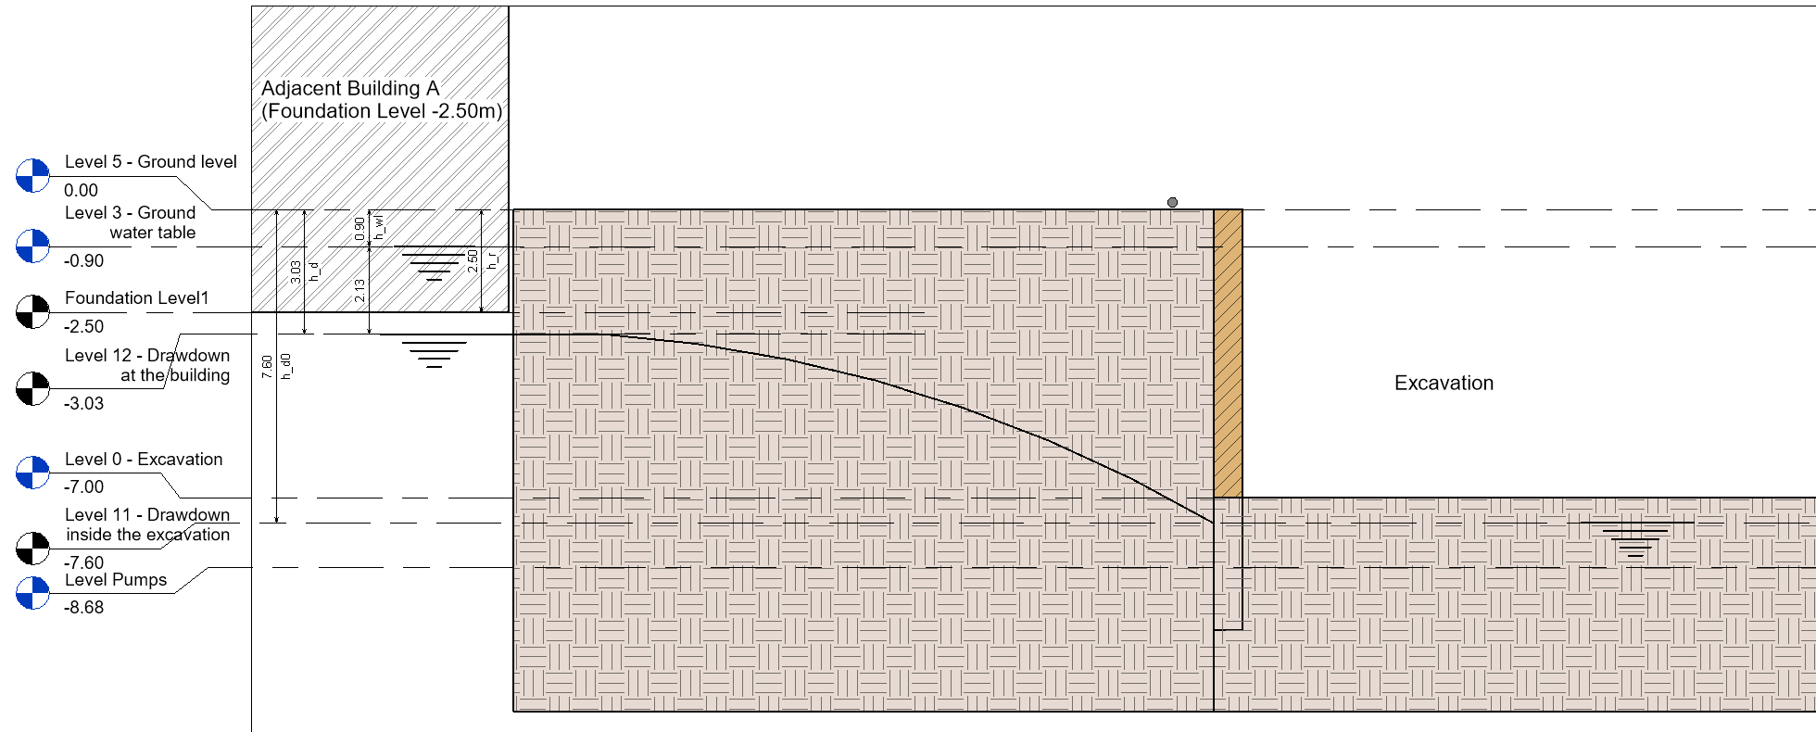

***Stresses:***

*Initial conditions (before dewatering):*

Total initial stress at building foundation depth 2.50 m

$$σ_{0@2.5m}=h_{wl}×γ_{d}+{(h}_{r}-h_{wl})× γ_{s}$$

where

$γ_{s}$ = saturated unit weight = 19 kN/m3

$γ_{d}$ = dry unit weight = 16.8 kN/m3

$γ_{w}$ = unit weight of water = 9.8 kN/m3

Effective initial stress at depth 2.5 m

${σ'}_{o@2.5m}=σ_{0@2.5m}-{(h}_{r}-h_{wl})× γ_{w}$

*Final conditions (after dewatering and excavation);*

Total final stress at depth 2.50 m depth

$σ_{f@2.5m}=h_{d}×γ_{d}$

Effective final stress at depth 2.50 m

$${σ'}_{f@2.5m}=σ_{f@2.5m}$$

***Settlements using cohesive soil conditions:***

We estimate that beneath the foundation neighboring buildings there is proper engineering soil material. For this, the cohesive soil consolidation formulas are applied, as per:

a. Terzaghi et al. Soil Mechanics in Engineering practice para. 16.7,

b. Bowles, J. E., *Foundation Analysis and Design,* The McGraw-Hill Companies, Inc., 5th Edition, para. 2-10.4,

c. *Deep excavation Theory and Practice* Chang-Yu Ou 2006, para. 9.7)

*Area below drawdown depth*

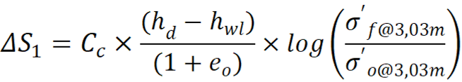

*Area above drawdown depth*

$${ΔS}_{2}=C_{c}×\frac{h_{r}}{(1+e_{o})}×log\left(\frac{{σ^{'}}_{f@2.5m}}{{σ^{'}}_{o@2.5m}}\right)$$

where

$C_{c}$ = Soil compression index = 0.07 (is taken)

0 = Soil void ratio= 0.42 (is taken)

The references concerning Cc and e0 are:

*FHWA-SA-02-054, Geotechnical engineering circular no. 6, Shallow Foundations, 2002, para. 5.3.3*

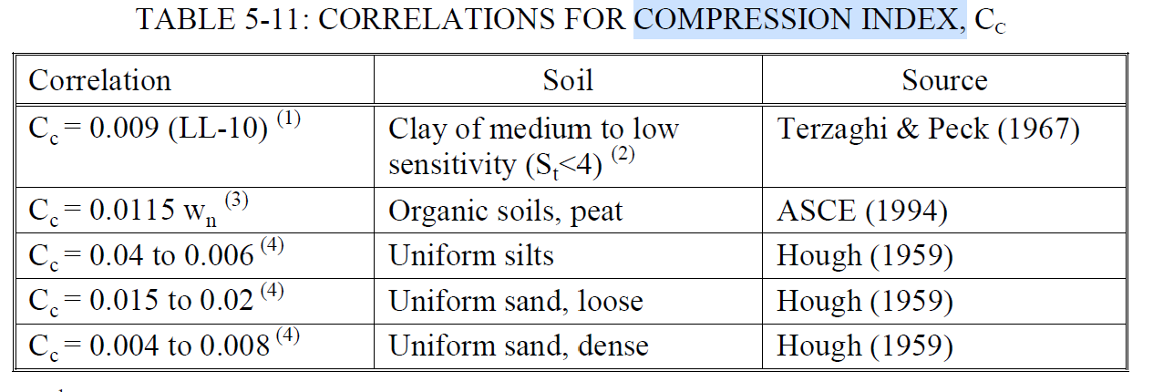

*Slamet Widodo, Abdelazim Ibrahim / International Journal of Engineering Research and Applications (IJERA) ISSN: 2248-9622 www.ijera.com Vol. 2, Issue 5, September- October 2012, pp.2232-2236*

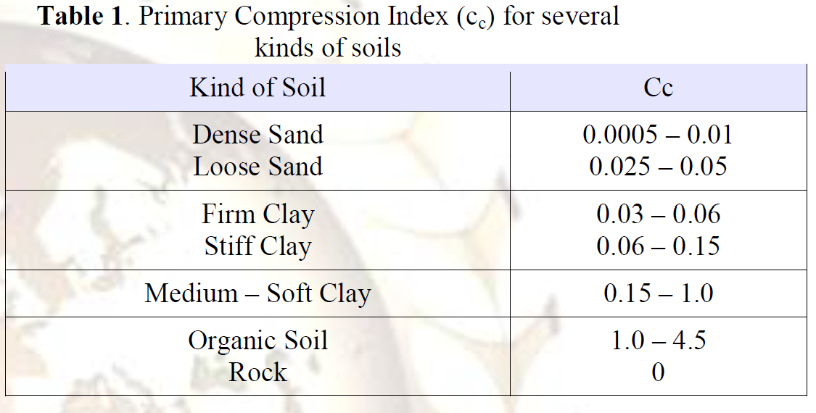

*Fundamentals of Geotechnical Engineering, Braja M. Das, 3nd Ed, Para. 3.2*

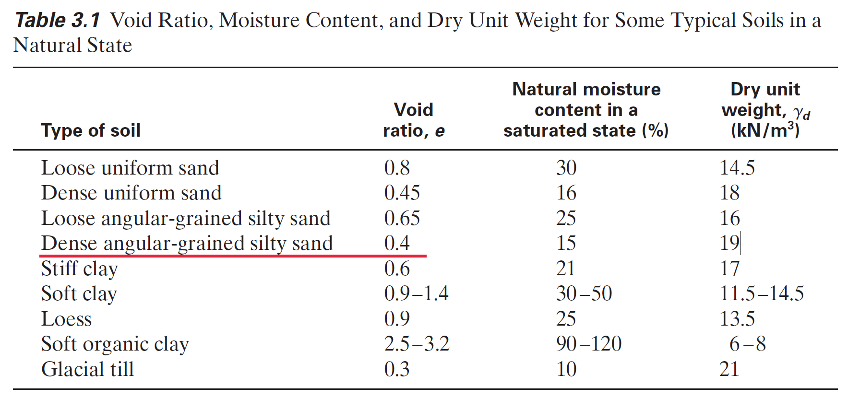

###### Total settlements at foundation level of the building A location (depth: -2.50m)

The total settlements at the foundation level of Building A location is:

$${ΔS=ΔS}_{1}+{ΔS}_{2}$$

##### Foundation level at -5.0m from ground level (one basement)

From the provided information, the neighboring buildings do not have any basement. Thus, this case of -5.0m foundation level is considered only as an exceptional case and for comparison.

Calculations are included in Excel Annex A-8A, sheet “A8a\_SuperWells-B5” and Annex A-8C “A8c\_SuperWells-F5m”

Conditions at final water level of the building A location (depth: -3.03m)

**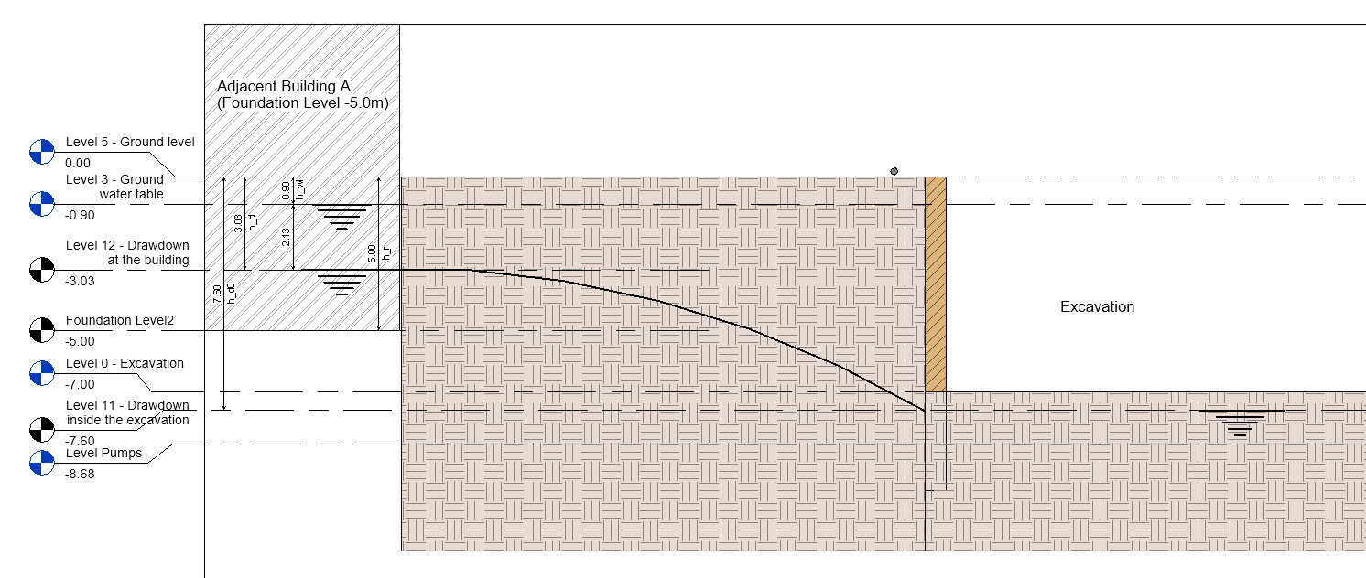**

***Stresses:***

*Initial conditions (before dewatering):*

Total initial stress at depth 3.03 m

where

= saturated unit weight = 19 kN/m3

= dry unit weight = 16.8 kN/m3

= unit weight of water = 9.8 kN/ m3

Effective initial stress at depth 3.03 m

*Final conditions (after dewatering and excavation);*

Total final stress at depth 3.03 m depth

Effective final stress at depth 3.03 m

***Settlements:***

*Area above drawdown depth*

We estimate that beneath the foundation neighboring buildings there is proper engineering soil material. It is an estimate since relevant information from the neighboring building (as built, geotechnical investigation, etc) is not available.

where

= Soil compression index = 0.07 (is taken)

e0 = Soil void ratio= 0.42 (is taken)

Conditions at foundation level of the building A location (depth: -5.0m)

****

***Stresses:***

*Initial conditions (before dewatering):*

Total initial stress at depth 5.0 m

where

= saturated unit weight = 19 kN/m3

= dry unit weight = 16.8 kN/m3

= unit weight of water = 9.8 kN/ m3

Effective initial stress at depth 5.0 m

→

*Final conditions (after dewatering and excavation);*

Total final stress at depth 5.0 m depth

$σ_{f@5.0m}=h_{d}×γ_{d}+{(h}_{r}-h_{d})× γ_{s}$

Effective final stress at depth 5.0 m

$${σ'}_{f@5.0m}=σ_{f@5.0m}-{(h}_{r}-h_{d})× γ_{w}$$

***Settlements using cohesive soil conditions:***

*Area above drawdown depth*

$${ΔS}_{2}=C_{c}×\frac{{(h}_{r}-h_{d})}{(1+e_{o})}×log\left(\frac{{σ^{'}}_{f@5.0m}}{{σ^{'}}_{o@5.0m}}\right)$$

where

$C_{c}$ = Soil compression index = 0.07 (is taken)

e0 = Soil void ratio= 0.42 (is taken)

###### Total settlements at foundation level of the building A location (depth: -5.0m)

The total settlements at the foundation level of Building A location is:

$${ΔS=ΔS}_{1}+{ΔS}_{2}$$

#### Formulas for the Middle of Layers

##### Foundation level at -2.5m from ground level (no basement)

###### Conditions at foundation level of the building A location (depth: -2.50m)

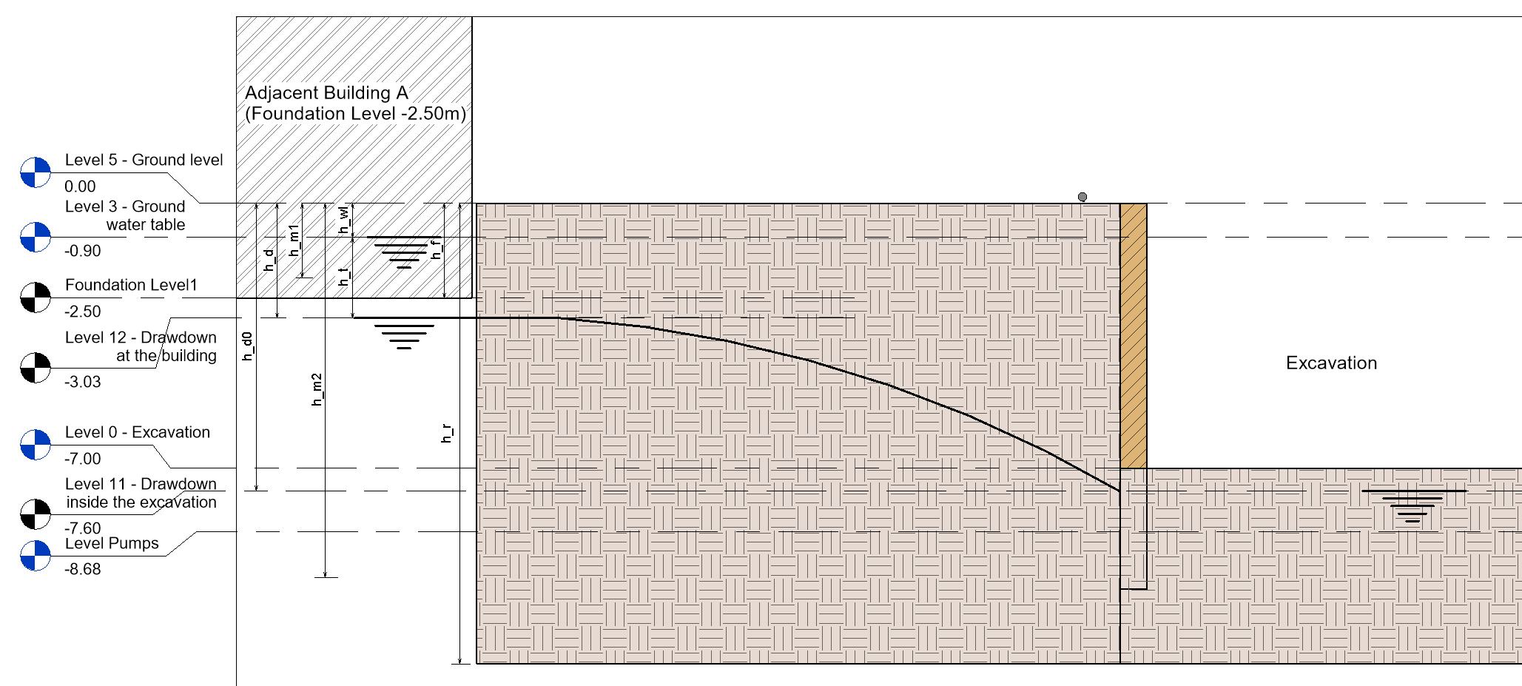

***Stresses:***

***Dewatered Section***

*Initial Stresses at Mid layer of the Dewatered Section:*

The mid layer of the dewatered section is located at a depth of *h\_m1* (m). The total and effective stresses in this location under conditions prior to dewatering are calculated below. By calculating the stresses in the middle of the layer, it is considered that the mean values of these stresses would yield a more representative result for the settlement analysis in this section of the soil.

Total initial stress at depth *h\_m1*

where

$γ_{s}$ = saturated unit weight = 19 kN/m3

$γ_{d}$ = dry unit weight = 16.8 kN/m3

$γ_{w}$ = unit weight of water = 9.8 kN/ m3

Effective initial stress at depth *h\_m1*

*Final stresses at Mid layer of the Dewatered Section:*

Total final stress at depth *h\_m1* depth

$σ_{f@h_m1}=\left(h_{WL}+\left(\frac{h_{d}-h_{wl}}{2}\right)\right)× γ_{d}$

Effective final stress at depth *h\_m1*

***Saturated Section***

*Initial Stresses at Mid-layer of the Saturated Section:*

The mid layer of the saturated section is located at a depth of *h\_m1* (m). The total and effective stresses in this location under conditions prior to dewatering are calculated below. By calculating the stresses in the middle of the layer, it is considered that the mean values of these stresses would yield a more representative result for the settlement analysis in this section of the soil.

Total initial stress at building foundation depth *h\_m1*

where

$γ_{s}$ = saturated unit weight = 19 kN/m3

$γ_{d}$ = dry unit weight = 16.8 kN/m3

$γ_{w}$ = unit weight of water = 9.8 kN/ m3

Effective initial stress at depth *h\_m2*

*Final Stresses at Mid layer of the Saturated Section:*

Total initial stress at building foundation depth *h\_m1*

Effective initial stress at depth *h\_m1*

***Settlements using cohesive soil conditions:***

We estimate that beneath the foundation neighboring buildings there is proper engineering soil material. For this, the cohesive soil consolidation formulas are applied, as per:

a. Terzaghi et al. Soil Mechanics in Engineering practice para. 16.7,

b. Bowles, J. E., *Foundation Analysis and Design,* The McGraw-Hill Companies, Inc., 5th *Edition, para. 2-10.4,*

*c. Deep excavation Theory and Practice Chang-Yu Ou 2006, para. 9.7)*

*d. Dewatering Guidelines for the City of Abu Dhabi PROJECT NO. 13-5015, Rev 1, 8/7/2014*

*Area above drawdown depth*

$${ΔS}_{1}=C_{c}×\frac{{(h}_{d}-h_{WL})}{(1+e_{o})}×log\left(\frac{{σ^{'}}_{f@h_m1}}{{σ^{'}}_{o@h_m1}}\right)$$

*Area above drawdown depth*

$${ΔS}_{2}=C_{c}×\frac{{(h}_{r}-h_{d})}{(1+e_{o})}×log\left(\frac{{σ^{'}}_{f@h_m2}}{{σ^{'}}_{o@h_m2}}\right)$$

where

$C_{c}$ = Soil compression index = 0.07 (is taken)

0 = Soil void ratio= 0.42 (is taken)

###### Total settlements at foundation level of the building A location (depth: -5.0m)

The total settlements at the foundation level of Building A location is:

$${ΔS=ΔS}_{1}+{ΔS}_{2}$$

###### **Foundation level at -5.0m from ground level (one basement)**

Calculations are included in Excel Annex A-8A, sheet “A8a\_SuperWells-B5”

Conditions at final water level of the building A location (depth: -3.03m)

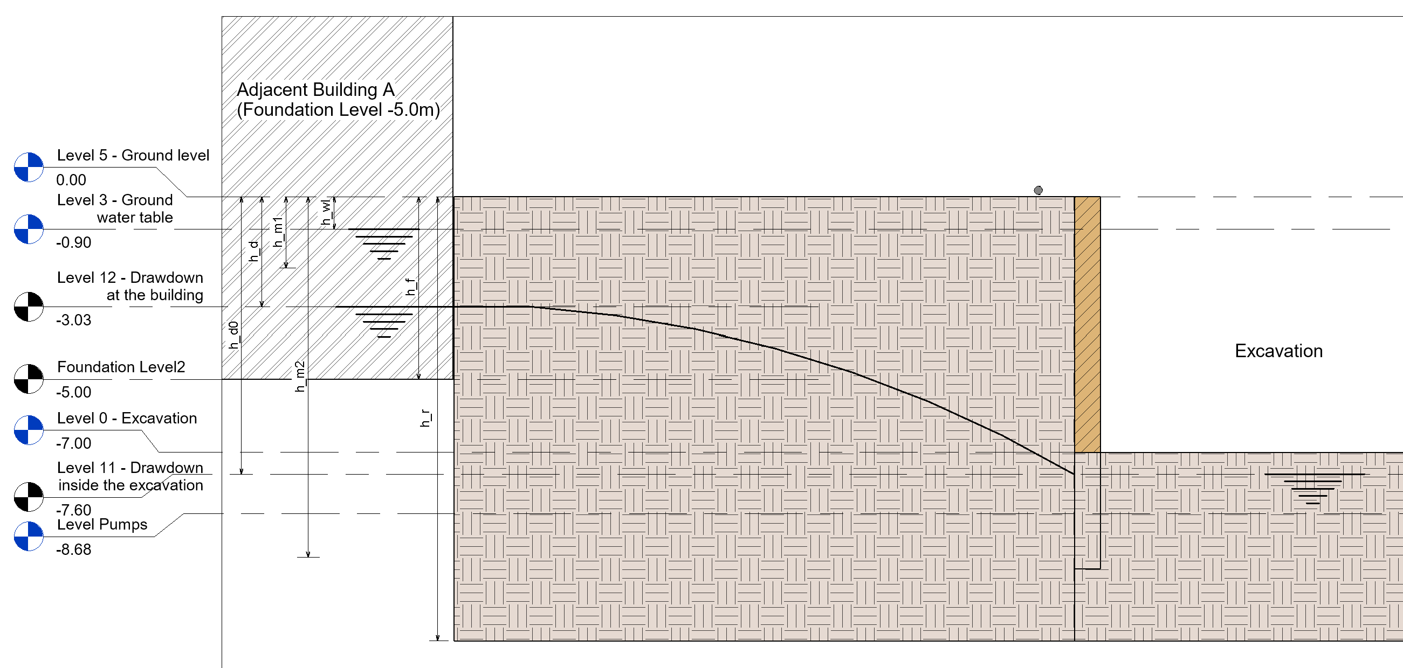

***Stresses:***

*Initial conditions (before dewatering):*

Total initial stress at depth 3.03 m

where

= saturated unit weight = 19 kN/m3

= dry unit weight = 16.8 kN/m3

= unit weight of water = 9.8 kN/ m3

Effective initial stress at depth 3.03 m

*Final conditions (after dewatering and excavation);*

Total final stress at depth 3.03 m depth

Effective final stress at depth 3.03 m

***Settlements:***

*Area above drawdown depth*

We estimate that beneath the foundation neighboring buildings there is proper engineering soil material. It is an estimate since relevant information from the neighboring building (as built, geotechnical investigation, etc) is not available.

where

= Soil compression index = 0.07 (is taken)

e0 = Soil void ratio= 0.42 (is taken)

###### Conditions at foundation level of the building A location (depth: -5.0m)

****

***Stresses:***

*Initial conditions (before dewatering):*

Total initial stress at depth 5.0 m

where

= saturated unit weight = 19 kN/m3

= dry unit weight = 16.8 kN/m3

= unit weight of water = 9.8 kN/ m3

Effective initial stress at depth 5.0 m

→

*Final conditions (after dewatering and excavation);*

Total final stress at depth 5.0 m depth

$σ_{f@5.0m}=h_{d}×γ_{d}+{(h}_{r}-h_{d})× γ_{s}$

Effective final stress at depth 5.0 m

$${σ'}_{f@5.0m}=σ_{f@5.0m}-{(h}_{r}-h_{d})× γ_{w}$$

***Settlements:***

*Area above drawdown depth*

$${ΔS}_{2}=C_{c}×\frac{{(h}_{r}-h_{d})}{(1+e_{o})}×log\left(\frac{{σ^{'}}_{f@5.0m}}{{σ^{'}}_{o@5.0m}}\right)$$

where

$C_{c}$ = Soil compression index = 0.07 (is taken)

e0 = Soil void ratio= 0.42 (is taken)

###### Total settlements at foundation level of the building A location (depth: -5.0m)

The total settlements at the foundation level of Building A location is:

$${ΔS=ΔS}_{1}+{ΔS}_{2}$$

## Displacement at two Nodes areas, using analytical cohesion soil model calculations and numerical model.

The displacements at the 2 nodes (F & B) at the buildings area also examined, as indicated below.

The calculations contacted analytically and numerically as well.

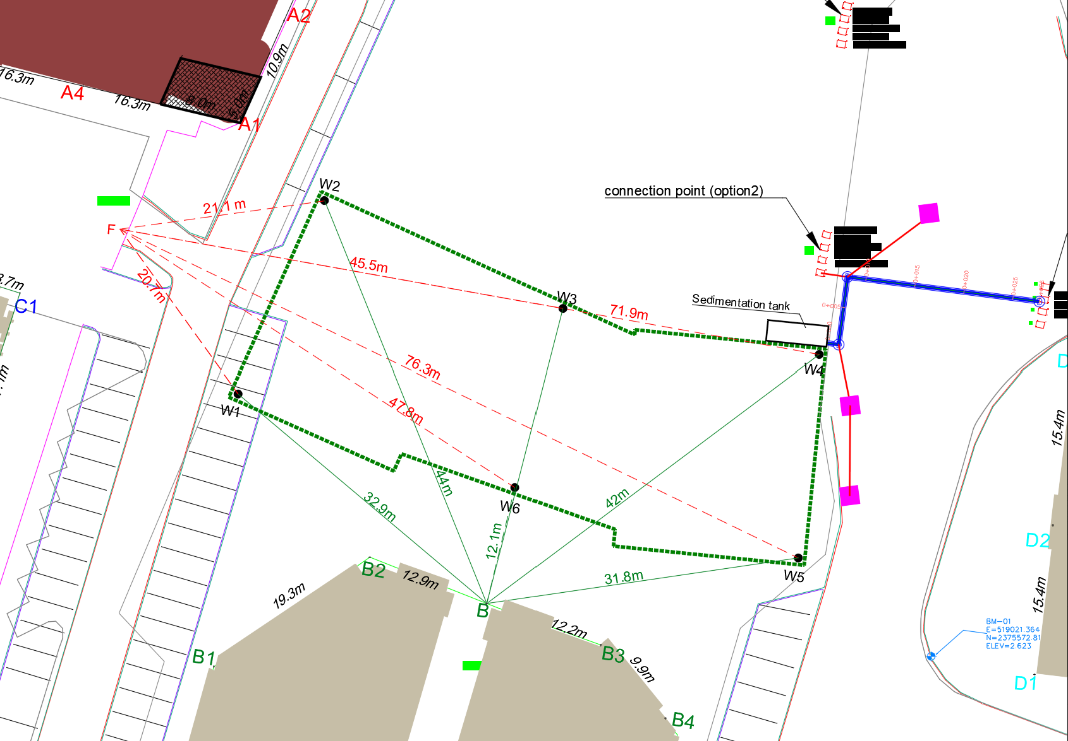

### Excavation and dewatering numerical modeling

CONSULTANT applied also numerical calculations regarding the settlement, using the PLAXIS software for the numerical modeling of the excavation (see results in Annex 6). This is only for displacements at two points F and B and only for comparison purposes, the proper differential settlement calculations have been done using the analytical methodology, as per above paragraphs.

To implement the model, various assumptions have been made, as surface load, secant piles rigid sheet wall.

Additional load from the neighboring structures applied at the foundation level.

The Plaxis numerical analysis simulates the process into construction stages with relevant water reduction, including the supporting system and wall anchors to restrict the settlements of the surrounding buildings.

#### Surface Loading

The following additional surface loading considered to the exterior to the excavation areas, on a perimeter of 10m wide, to reflect any external loading:

* West: 40 kN/m2 (5kN/m2 x 8floors)
* South: 30 kN/m2 (5kN/m2 x 6floors)
* East: 20 kN/m2 taken
* North: 20 kN/m2 taken

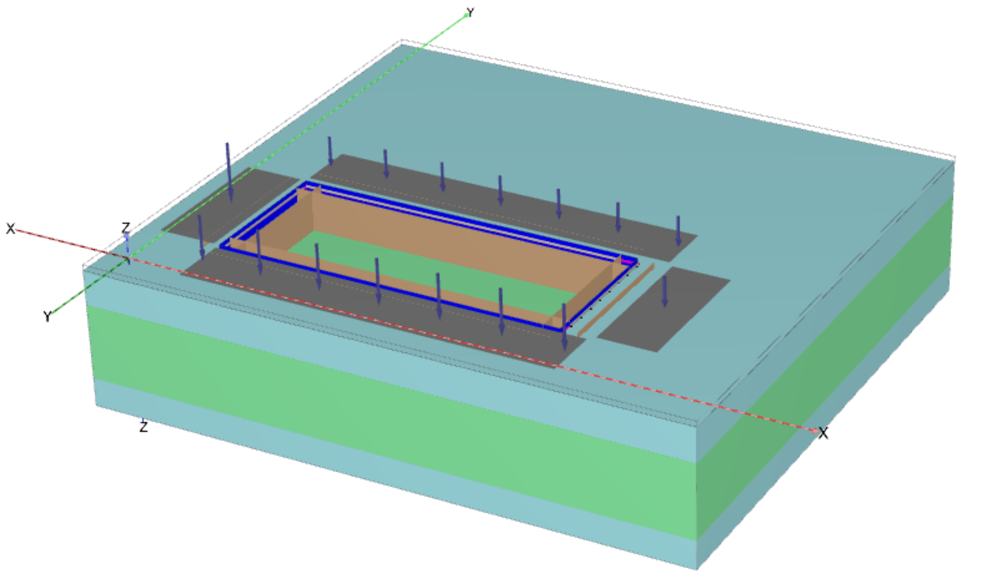

#### Type of Analysis:

Groundwater flow with time tending to infinity, it is similar to steady state type

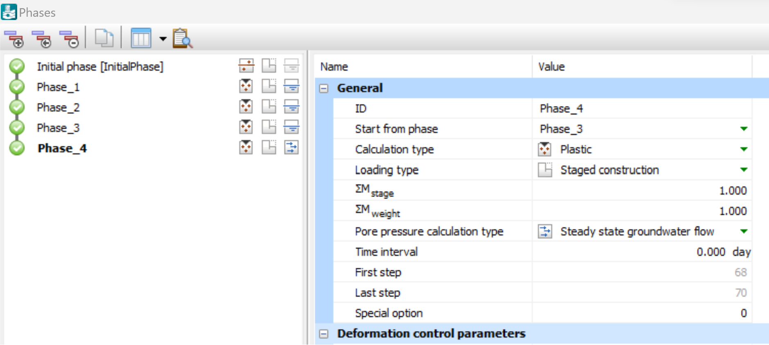

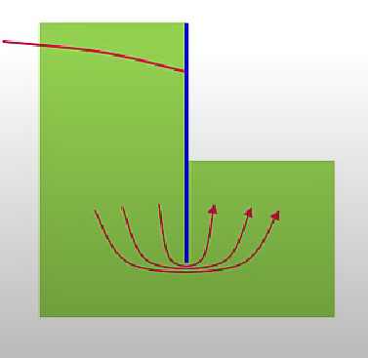

#### Pumping Wells

Six (6) wells considered, with 336 m3/day extraction capacity each (inline with the Excel sheet calculations). The minimum possible head in the well considered is ***hmin = - 7.5m***. When the groundwater head reduces below the *hmin* level no further extraction will occur. This figure is required from the software.

Flow direction X-X:

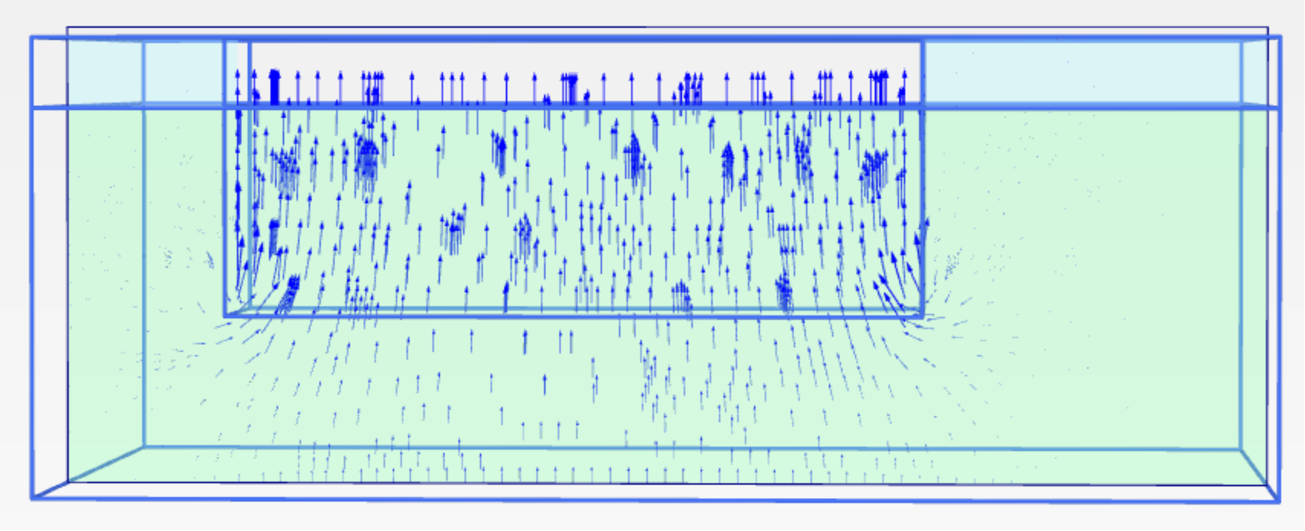

Flow direction Y-Y:

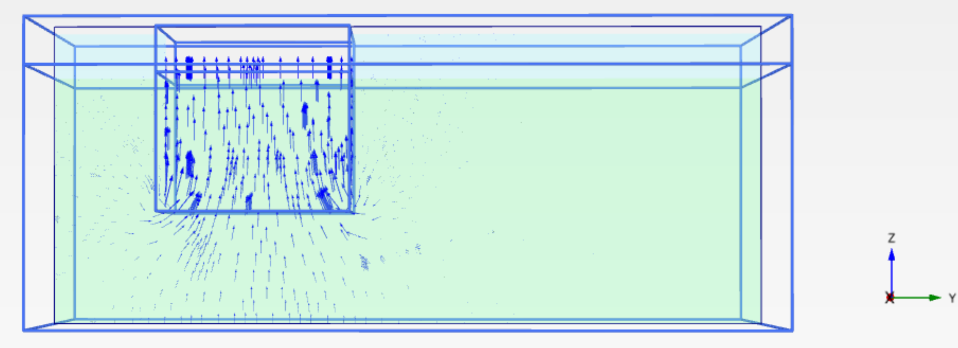

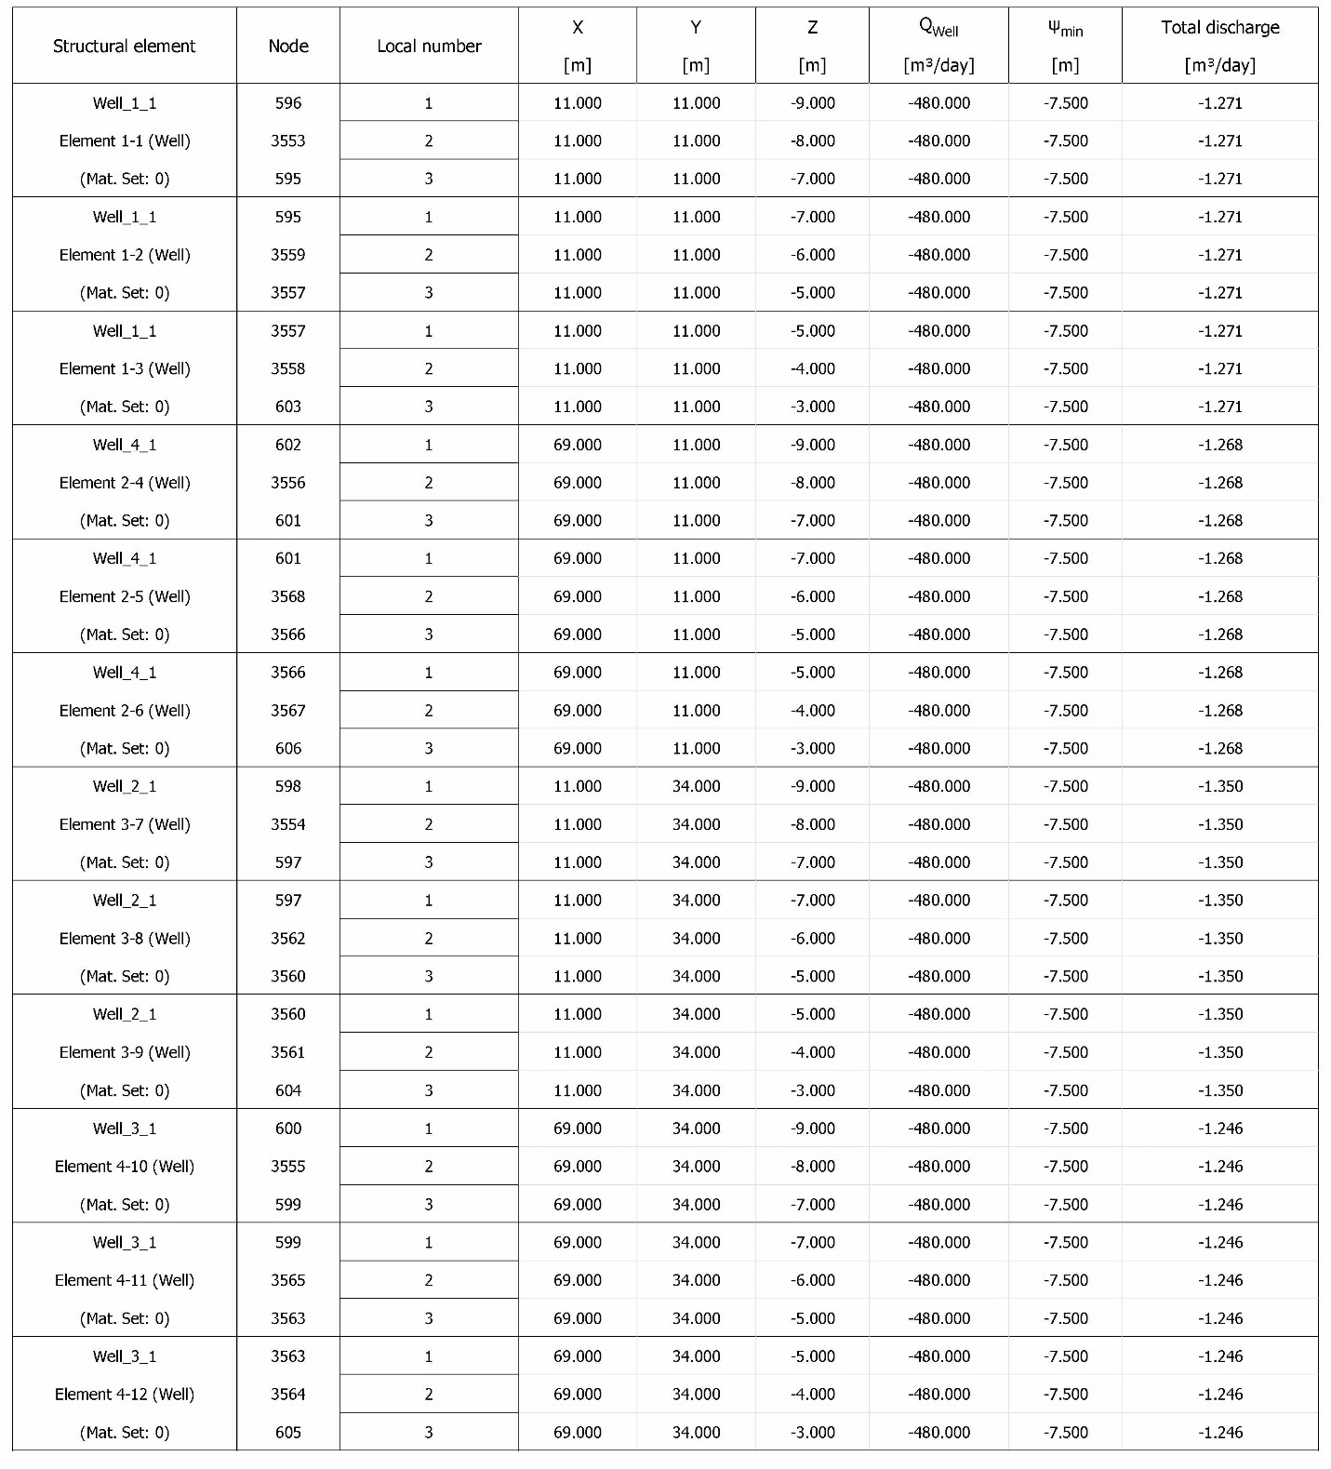

#### Displacement results in a cross section at X and Y directions

PLAXIS groundwater head calculations give:

Groundwater head in X-X direction:

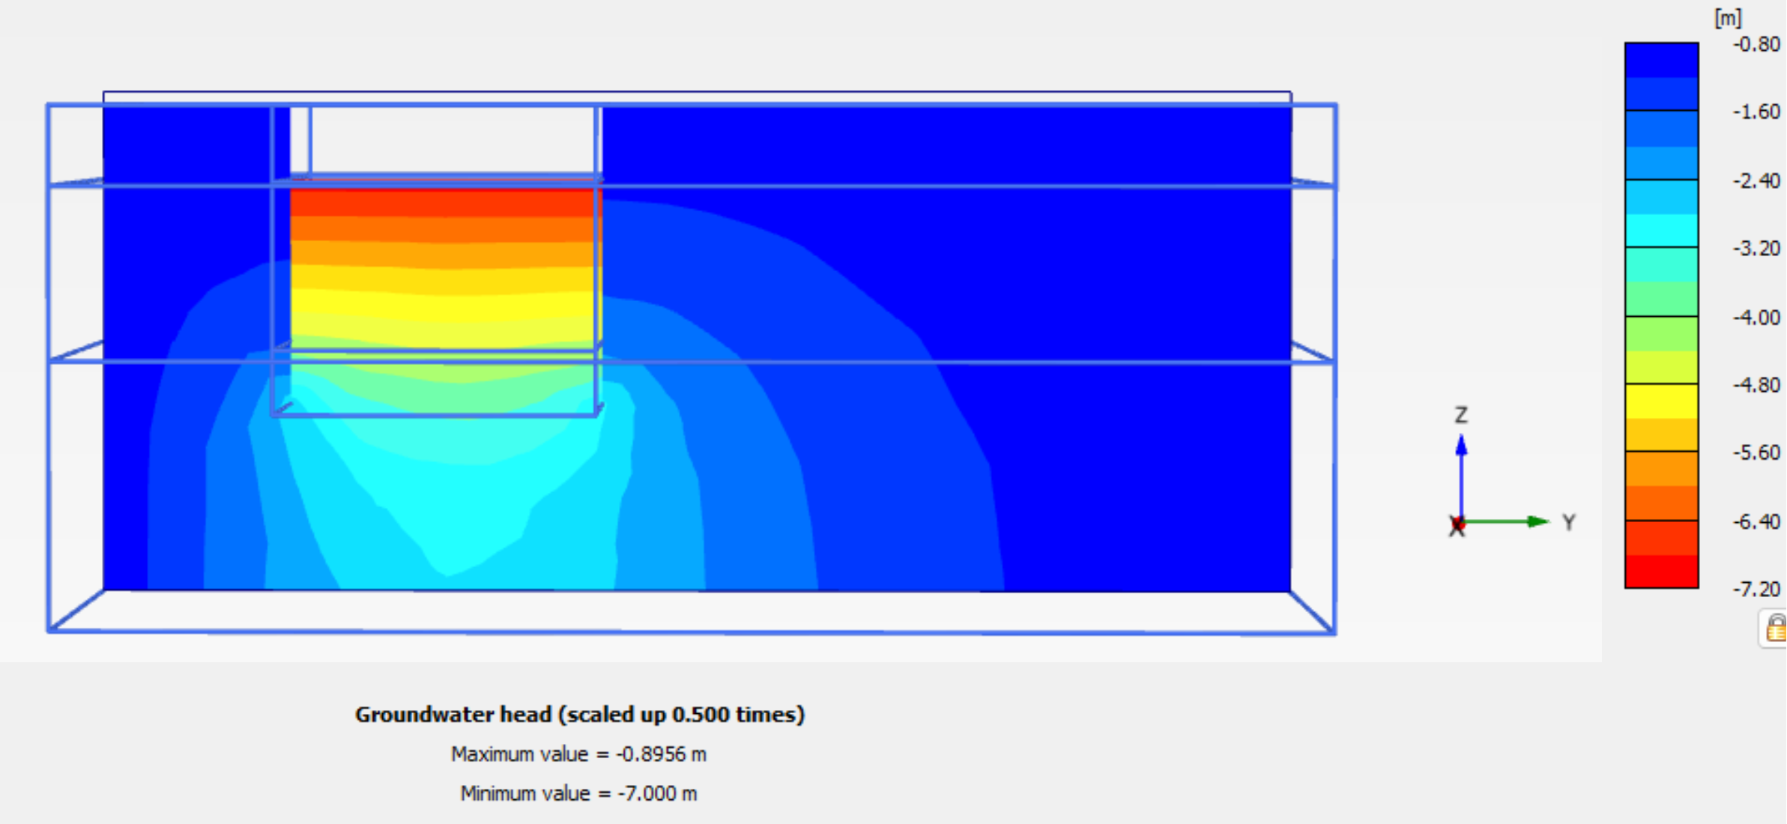

Groundwater head in Y-Y direction:

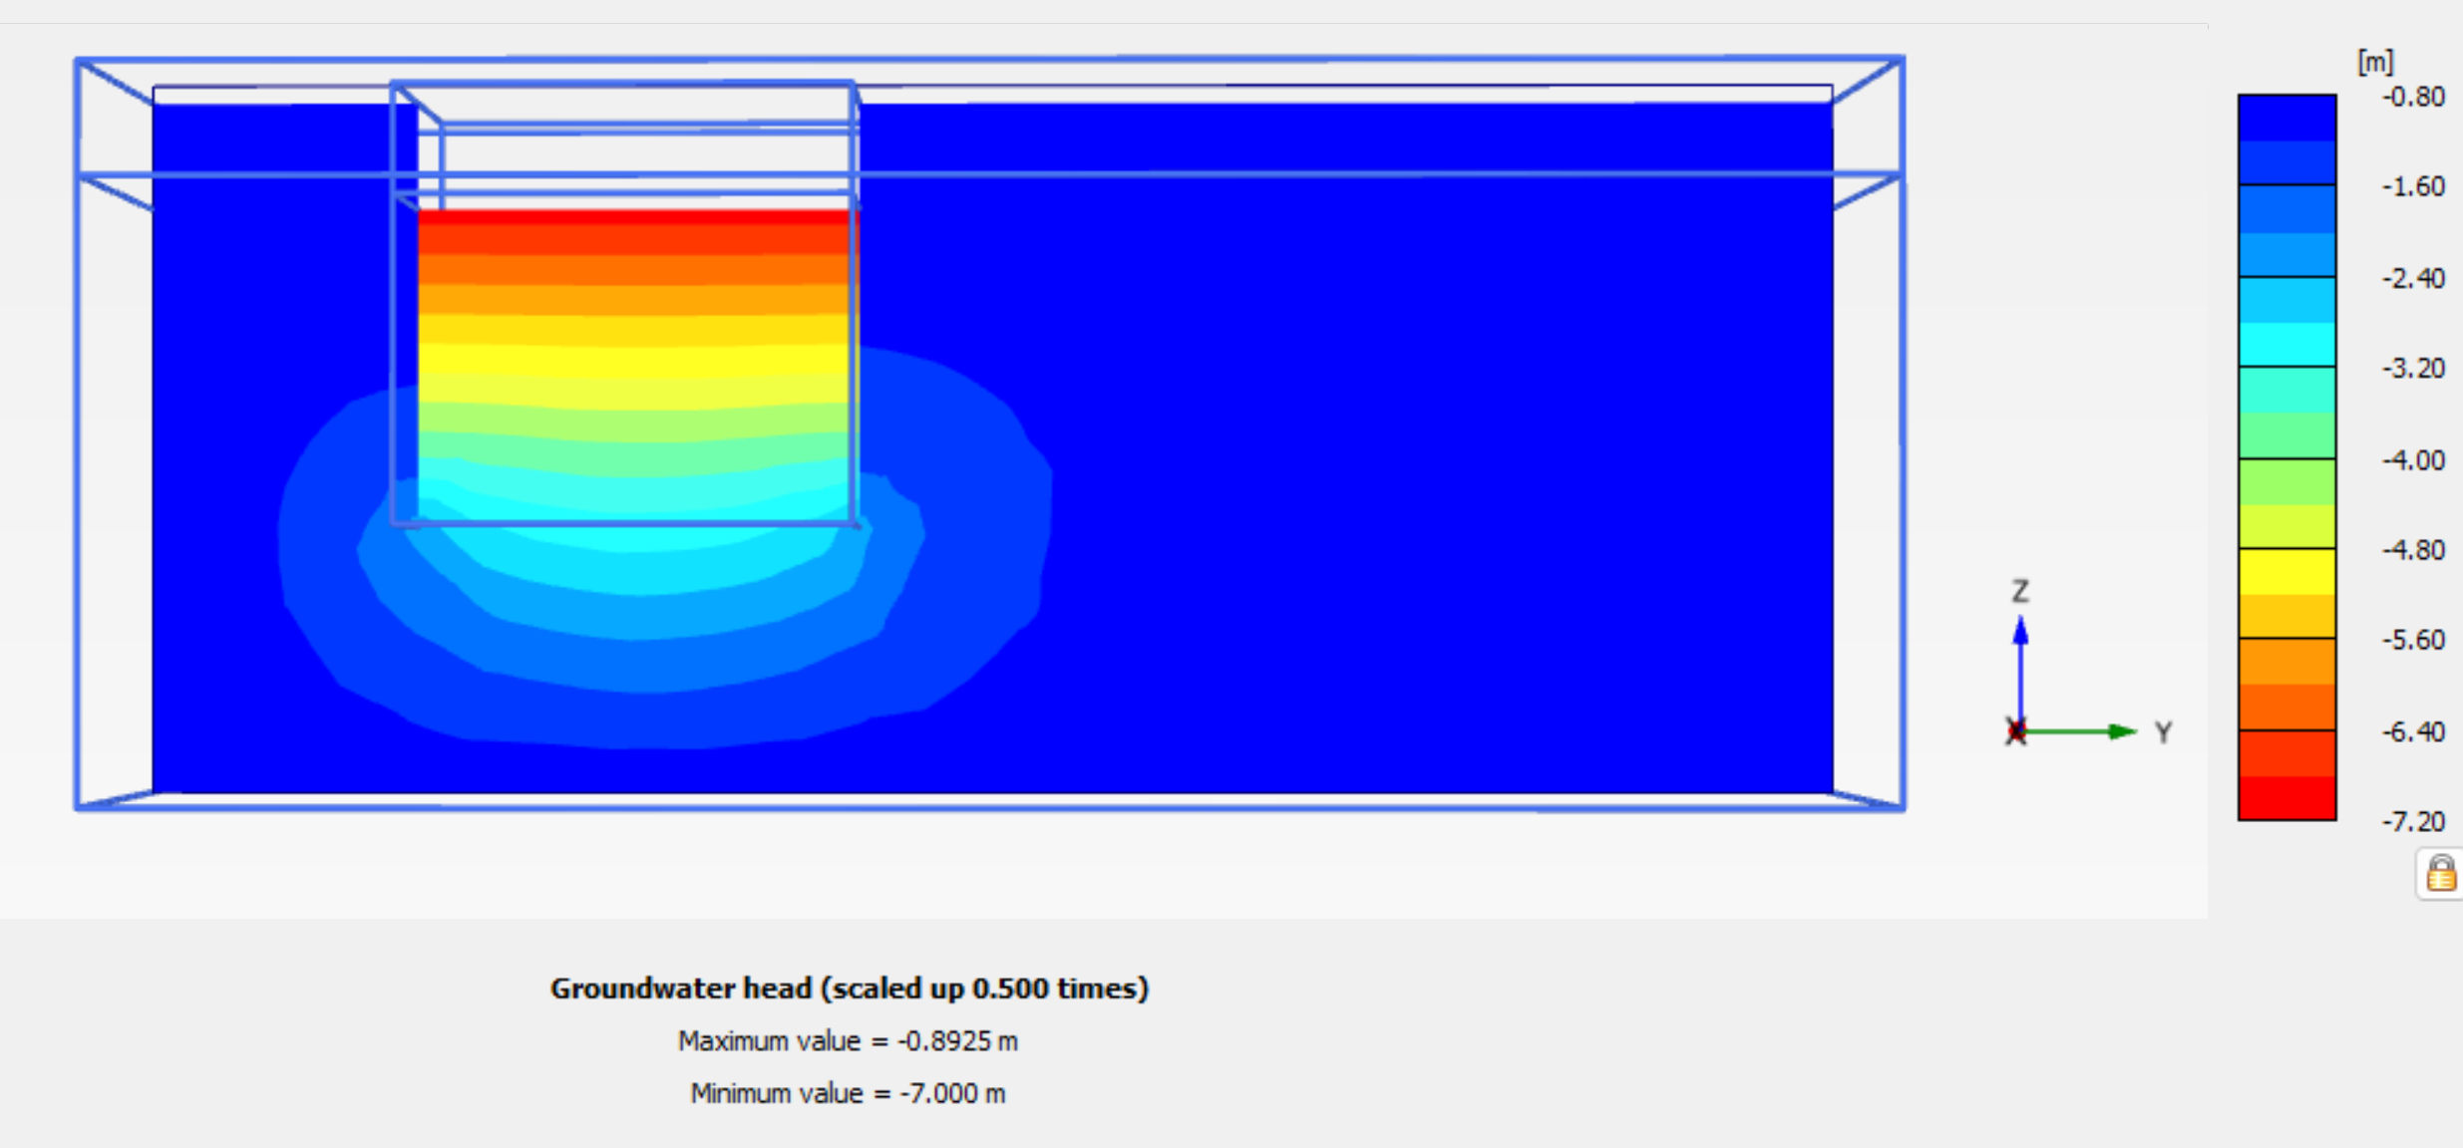

#### Displacement results in a cross section at X and Y directions

#### Only deformations due to dewatering effect are considered within the project area. Surface loading is considered only outside the project boundaries due to existing buildings loading and is taken into account for the effective water pressure effects.

The displacements in a cross section in X direction, is shown below:

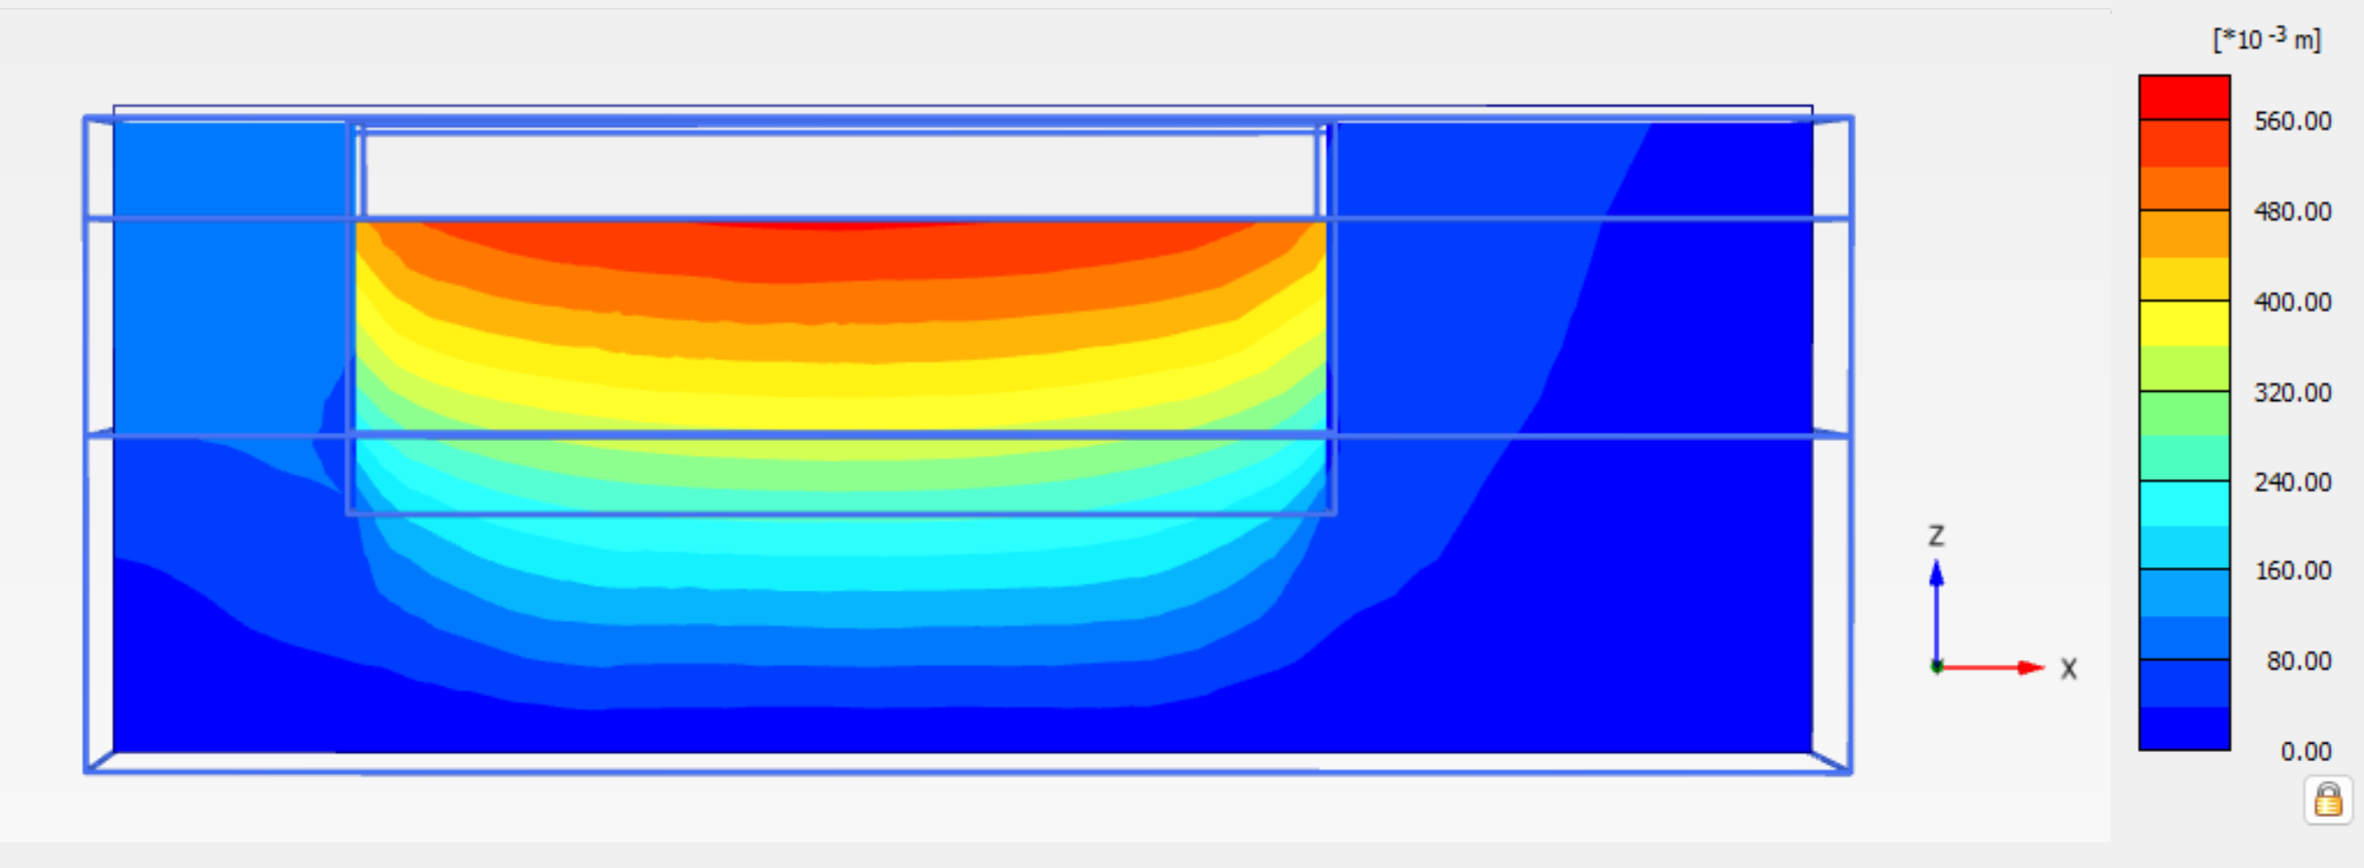

And considering the buildings location

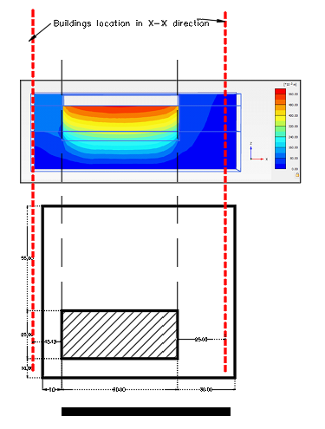

The displacements in cross section in Y direction, are shown below:

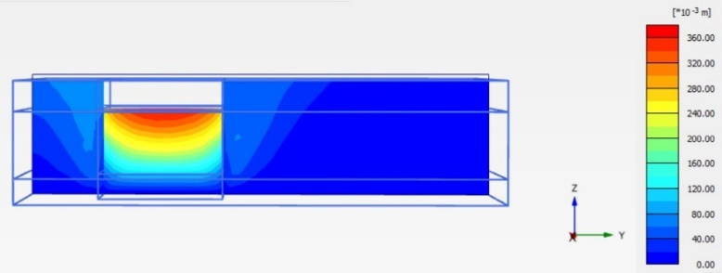

And considering the buildings location

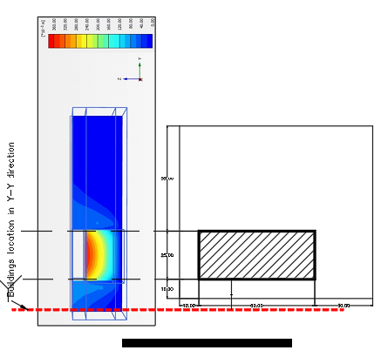

##### Numerical calculation of settlements

###### Displacements at Point F (12936):

#### Only deformations due to dewatering effect are considered within the project area. Surface loading is considered only outside the project boundaries due to existing buildings loading and is taken into account for the effective water pressure effects.

**West** Point F (West side) at Heritage building foundation: (-5.00, 22.94, -5.55). The deformation at this point is shown in the below graph.

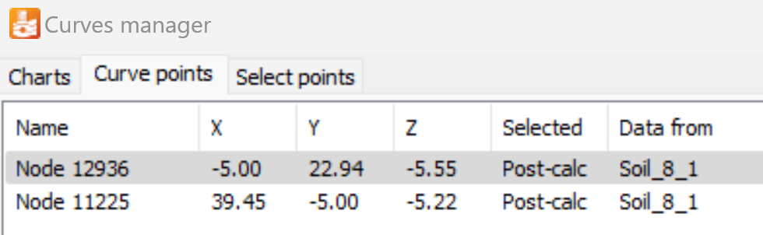

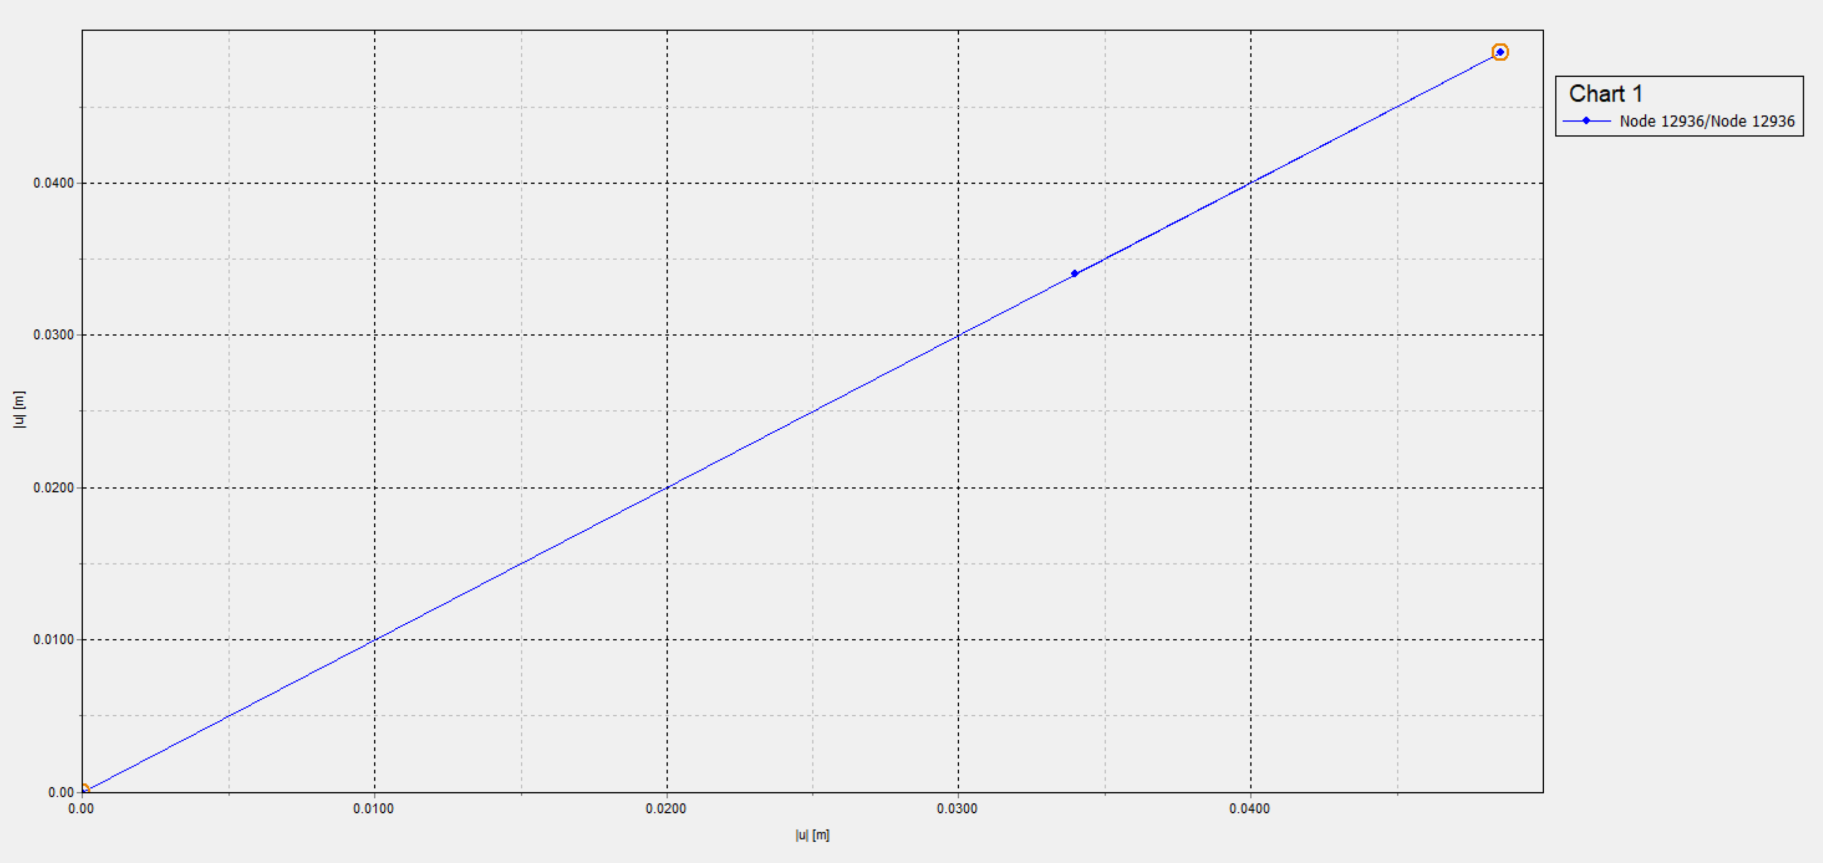

###### Displacements at Node B (11225) (South side building):

**South** Point B at Heritage building foundation: (39.45, -5.00, -5.22). The deformation at this point is shown in the below graph.

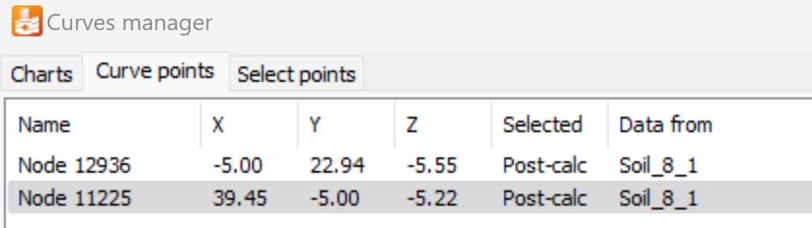

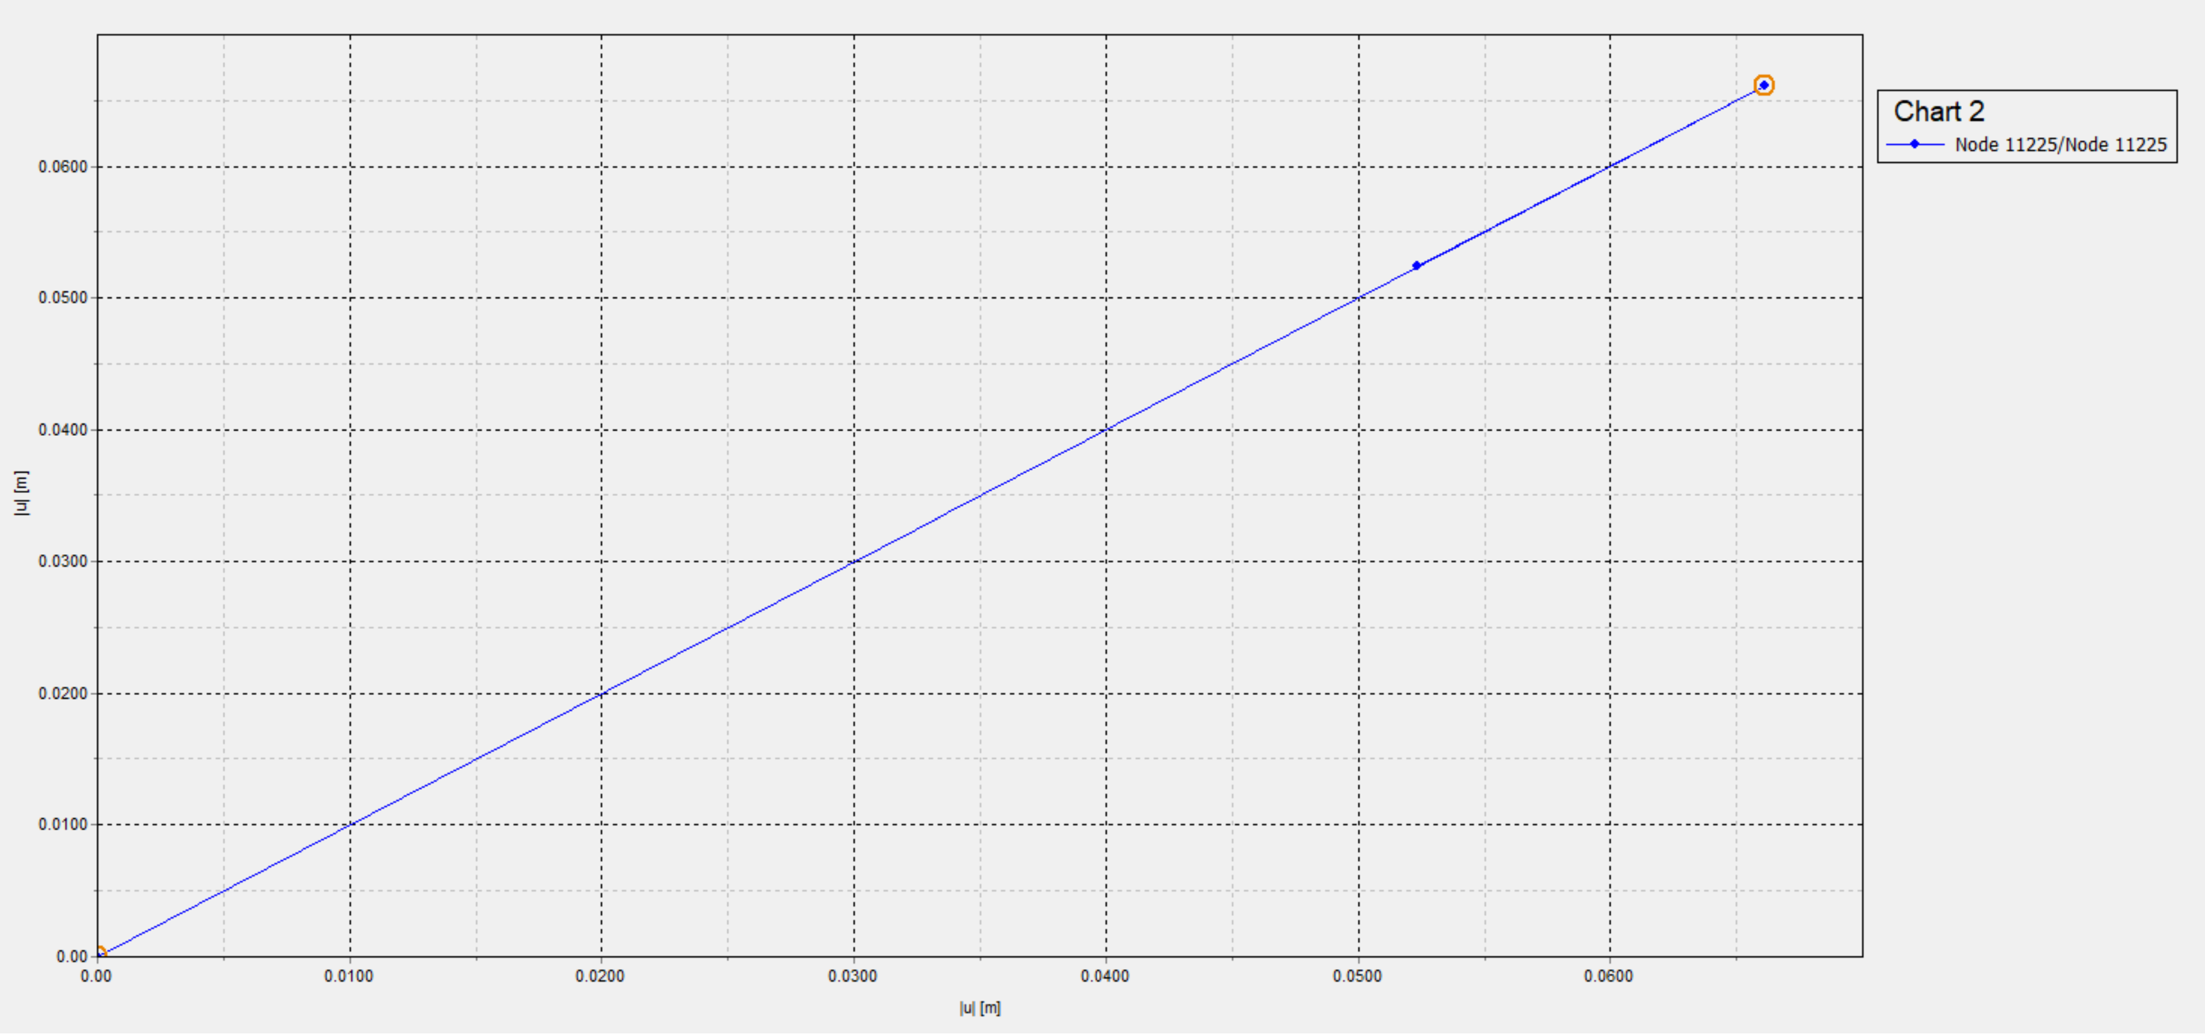

* + - * 1. Soil material used in Plaxis

The main soil material, as per the geotechnical investigation is silty sand, all landfill will be removed.

The relevant data used in the program, are:

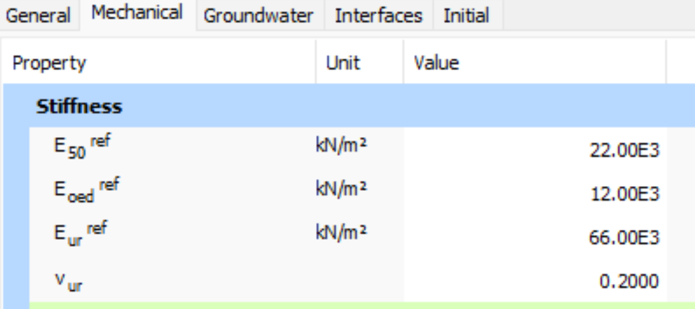

Also, the below graph from the Plaxis, shows additional characteristics of Silty Sand material (hardening soil)

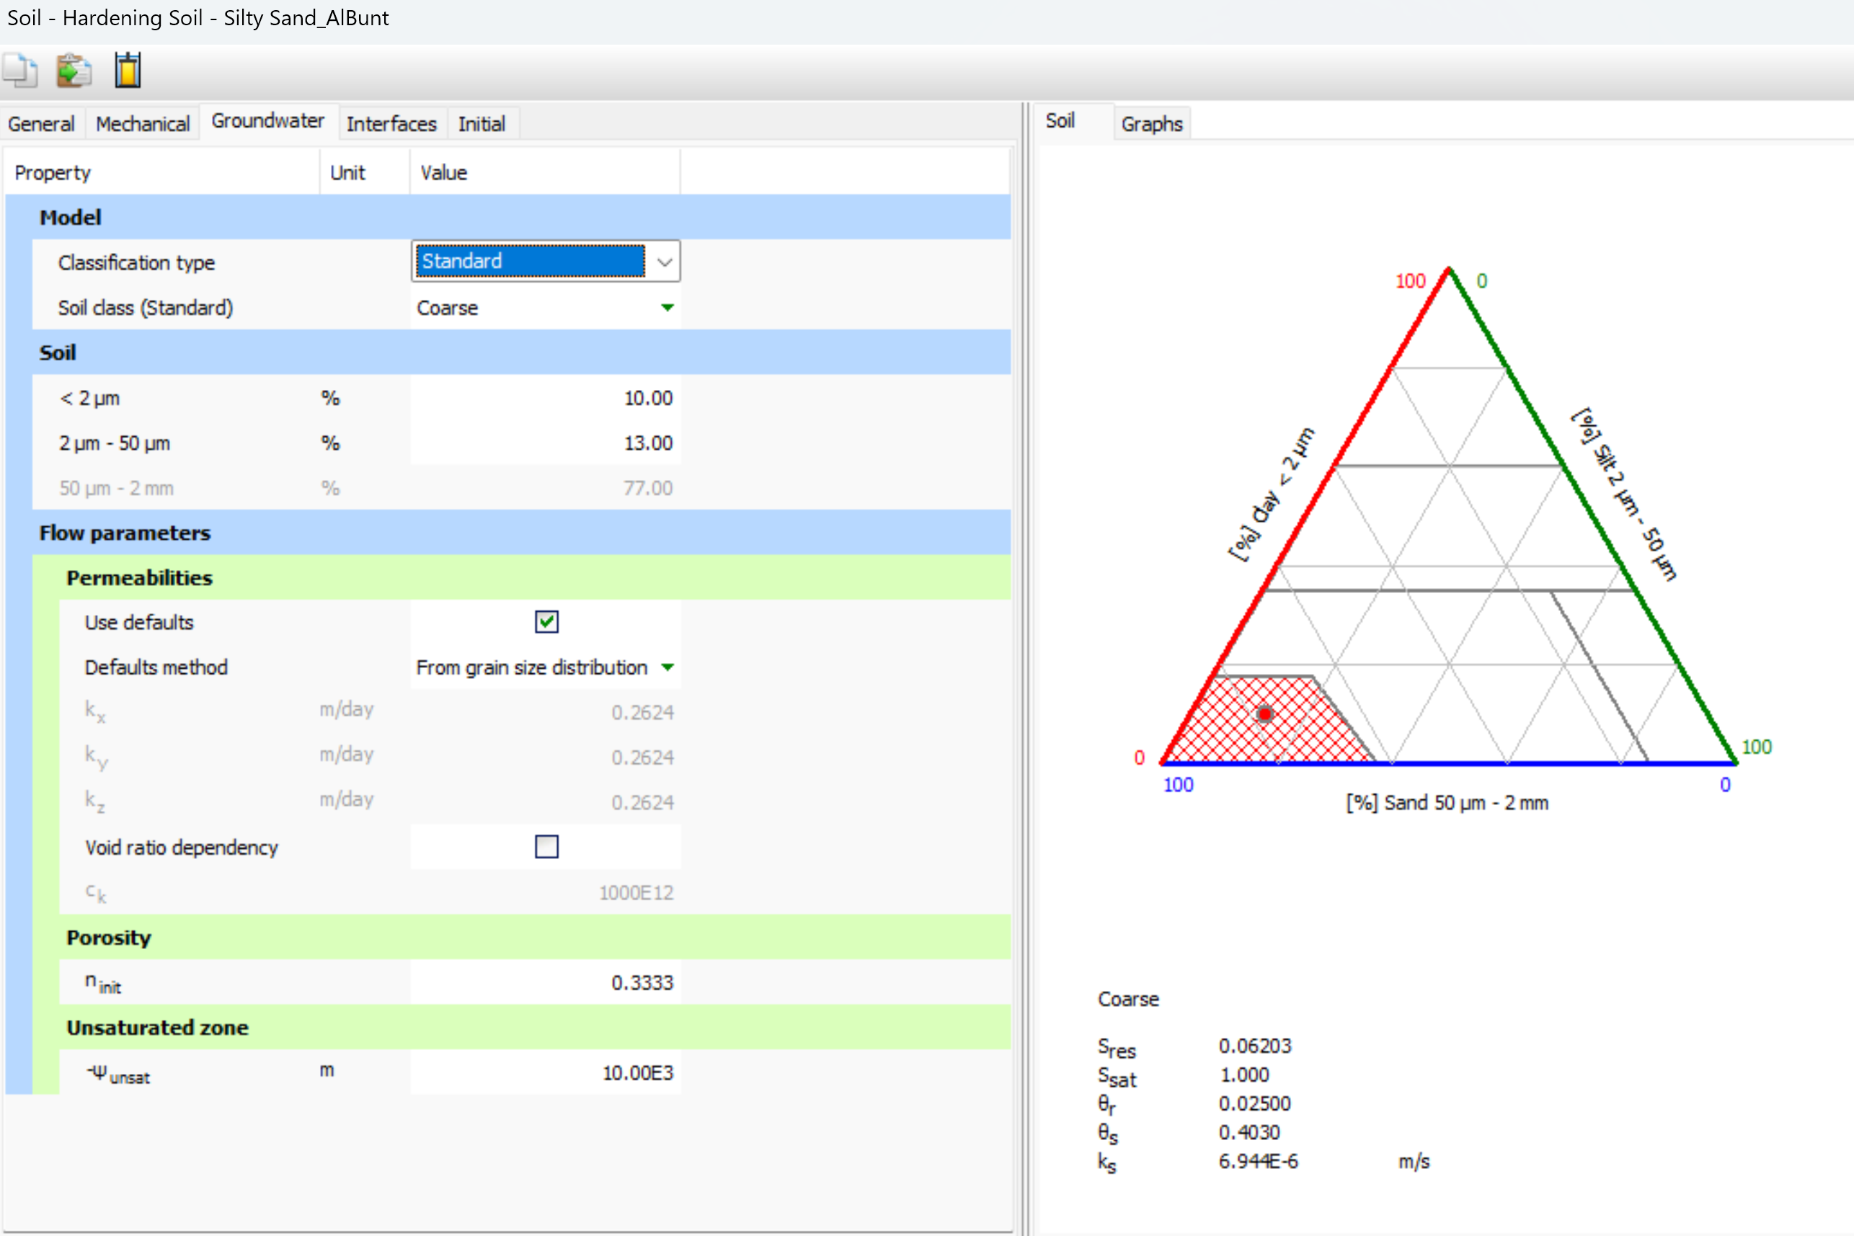

## Summary of analytical maximum settlements and differential settlements at buildings’ nodes

The maximum settlement at the footing foundation level (depth 2.50m) of neighboring buildings points A(A1,A2,A3,A4,A5), B(B,B1,B2,B3,B4), C(C1,C2,C3,C4), D(D1,D2,D3), using cohesionless and cohesion soil model formulas, is:

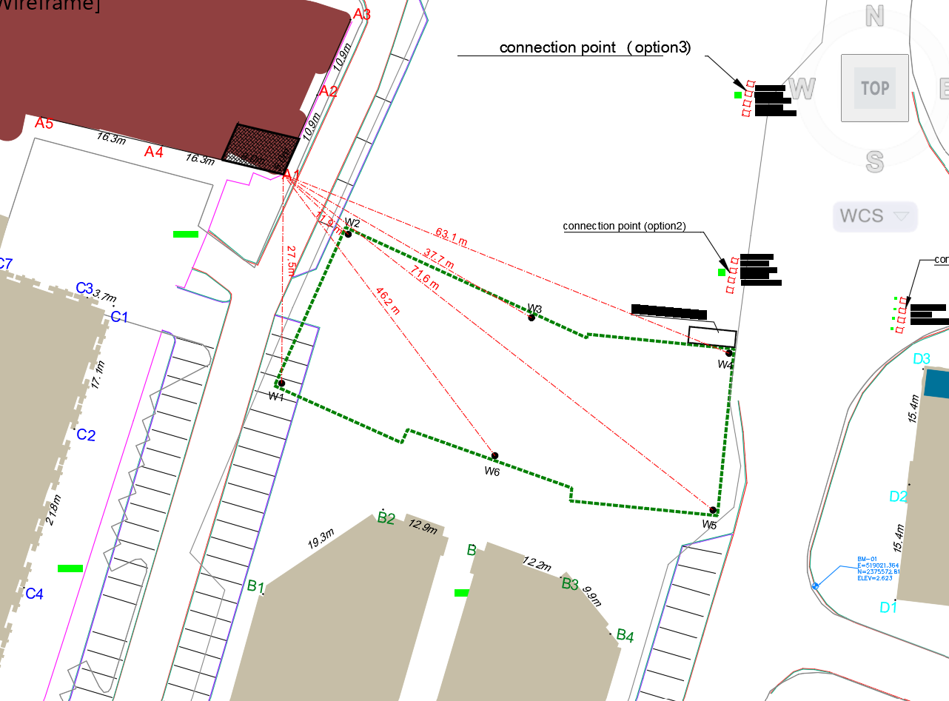

**Building A, Annex A-4H (Excel sheet “A4h Build A-SettlementSum”)**

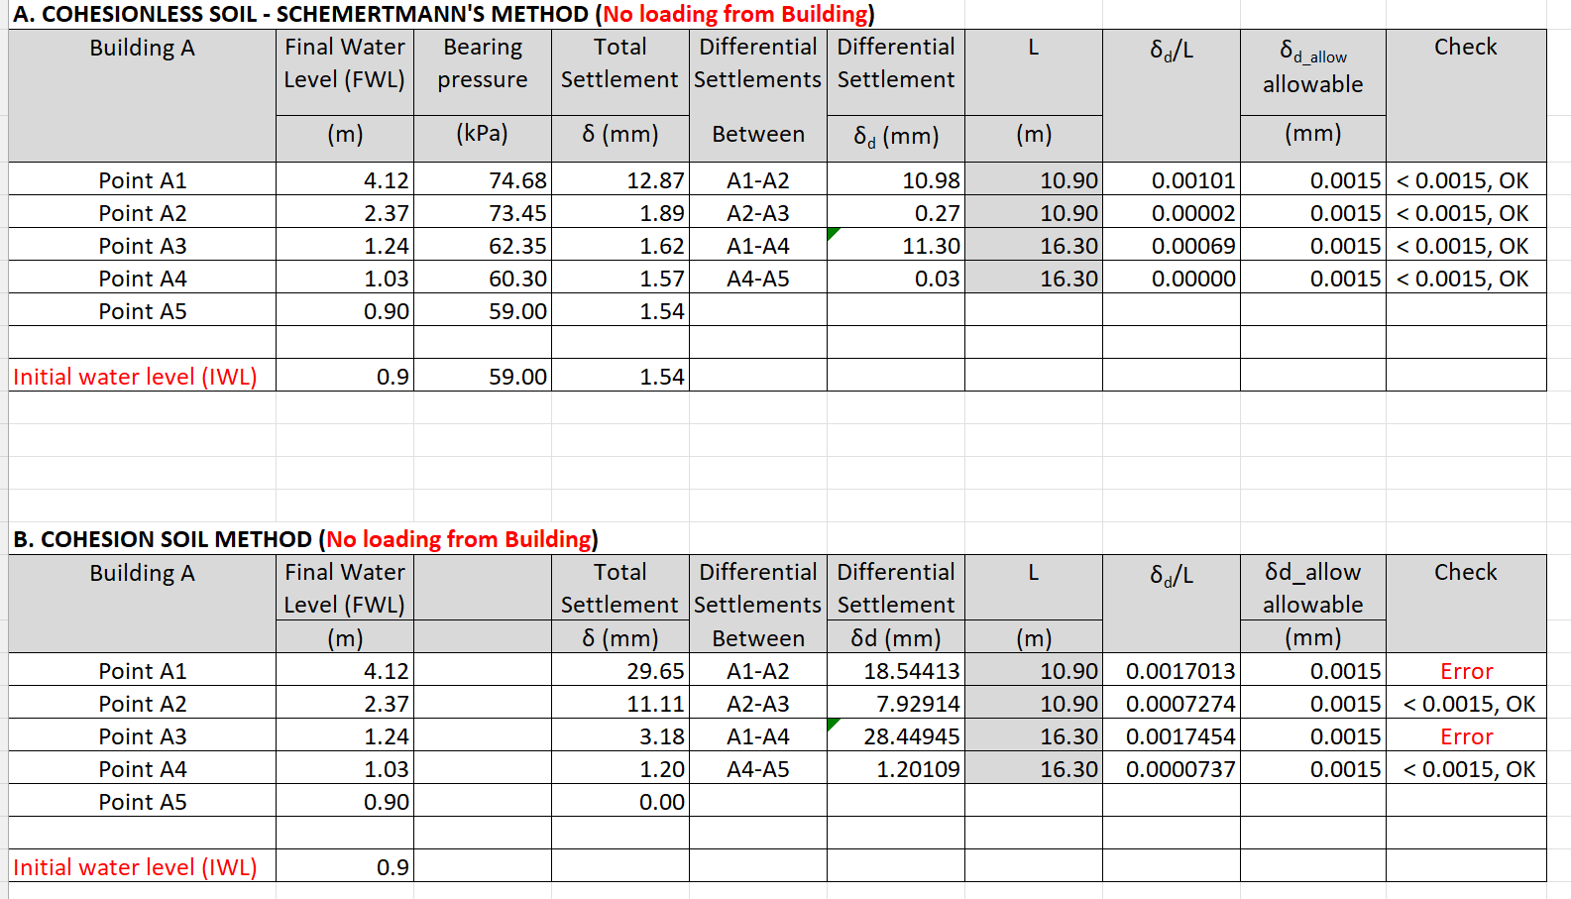

**Building C, Annex A-5G (Excel sheet “A5g Build C-SettlementSum”)**

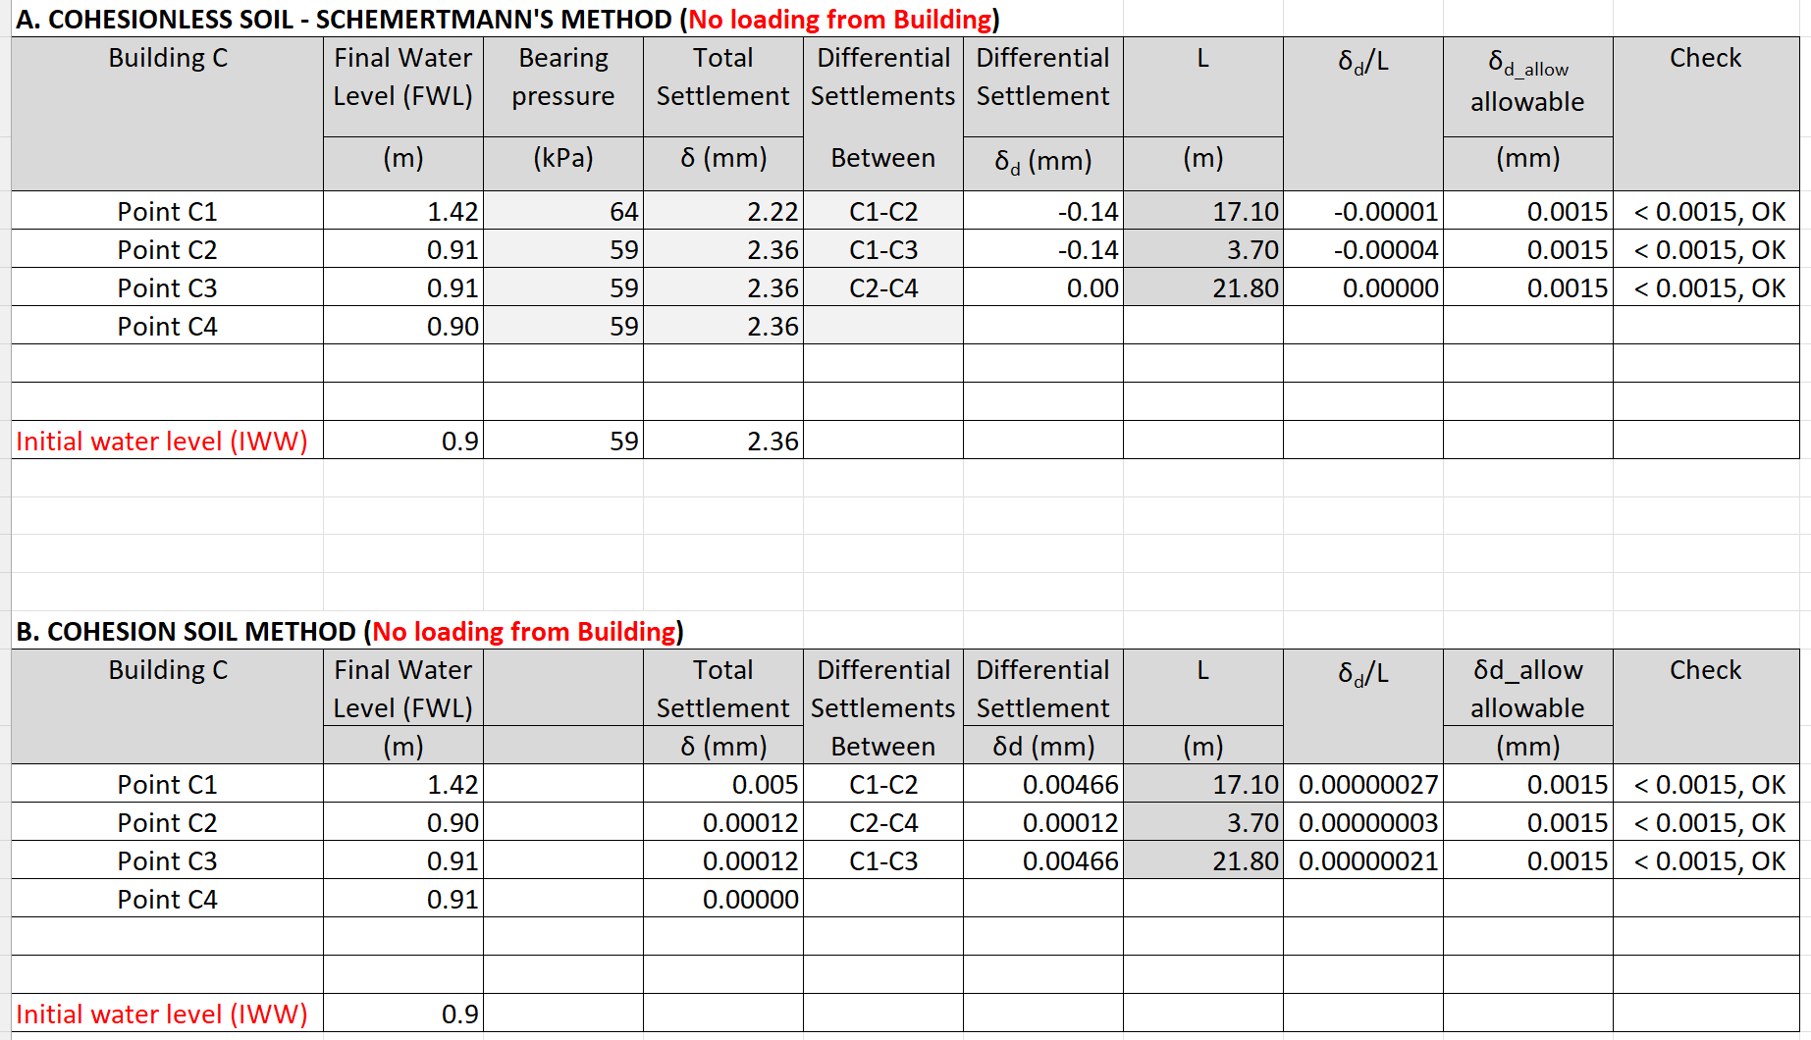

**Building B, Annex A-6H (Excel sheet “A6h Build B-SettlementSum”)**

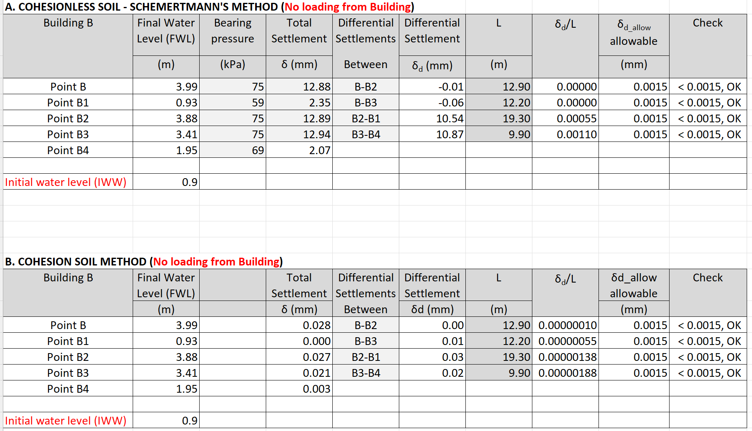

**Building D, Annex A-7F (Excel sheet “A7f Build D-SettlementSum”)**

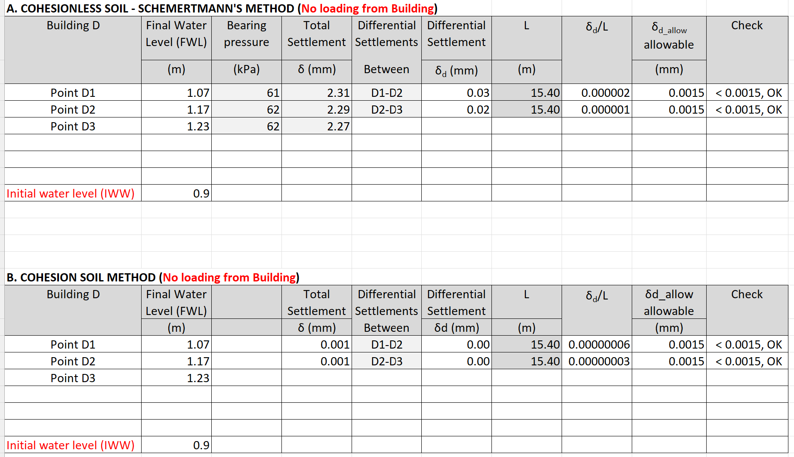

## Summary of analytical and numerical maximum settlements at points F and B

Also, the settlements of the below points have been calculated, for comparison only.



Point F - Analytical calculation (without loading from building), footing depth 2.5 and 5.0m, using cohesion soil model:

* Point F (West), foundation level 2.5m, calculations as per the attached Annex A8b (Excel sheet “A8b\_SuperWells-F2.5m”): settlement 17 mm
* Point F (West), foundation level (-5.0m) calculations as per the attached Annex A8c (Excel sheet “A8c\_SuperWells-F5m”) : settlement 28 mm

Point B - Analytical calculation (without loading from building), footing depth 5.0m, using cohesion soil model:

* Point B (South), foundation level 5.0m, calculations as per the attached Annex A8a (Excel sheet “A8a\_SuperWells-B5”): settlement 36 mm

#### Point A - Numerical calculation (additional surface loads):

* For Point F (West): the settlement at foundation level (-5.0m) is 49 mm
* For building B (South): the settlement at foundation level (-5.0m) is 66 mm.

### Comparison of results to the standards

The allowable angular distortion, as per Saudi Building Code (SBC-303), Table 5.2, is 0.0015

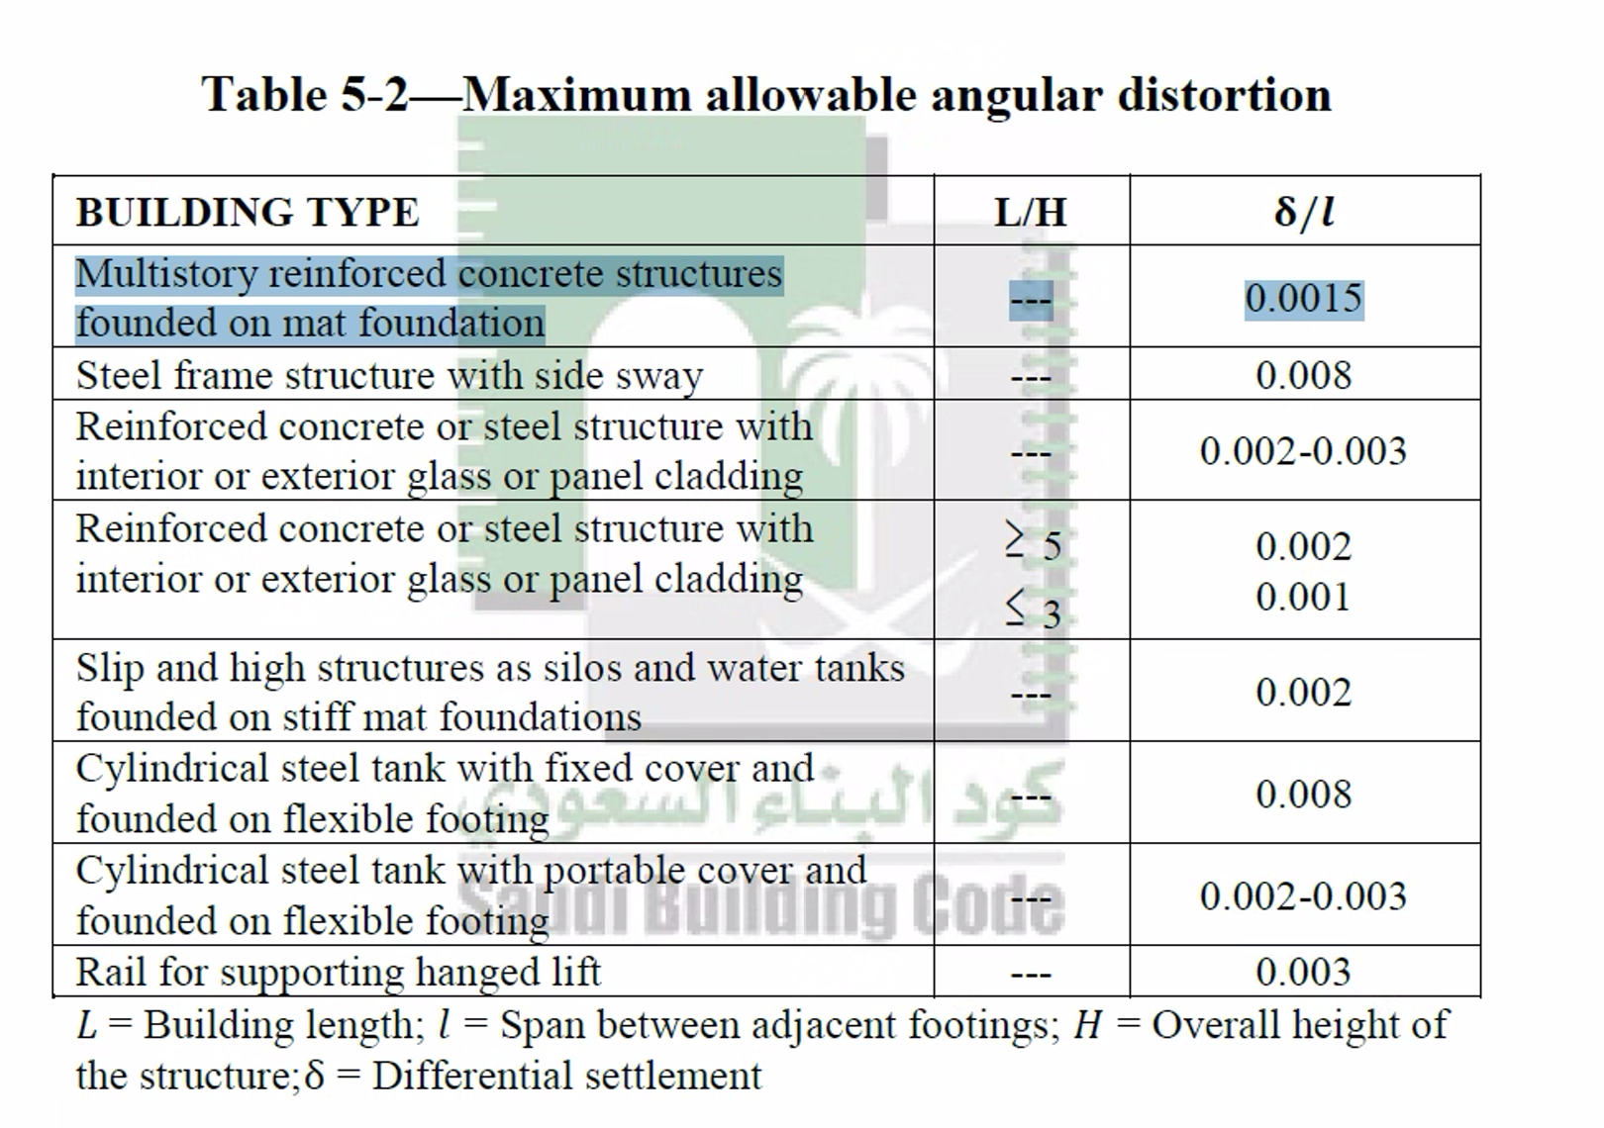

The following differential settlements at some front building points, exceed slightly the allowable angular distortion of 0.0015, **and only using the cohesion method**.

Building A: Α1-A2 and Α1-A4: differential settlements 0.0017 > 0.0015

This is the worst case scenario, since the distances between the points A1-A2 and A1-A4 that the angular distortion is calculated, is 16.3 and 19.3m respectively, which are very large.

As far as the settlements concern, all of them are less than the allowable of 40mm.

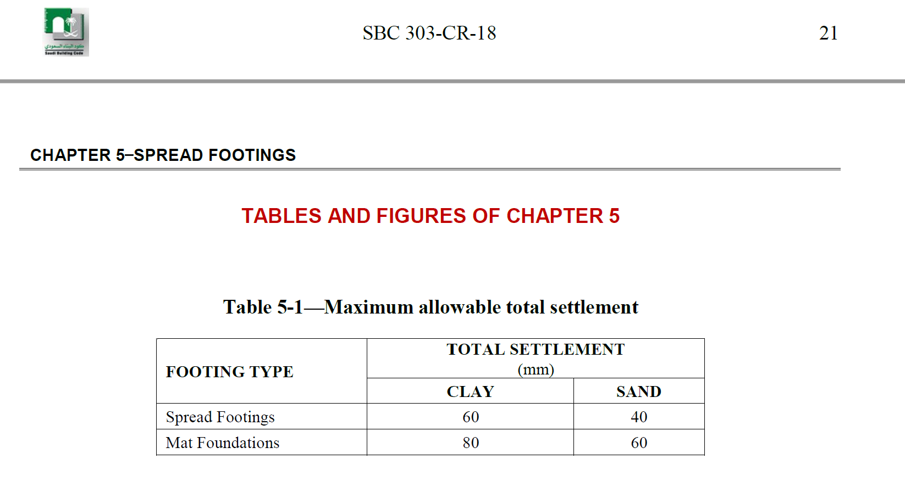

## Recommendation

The below are CONSULTANT recommendations and do not restrict the Client from designing and constructing the works in other acceptable engineering practices.

### Supporting system

The supporting system design is out of CONSULTANT scope and below only recommendations are provided.

* As was explained above, there is no risk from settlements to the heritage and neighboring buildings due to dewatering, since the analytical calculations gave differential settlements, within acceptable limits.

Despite this, the supporting system must be designed carefully to avoid additional settlements

* The excavation and foundation designer and specialized contractor have to design and construct the excavations supporting system, minimizing the deformations and settlements, keeping them within acceptable limits. CONSULTANT is proposing the following methodology, on the condition that extensive design of the supporting system will be implemented by another designer and the specialized excavation and dewatering Contractor:
* To avoid risk to the adjacent heritage buildings, combination of Secant Piles wall (concrete piles diameter minimum 1.2m) with minimum double anchoring rows (at -1m and -3.5m depth) must be used, as indicated in the below sketch (do not take into account the indicated dimensions):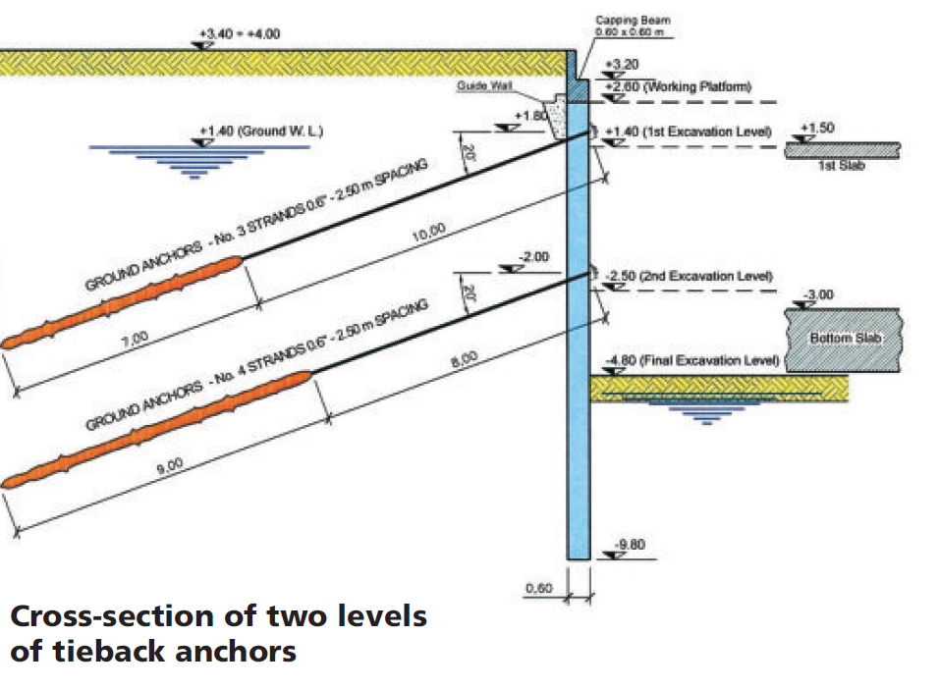
* Additional Supporting Struts or **Rakers** with kicker concrete boxes can be used at the boundaries of the excavated areas that are in close contact with existing buildings and near the pumping wells, as shown in the below photos:

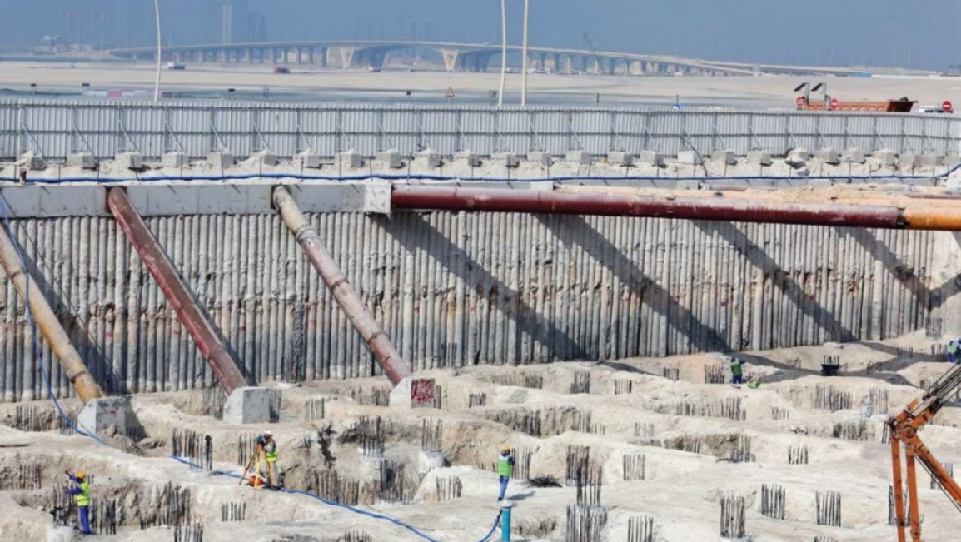

### Contractor’s precautious measures During Excavations

* Careful excavation and construction without disturbing the project area.
* The shoring secant piles should be casted in place to avoid vibrations.

# WORKS EXECUTION

## Execution steps

The dewatering works consist of three steps:

* The first step is divided into 2 activities running in parallel:
* Activity one is to complete the solid shoring around the site perimeter to block the horizontal flow of groundwater during dewatering operation.
* Activity two is to start installation of designed dewatering discharge line upon obtaining the permit from the supervision consultant.
* The second step is to install the **6** wells in their specified design locations, based on dewatering calculation as shown in the attached design, then monitor the water table inside the site to start the mass excavation work of the site.
* The third step is to construct filter drains at the final excavation level, connected to the **6** dewatering wells locations.

## Sequence of work

1- Proper shoring (as secant piles) around site perimeter to be completed.

2- In parallel, upon obtaining the permit, the registered in Amana subcontractor will apply for all necessary road and work permits and install the dewatering discharge line to be ready to discharge at the time of shoring completion.

3- The **6** wells locations to be marked on site and approved by all concerned parties.

4- Drilling and installation of the **6** dewatering wells.

Detail of dewatering well is shown in the attached drawings showing depth, filter material, solid and perforated parts of the riser pipes.

5- Installation of the piping around the excavation and the sedimentation tank

6- Installation of the discharge lines and connection the external storm network.

6- Running of dewatering system at the **6** locations and monitor the water table on site to progress with excavation work.

6- Continue pumping out water to the required contractual period to allow main contractor to construct the raft and basements works till reaching the desired level. The target water lowered level should be minimum 30cm under maximum excavation level.

## Control Panels

Control panels and generator will be installed for running the system, where each panel can operate several pumps. Entire system shall be monitored via an audio and visual alarm to provide warning and prevent any failure.

## Connection from pumps to discharge Lines

Upon installation of the discharge line, the riser pipes will be connected to the collection tank and all pumps are ready to operate pumping the groundwater into the collection (sedimentation) tank and from there to the discharged external lines. Plan showing exact location of sedimentation tanks and generators will be submitted from the specialized contractor to the management of the project for allocating suitable free location.

# COMMISSIONING

Once the system and installation completed and tested the dewatering system shall be started with the approval of all concerned parties and will be monitored by the Supervision Consultant during the dewatering period, reporting to Amana, as per the standard process.

# HEALTH AND SAFETY

The specialized contractor will ensure the application of Environmental, Health and safety standards applicable for the specific project

The Operational Risk Assessment report will be submitted from the specialized Contractor.

**References**

1. *A Practical Guide to Dewatering, 2nd Edition, Pat M. Cashman and Martin Preene*
2. *Construction dewatering and groundwater control, New Methods and Applications, J. PATRICK POWERS, P.E., ARTHUR B. CORWIN, et al*
3. *Deep excavation Theory and Practice Chang-Yu Ou 2006*
4. *Dewatering Guidelines for the City of Abu Dhabi PROJECT NO. 13-5015, Rev 1, 8/7/2014*
5. *Terzaghi et al. Soil Mechanics in Engineering practice*
6. *Bowles, J. E., Foundation Analysis and Design, The McGraw-Hill Companies, Inc., 5th Edition, para. 2-10.4,*
7. *NAFAC P-418*
8. *Foundation Engineering Handbook, Braja M. Das, 2011*
9. *Fundamentals of Geotechnical Engineering, Braja M. Das, 3nd Ed*
10. *FHWA-SA-02-054, Geotechnical engineering circular no. 6, Shallow Foundations, 2002*

# **ANNEXES**

|  |  |  |  |  |
| --- | --- | --- | --- | --- |
| SEQ | ANNEX | Anex Description | Excel Sheet | INSTRUCTIONS |
| 1 | A-1 | ANNEX [A1](file:///D:\SAK\Projects\Dewater\MultipleSites-BALAD\design\4-AlBunt\SAK\work\calcs\240313-AlBunt_calcs.xlsm#'A2 Meth1-BigWellEquival'!Print_Area) Pumps |  | These instructions |
| 2 | A-2 | ANNEX [A2](file:///D:\SAK\Projects\Dewater\MultipleSites-BALAD\design\4-AlBunt\SAK\work\calcs\240313-AlBunt_calcs.xlsm#'A2 Meth1-BigWellEquival'!Print_Area) Method1-Big Well Equivalent | [A2 Meth1-BigWellEquival](file:///D:\SAK\Projects\Dewater\MultipleSites-BALAD\design\4-AlBunt\SAK\work\calcs\240327f-AlBunt_calcs.xlsm#'A2 Meth1-BigWellEquival'!A1) | Calculates the required pumping discharge quantity Q, to succeed the desirable water drawdown, modeling the excavation as one big well. The working pump capacity is taken from the sheet "A2 SuperWells-InsideProject" |
| 3 | A-3 | ANNEX A3Superposition Method Wells-InsideProject | [A3 SuperWells-InsideProject](file:///D:\SAK\Projects\Dewater\MultipleSites-BALAD\design\4-AlBunt\SAK\work\calcs\240327f-AlBunt_calcs.xlsm#'A3 SuperWells-InsideProject'!A1) | Calculates the water drawdown inside the project (3 points, one in the center and two at sides), based on wells superposition method. Also the working pump capacity is defined here, checking to succeed the required drawdown at all internal points |
| 4 | A-4A | ANNEX [A4A](file:///D:\SAK\Projects\Dewater\MultipleSites-BALAD\design\4-AlBunt\SAK\work\calcs\240313-AlBunt_calcs.xlsm#'A4a SuperWells-A1,A2,A3,A4,A5'!Print_Area) Superposition Method Wells-Building A, Points A1,A2,A3,A4,A5Cohesion soil material | [A4a SuperWells-A1,A2,A3,A4,A5](file:///D:\SAK\Projects\Dewater\MultipleSites-BALAD\design\4-AlBunt\SAK\work\calcs\240327f-AlBunt_calcs.xlsm#'A4a SuperWells-A1,A2,A3,A4,A5'!A1) | Calculates the water drawdown at the points A1, A2, A3, A4 and A5 of building A (foundation depth -2.50m), based on wells superposition method Also the settlements due to drawdown from the original level to the one after dewatering, based on cohesion soil formulas are calculated. Loads from the building are not considered, only the effect of change of the original and effective stresses and due to this the relevant settlements are taken into account. |
| 5 | A-4B | ANNEX A4BBuilding A, Summary of initial and final water levels | [A4b Build A-FWL&p](file:///D:\SAK\Projects\Dewater\MultipleSites-BALAD\design\4-AlBunt\SAK\work\calcs\240327f-AlBunt_calcs.xlsm#'A4b Build A-FWL&p'!A1) | For building A summarizes the initial and final water level after dewatering and calculates the bearing pressure on the foundation level, for each building A point (A1,A2,A3,A4,A5) |
| 6 | A-4C | ANNEX A4CBuilding A, Point A, Schemertmann method, Cohesionless soil material | [A4c Build A1-Schem](file:///D:\SAK\Projects\Dewater\MultipleSites-BALAD\design\4-AlBunt\SAK\work\calcs\240327f-AlBunt_calcs.xlsm#'A4c Build A1-Schem'!A1) | Based on the previously found drawdowns and bearing pressure on the foundation level, it calculates the settlements beneath Point A1 of Building A (foundation depth -2.50m). Since the effect of the dewatering is examined, the building loading is ignored, only the footing weight is considered. The Schmertmann method concerning cohesionless soil is applied |
| 7 | A-4D | ANNEX A4DBuilding A, Point A1, Schemertmann method, Cohesionless soil material | [A4d Build A2-Schem](file:///D:\SAK\Projects\Dewater\MultipleSites-BALAD\design\4-AlBunt\SAK\work\calcs\240327f-AlBunt_calcs.xlsm#'A4d Build A2-Schem'!A1) | Similarly for Point A2 of Building A |
| 8 | A-4E | ANNEX A4EBuilding A, Point A1, Schemertmann method, Cohesionless soil material | [A4e Build A3-Schem](file:///D:\SAK\Projects\Dewater\MultipleSites-BALAD\design\4-AlBunt\SAK\work\calcs\240327f-AlBunt_calcs.xlsm#'A4e Build A3-Schem'!A1) | Similarly for Point A3 of Building A |
| 9 | A-4F | ANNEX A4FBuilding A, Point A1, Schemertmann method, Cohesionless soil material | [A4f Build A4-Schem](file:///D:\SAK\Projects\Dewater\MultipleSites-BALAD\design\4-AlBunt\SAK\work\calcs\240327f-AlBunt_calcs.xlsm#'A4f Build A4-Schem'!A1) | Similarly for Point A4 of Building A |
| 10 | A-4G | ANNEX A4GBuilding A, Point A1, Schemertmann method,Cohesionless soil material | [A4g Build A5-Schem](file:///D:\SAK\Projects\Dewater\MultipleSites-BALAD\design\4-AlBunt\SAK\work\calcs\240327f-AlBunt_calcs.xlsm#'A4g Build A5-Schem'!A1) | Similarly for Point A5 of Building A |
| 11 | A-4H | ANNEX A4GBuilding A, Summary of settlements and differential settlements | [A4h Build A-SettlementSum](file:///D:\SAK\Projects\Dewater\MultipleSites-BALAD\design\4-AlBunt\SAK\work\calcs\240327f-AlBunt_calcs.xlsm#'A4h Build A-SettlementSum'!A1) | Summarizes the settlements and differential settlements of the two methodologies (cohesion and cohesionless) of Building A |
| 12 | A-5A | ANNEX [A5A](file:///D:\SAK\Projects\Dewater\MultipleSites-BALAD\design\4-AlBunt\SAK\work\calcs\240313-AlBunt_calcs.xlsm#'A4a SuperWells-A1,A2,A3,A4,A5'!Print_Area) Superposition MethodWells- Building C, Points C1,C2,C3,C4,C5 Cohesion soil material | [A5a SuperWells-C1,C2,C3,C4,C5](file:///D:\SAK\Projects\Dewater\MultipleSites-BALAD\design\4-AlBunt\SAK\work\calcs\240327f-AlBunt_calcs.xlsm#'A5a SuperWells-C1,C2,C3,C4,C5'!A1) | Calculates the water drawdown at the points C1,C2,C3,C4,C5 of building C (foundation depth -2.50m), based on wells superposition method Also the settlements due to drawdown from the original level to the one after dewatering, based on cohesion soil formulas are calculated. Loads from the building are not considered, only the effect of change of the original and effective stresses and due to this the relevant settlements are taken into account. |
| 13 | A-5B | ANNEX A5BBuilding CSummary of initial and final water levels | [A5b Build C-FWL&p](file:///D:\SAK\Projects\Dewater\MultipleSites-BALAD\design\4-AlBunt\SAK\work\calcs\240327f-AlBunt_calcs.xlsm#'A5b Build C-FWL&p'!A1) | For building C summarizes the initial and final water level after dewatering and calculates the bearing pressure on the foundation level, for each building C point (C,C1,C2,C3,C4) |
| 14 | A-5C | ANNEX A5CBuilding C, Point C1, Schemertmann method, Cohesionless soil material | [A5c Build C1-Schem](file:///D:\SAK\Projects\Dewater\MultipleSites-BALAD\design\4-AlBunt\SAK\work\calcs\240327f-AlBunt_calcs.xlsm#'A5c Build C1-Schem'!A1) | Based on the previously found drawdowns and bearing pressure on the foundation level, it calculates the settlements beneath Point C1 of Building C (foundation depth -2.50m). Since the effect of the dewatering is examined, the building loading is ignored, only the footing weight is considered. The Schmertmann method concerning cohesionless soil is applied |
| 15 | A-5D | ANNEX A5DBuilding C, Point C2, Schemertmann method, Cohesionless soil material | [A5d Build C2-Schem](file:///D:\SAK\Projects\Dewater\MultipleSites-BALAD\design\4-AlBunt\SAK\work\calcs\240327f-AlBunt_calcs.xlsm#'A5d Build C2-Schem'!A1) | Similarly for Point C2 of Building C |
| 16 | A-5E | ANNEX A5EBuilding C, Point C3, Schemertmann method, Cohesionless soil material | [A5e Build C3-Schem](file:///D:\SAK\Projects\Dewater\MultipleSites-BALAD\design\4-AlBunt\SAK\work\calcs\240327f-AlBunt_calcs.xlsm#'A5e Build C3-Schem'!A1) | Similarly for Point C3 of Building C |
| 17 | A-5F | ANNEX A5FBuilding C, Point C4, Schemertmann method, Cohesionless soil material | [A5f Build C4-Schem](file:///D:\SAK\Projects\Dewater\MultipleSites-BALAD\design\4-AlBunt\SAK\work\calcs\240327f-AlBunt_calcs.xlsm#'A5f Build C4-Schem'!A1) | Similarly for Point C4 of Building C |
| 18 | A-5G | ANNEX A5GBuilding C, Summary of settlements and differential settlements | [A5g Build C-SettlementSum](file:///D:\SAK\Projects\Dewater\MultipleSites-BALAD\design\4-AlBunt\SAK\work\calcs\240327f-AlBunt_calcs.xlsm#'A5g Build C-SettlementSum'!A1) | Summarizes the settlements and differential settlements of the two methodologies (cohesion and cohesionless) of Building C |
| 19 | A-6A | ANNEX [A6A](file:///D:\SAK\Projects\Dewater\MultipleSites-BALAD\design\4-AlBunt\SAK\work\calcs\240313-AlBunt_calcs.xlsm#'A4a SuperWells-A1,A2,A3,A4,A5'!Print_Area) Superposition MethodWells- Building C, Points B1,B2,B3,B4 Cohesion soil material | [A6a\_SuperWell-B,B1,B2,B3,B4](file:///D:\SAK\Projects\Dewater\MultipleSites-BALAD\design\4-AlBunt\SAK\work\calcs\240327f-AlBunt_calcs.xlsm#'A6a_SuperWell-B,B1,B2,B3,B4'!A1) | Calculates the water drawdown at the points B,B1,B2,B3,B4 of building B (foundation depth -2.50m), based on wells superposition method Also the settlements due to drawdown from the original level to the one after dewatering, based on cohesion soil formulas are calculated. Loads from the building are not considered, only the effect of change of the original and effective stresses and due to this the relevant settlements are taken into account. |
| 20 | A-6B | ANNEX A6BBuilding BSummary of initial and final water levels | [A6b Build B-FWL&p](file:///D:\SAK\Projects\Dewater\MultipleSites-BALAD\design\4-AlBunt\SAK\work\calcs\240327f-AlBunt_calcs.xlsm#'A6d Build B1-Schem'!A1) | For building B summarizes the initial and final water level after dewatering and calculates the bearing pressure on the foundation level, for each building B point (B,B1,B2,B3,B4) |
| 21 | A-6C | ANNEX A6CBuilding B, Point B, Schemertmann method, Cohesionless soil material | [A6c Build B-Schem](file:///D:\SAK\Projects\Dewater\MultipleSites-BALAD\design\4-AlBunt\SAK\work\calcs\240327f-AlBunt_calcs.xlsm#'A6c Build B-Schem'!A1) | Based on the previously found drawdowns and bearing pressure on the foundation level, it calculates the settlements beneath Point B of Building B (foundation depth -2.50m). Since the effect of the dewatering is examined, the building loading is ignored, only the footing weight is considered. The Schmertmann method concerning cohesionless soil is applied |
| 22 | A-6D | ANNEX A6DBuilding B, Point B1, Schemertmann method, Cohesionless soil material | [A6d Build B1-Schem](file:///D:\SAK\Projects\Dewater\MultipleSites-BALAD\design\4-AlBunt\SAK\work\calcs\240327f-AlBunt_calcs.xlsm#'A6d Build B1-Schem'!A1) | Similarly for Point B1 of Building B |
| 23 | A-6E | ANNEX A6EBuilding B, Point B2, Schemertmann method, Cohesionless soil material | [A6e Build B2-Schem](file:///D:\SAK\Projects\Dewater\MultipleSites-BALAD\design\4-AlBunt\SAK\work\calcs\240327f-AlBunt_calcs.xlsm#'A6e Build B2-Schem'!A1) | Similarly for Point B2 of Building B |
| 24 | A-6F | ANNEX A6FBuilding B, Point B3, Schemertmann method, Cohesionless soil material | [A6f Build B3-Schem](file:///D:\SAK\Projects\Dewater\MultipleSites-BALAD\design\4-AlBunt\SAK\work\calcs\240327f-AlBunt_calcs.xlsm#'A6f Build B3-Schem'!A1) | Similarly for Point B3 of Building B |
| 25 | A-6G | ANNEX A6GBuilding B, Point B4, Schemertmann method, Cohesionless soil material | [A6g Build B4-Schem](file:///D:\SAK\Projects\Dewater\MultipleSites-BALAD\design\4-AlBunt\SAK\work\calcs\240327f-AlBunt_calcs.xlsm#'A6g Build B4-Schem'!A1) | Similarly for Point B4 of Building B |
| 26 | A-6H | ANNEX A6HBuilding B, Summary of settlements and differential settlements | [A6h Build B-SettlementSum](file:///D:\SAK\Projects\Dewater\MultipleSites-BALAD\design\4-AlBunt\SAK\work\calcs\240327f-AlBunt_calcs.xlsm#'A6h Build B-SettlementSum'!A1) | Summarizes the settlements and differential settlements of the two methodologies (cohesion and cohesionless) of Building B |
| 27 | A-7A | ANNEX [A7A](file:///D:\SAK\Projects\Dewater\MultipleSites-BALAD\design\4-AlBunt\SAK\work\calcs\240313-AlBunt_calcs.xlsm#'A4a SuperWells-A1,A2,A3,A4,A5'!Print_Area) Superposition MethodWells- Building D, Points D1,D2,D3 Cohesion soil material | [A7a SuperWells-D1,D2,D3](file:///D:\SAK\Projects\Dewater\MultipleSites-BALAD\design\4-AlBunt\SAK\work\calcs\240327f-AlBunt_calcs.xlsm#'A7a SuperWells-D1,D2,D3'!A1) | Calculates the water drawdown at the points D1,D2,D3 of building D (foundation depth -2.50m), based on wells superposition method Also the settlements due to drawdown from the original level to the one after dewatering, based on cohesion soil formulas are calculated. Loads from the building are not considered, only the effect of change of the original and effective stresses and due to this the relevant settlements are taken into account. |
| 28 | A-7B | ANNEX A7BBuilding D, Summary of initial and final water levels | [A7b Build D-FWL&p](file:///D:\SAK\Projects\Dewater\MultipleSites-BALAD\design\4-AlBunt\SAK\work\calcs\240327f-AlBunt_calcs.xlsm#'A7b Build D-FWL&p'!A1) | For building D summarizes the initial and final water level after dewatering and calculates the bearing pressure on the foundation level, for each building D point (D1,D2,D3) |
| 29 | A-7C | ANNEX A7CBuilding D, Point D1, Schemertmann method, Cohesionless soil material | [A7c Build D1-Schem](file:///D:\SAK\Projects\Dewater\MultipleSites-BALAD\design\4-AlBunt\SAK\work\calcs\240327f-AlBunt_calcs.xlsm#'A7c Build D1-Schem'!A1) | Based on the previously found drawdowns and bearing pressure on the foundation level, it calculates the settlements beneath Point D1 of Building D (foundation depth -2.50m). Since the effect of the dewatering is examined, the building loading is ignored, only the footing weight is considered. The Schmertmann method concerning cohesionless soil is applied |
| 30 | A-7D | ANNEX A7DBuilding D, Point D2, Schemertmann method, Cohesionless soil material | [A7d Build D2-Schem](file:///D:\SAK\Projects\Dewater\MultipleSites-BALAD\design\4-AlBunt\SAK\work\calcs\240327f-AlBunt_calcs.xlsm#'A7d Build D2-Schem'!A1) | Similarly for Point D2 of Building D |
| 31 | A-7E | ANNEX A7EBuilding D, Point D3, Schemertmann method, Cohesionless soil material | [A7e Build D3-Schem](file:///D:\SAK\Projects\Dewater\MultipleSites-BALAD\design\4-AlBunt\SAK\work\calcs\240327f-AlBunt_calcs.xlsm#'A7e Build D3-Schem'!A1) | Similarly for Point D3 of Building D |
| 32 | A-7F | ANNEX A7FBuilding D, Summary of settlements and differential settlements | [A7f Build D-SettlementSum](file:///D:\SAK\Projects\Dewater\MultipleSites-BALAD\design\4-AlBunt\SAK\work\calcs\240327f-AlBunt_calcs.xlsm#'A7f Build D-SettlementSum'!A1) | Summarizes the settlements and differential settlements of the two methodologies (cohesion and cohesionless) of Building D |
| 33 | A-8A | ANNEX [A8A](file:///D:\SAK\Projects\Dewater\MultipleSites-BALAD\design\4-AlBunt\SAK\work\calcs\240313-AlBunt_calcs.xlsm#'A4a SuperWells-A1,A2,A3,A4,A5'!Print_Area) Superposition MethodWells-Points B, foundation depth 5.0m, Cohesion soil material | [A8a\_SuperWells-B5](file:///D:\SAK\Projects\Dewater\MultipleSites-BALAD\design\4-AlBunt\SAK\work\calcs\240327f-AlBunt_calcs.xlsm#'A8a_SuperWells-B5'!A1) | Calculates the water drawdown at the point B of building B (foundation deth -5.0m), based on wells superposition method . Also the settlements due to drawdown from the original level to the one after dewatering, based on cohesion soil formulas are calculated. Loads from the building are not considered, only the effect of change of the original and effective stresses and due to this the relevant settlements are taken into account. |
| 34 | A-8B | ANNEX [A8B](file:///D:\SAK\Projects\Dewater\MultipleSites-BALAD\design\4-AlBunt\SAK\work\calcs\240313-AlBunt_calcs.xlsm#'A4a SuperWells-A1,A2,A3,A4,A5'!Print_Area) Superposition MethodWells-Point F, foundation depth 2.5m, Cohesion soil material | [A8b\_SuperWells-F2.5m](file:///D:\SAK\Projects\Dewater\MultipleSites-BALAD\design\4-AlBunt\SAK\work\calcs\240327f-AlBunt_calcs.xlsm#'A8b_SuperWells-F2.5m'!A1) | Calculates the water drawdown at the point F (foundation deth -2.5m), based on wells superposition method . Also the settlements due to drawdown from the original level to the one after dewatering, based on cohesion soil formulas are calculated. Loads from the building are not considered, only the effect of change of the original and effective stresses and due to this the relevant settlements are taken into account. |
| 35 | A-8C | ANNEX [A8C](file:///D:\SAK\Projects\Dewater\MultipleSites-BALAD\design\4-AlBunt\SAK\work\calcs\240313-AlBunt_calcs.xlsm#'A4a SuperWells-A1,A2,A3,A4,A5'!Print_Area) Superposition MethodWells-Points F, foundation depth 5.0m, Cohesion soil material | [A8c\_SuperWells-F5m](file:///D:\SAK\Projects\Dewater\MultipleSites-BALAD\design\4-AlBunt\SAK\work\calcs\240327f-AlBunt_calcs.xlsm#'A8c_SuperWells-F5m'!A1) | Calculates the water drawdown at the point F (foundation deth -5.0m), based on wells superposition method . Also the settlements due to drawdown from the original level to the one after dewatering, based on cohesion soil formulas are calculated. Loads from the building are not considered, only the effect of change of the original and effective stresses and due to this the relevant settlements are taken into account. |
| 36 | A-9 | ANNEX [A9](file:///D:\SAK\Projects\Dewater\MultipleSites-BALAD\design\4-AlBunt\SAK\work\calcs\240313-AlBunt_calcs.xlsm#'A9 DewaterLinesSizing'!A1) Dewater Lines Sizing | [A9 DewaterLinesSizing](file:///D:\SAK\Projects\Dewater\MultipleSites-BALAD\design\4-AlBunt\SAK\work\calcs\240327f-AlBunt_calcs.xlsm#'A9 DewaterLinesSizing'!A1) | Calculates the pipiline diameters from the pumps to the sedimentation tank and from the project to the external storm line connection |
| 37 | A-10 | ANNEX [A10](file:///D:\SAK\Projects\Dewater\MultipleSites-BALAD\design\4-AlBunt\SAK\work\calcs\240313-AlBunt_calcs.xlsm#'A10 FilterPack'!A1) FilterPack calculations | [A10 FilterPack](file:///D:\SAK\Projects\Dewater\MultipleSites-BALAD\design\4-AlBunt\SAK\work\calcs\240327f-AlBunt_calcs.xlsm#'A10 FilterPack'!A1) | Calculates the required Filter pack in each pump well |
| 38 | A-11 | ANNEX [A11](file:///D:\SAK\Projects\Dewater\MultipleSites-BALAD\design\4-AlBunt\SAK\work\calcs\240313-AlBunt_calcs.xlsm#'A11 WellScreen'!A1) WellScreen calculations | [A11 WellScreen](file:///D:\SAK\Projects\Dewater\MultipleSites-BALAD\design\4-AlBunt\SAK\work\calcs\240327f-AlBunt_calcs.xlsm#'A11 WellScreen'!A1) | Calculates the required Well screen in each pump well |
| 39 | A-12 | [ANNEX A12](file:///D:\SAK\Projects\Dewater\MultipleSites-BALAD\design\4-AlBunt\SAK\work\calcs\240313-AlBunt_calcs.xlsm#'A12 Permeability'!A1) Permeability index | [A12 Permeability](file:///D:\SAK\Projects\Dewater\MultipleSites-BALAD\design\4-AlBunt\SAK\work\calcs\240327f-AlBunt_calcs.xlsm#'A12 Permeability'!A1) | Presents the permeability indexes as per the Geotechnical reports and selects one |
|  |  | [ANNEX A13](file:///D:\SAK\Projects\Dewater\MultipleSites-BALAD\design\4-AlBunt\SAK\work\calcs\240313-AlBunt_calcs.xlsm#'A12 Permeability'!A1) PLAXIS NUMERICAL ANALYSIS |  |  |

ANNEX 1

PUMPS

Note: The proposed model is indicative, any other acceptable from authorities pump with similar characteristics, can be used

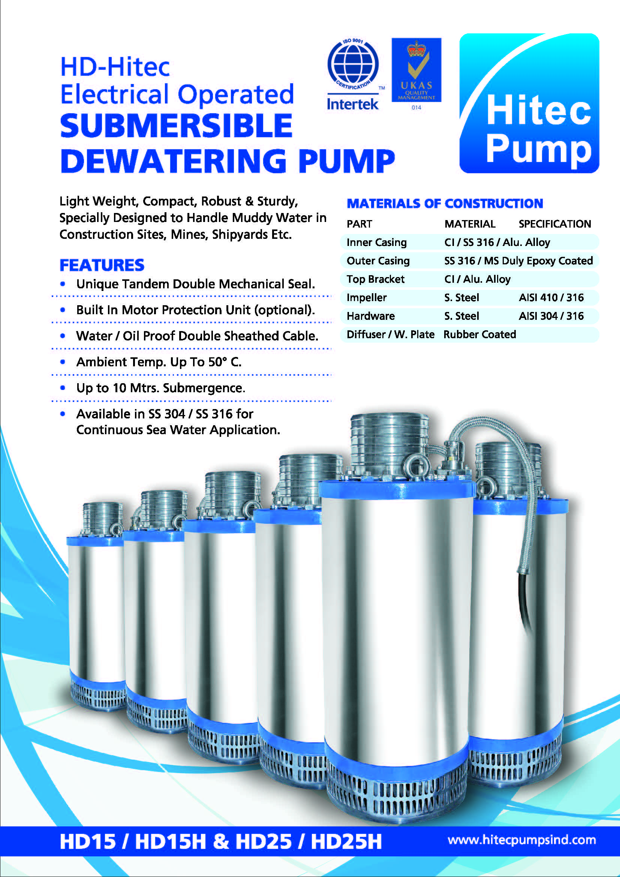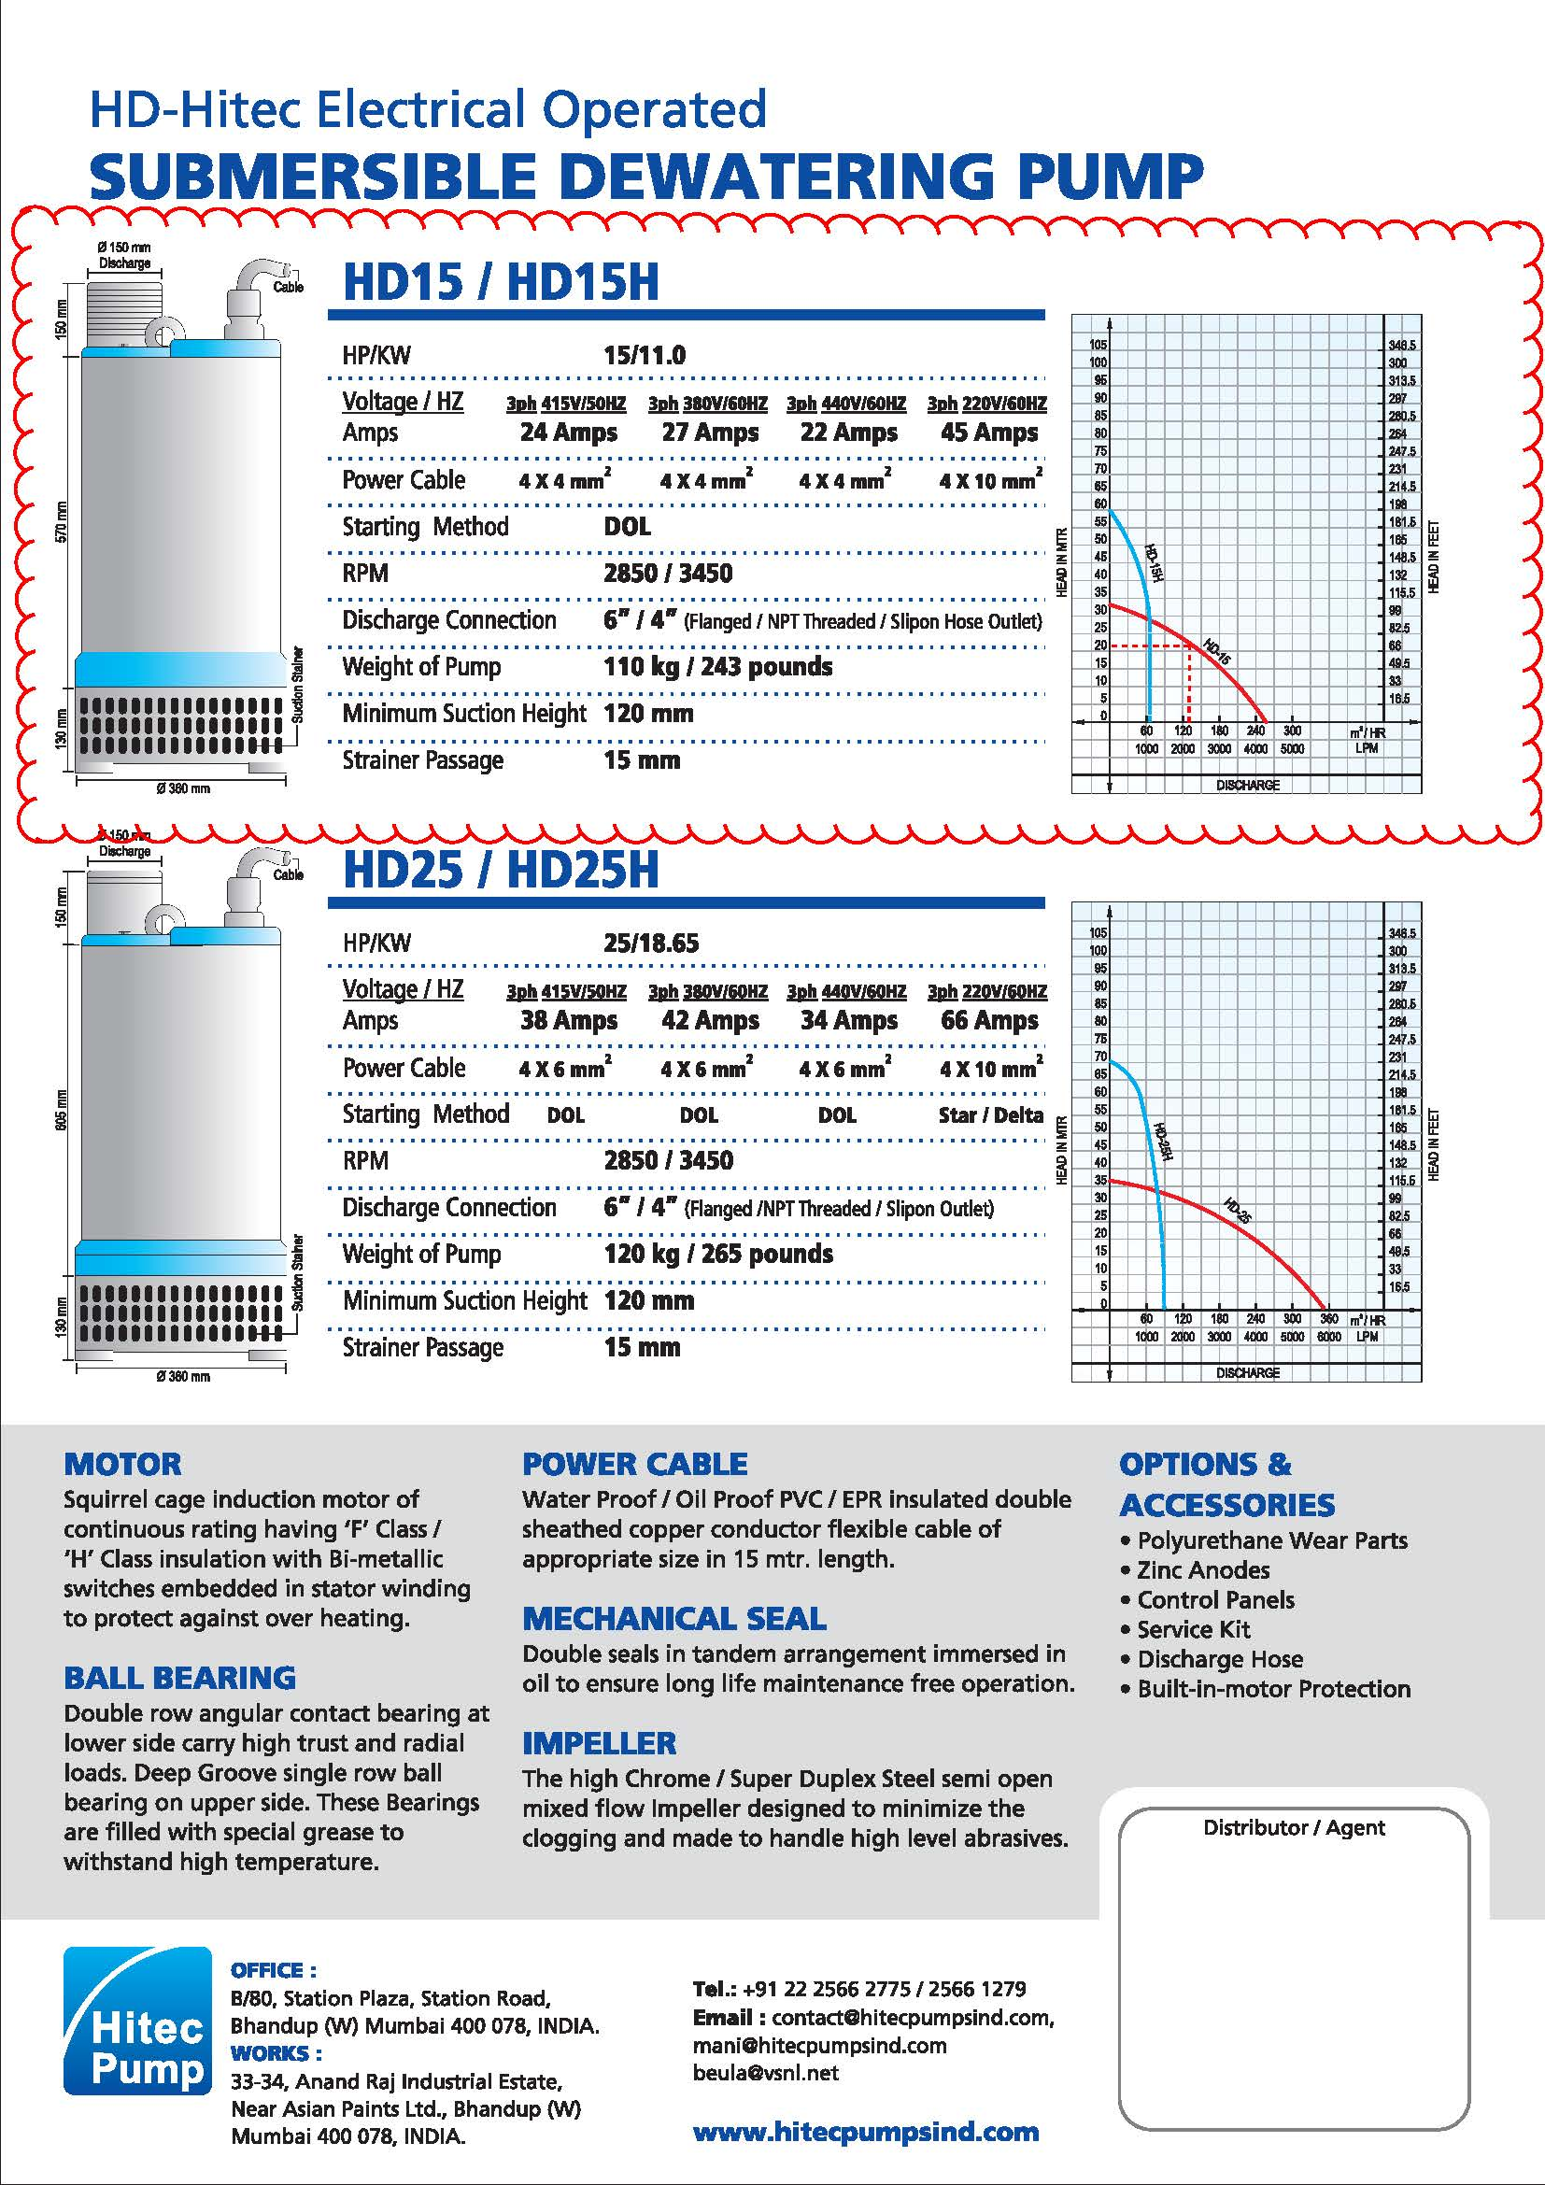

ANNEX 13

PLAXIS NUMERICAL ANALYSIS

(Displacement calculations)